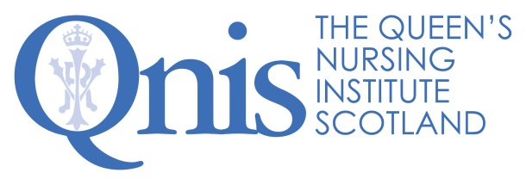
Chief Executive and Nurse Director Excellence Profile
Leadership | - Sets the values, purpose and vision of the charity, working creatively and collectively with trustees, staff and stakeholders to create an organisation which everyone loves to work with and for.  - Leads staff and volunteers, so they feel valued and motivated to do their very best for the organisation.  - Inspires others enabling the development of community nursing leadership capacity and capability to create healthful workplace cultures across Scotland.  - Continually reviews the short-, medium- and long-term strategy, listening to community nurses, funders and policymakers to maximise the impact of the charity, so we are truly making a difference.  - In person and across digital channels, communicates skilfully, building our reputation as an organisation promoting compassion, equity and social justice through nursing.  - Using highly developed networking skills, acts as a conduit to develop strong working relationship between QNIS and strategic stakeholders across health and social care, higher education and current/potential funders so others enjoy working with us and seek us out.  - Builds effective relationships with policy leaders in Scottish Government, NHS, professional bodies and other stakeholders in health and social care.  - Advises on practice, education and research requirements for community nursing at strategic level, contributing thoughtfully, bringing evidence, compassion and wisdom to discussions such that the views of QNIS are actively sought.  - Stays alert to changes in the health and social care or regulatory landscape that affect the charity or its work and develops a reputation for responding wisely.  - Builds trust through delivering on actions agreed and exceeding the expectations of others.

Outputs and productivity | - Enables excellent governance of the charity, working with QNIS Council to ensure best practice in all matters financial, legal, and regulatory.  - Manages risk for the charity diligently, horizon scanning, identifying and mitigating risk to business continuity, finance and reputation.  - Supports and enables the staff team ensuring a compassionate workplace culture so that staff find a sense of purpose and joy at work.  - Oversees the evolution of the Queen’s Nurse Development Programme ensuring its reputation for excellence and innovation continues.  - Leads QNIS operational planning and programmes ensuring that work is delivered on time, to budget and to a standard of excellence.  - Brings energy and vision to fundraising, balancing expenditure with income and managing financial risk with the trustees.  - Brings improvement thinking to systems and processes, to enable the team to work effectively together, continually developing and evaluating the impact of change.  - Leads work on policy priorities, developing high-quality thought pieces which shape national decision-making.

Technical know how | - Outstanding communication skills which enable excellence across all the areas above.  - Leaderships skills; values driven, collaborative, approachable - acting as a role model to others.  - Exceptional programme management skills and significant experience of delivering a range of complex projects.  - Strong financial skills, preparing and managing complex budgets with confidence and accuracy.  - Writes great reports and grant applications which have impact.  - A good understanding of methodologies used within health and social care research, and quality improvement, including co-production.  - Consults with others in enjoyable and creative ways, facilitating conversations which leave people feeling energised.  - Understands the political and policy influences on community nursing practice, research and development.  - A deep understanding of the challenges and barriers for nurses in developing practice, particularly working with marginalised communities.  - Skilled in IT, in particular Microsoft 365 and confident to take on new software.

Team work | - Builds and maintains a great rapport with colleagues.  - Leads the team in our commitment to becoming a truly mindful employer and creating a workplace where people flourish.  - Leads the team, enabling shared decision-making where everyone feels heard and involved.  - Acts as a role model and welcomes ideas to enable our development as a high performing team.  - Demonstrates a ‘can do/will do’ attitude and a willingness to roll up sleeves and get involved in anything that needs doing.  - Understands the challenges and benefits of working in a small team and enjoys doing so.  - Embodies their passion for the purpose of the Queen’s Nursing Institute Scotland and its contribution to health and social care.  - Takes time to celebrate with the team after working hard to achieve goals.  - Balances the urgent and important and enjoys working flexibly.  - Thrives in a dynamic and rapidly changing environment, embracing change and bringing others with them.  - Brings a sense of joy, takes responsibility for gauging the mood in the office and attuning to interpersonal issues that may need addressing.

QNIS 2024

