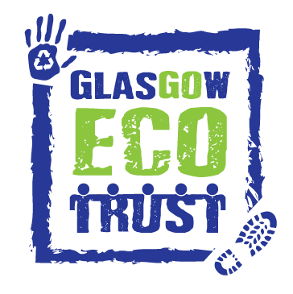 | Glasgow Eco Trust
Heart of Scotstoun Community Centre, 64 Balmoral St, Glasgow G14 0BL
t: 0141 433 0427 | e: hello@glasgowecotrust.org.uk
w: www.glasgowecotrust.org.uk
 | 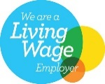 |   GlasgowEcoTrust  #GoEcoGlasgow
EQUAL OPPORTUNITIES MONITORING
THIS PAGE WILL BE REMOVED FOR SHORTLISTING

Glasgow Eco Trust is committed to equal opportunities in employment ensuring that no job applicant or employee receives less favourable treatment because of age, disability, gender reassignment, marriage and civil partnership, pregnancy or maternity, race, religion or belief, sex or sexual orientation.

If you wish to assist us in achieving a diverse workforce, and advertising our vacancies appropriately, please complete the following questionnaire. If you do not wish to complete the form, this will have no bearing on any selection decisions.

All information will be treated in the strictest confidence, processed anonymously and separately from any application form you submit. The information will not be provided to or shared with the shortlisting or interview panel. The information will be used for monitoring purposes only.

Please complete all sections of the questionnaire below by placing a tick (✔) or by providing information where appropriate in the classification box applying to you in each section.

AGE
☐ 16-24 ☐ 25-34 ☐ 35-44 ☐ 45-54 ☐ 55-64 ☐ 65-74 ☐ 75+ ☐ Prefer not to say

GENDER IDENTITY
What is your gender?
☐ Cisgender Man (your gender corresponds with your birth sex)
☐ Cisgender Woman (your gender corresponds with your birth sex)
☐ Non-binary ☐ Agender
☐ Transgender Man ☐ Transgender Woman
☐ Prefer not to say ☐ Prefer to self describe:____________________________

SEXUAL ORIENTATION
Which of the following best describes your sexual orientation?
☐ Asexual ☐ Bisexual
☐ Gay man ☐ Gay woman/lesbian
☐ Pansexual ☐ Straight/heterosexual
☐ Prefer not to say ☐ Prefer to self describe:____________________________

PHYSICAL OR MENTAL HEALTH CONDITION OR ILLNESS
Do you have a physical or mental health condition or illness lasting or expected to last 12 months or more?
☐ Yes ☐ No ☐ Don’t know ☐ Prefer not to say
If Yes does your condition or illness reduce your ability to carry-out day-to-day activities?
☐ Yes, a lot ☐ Yes, a little ☐ Not at all

RELIGION / BELIEFS
What is your religion / beliefs?
☐ Buddhist ☐ Christian
☐ Hindu ☐ Jewish
☐ Muslim ☐ No religion or belief
☐ Pagan ☐ Sikh
☐ Prefer not to say ☐ Prefer to self describe:____________________________

ETHNICITY
What is your ethnic group?
☐ White English/Welsh/Scottish/Northern Irish/British
☐ White Irish ☐ White Gypsy or Irish Traveller
☐ Mixed/Multiple ethnic groups White and Black Caribbean
☐ Mixed/Multiple ethnic groups White and Black African
☐ Mixed/Multiple ethnic groups White and Asian
☐ Asian/Asian British ☐ Asian/Asian British Indian
☐ Asian/Asian British Pakistani ☐ Asian/Asian British Bangladeshi
☐ Asian/Asian British Chinese
☐ Black/African/Caribbean/Black British African
☐ Black/African/Caribbean/Black British Caribbean
☐ Arab
☐ Prefer not to say ☐ Prefer to self describe:____________________________

OTHER
Position applied for: ____________________________
Where did you see the vacancy advertised? ____________________________

THIS PAGE WILL BE REMOVED FOR SHORTLISTING

