CAPS Independent Advocacy

Job Description

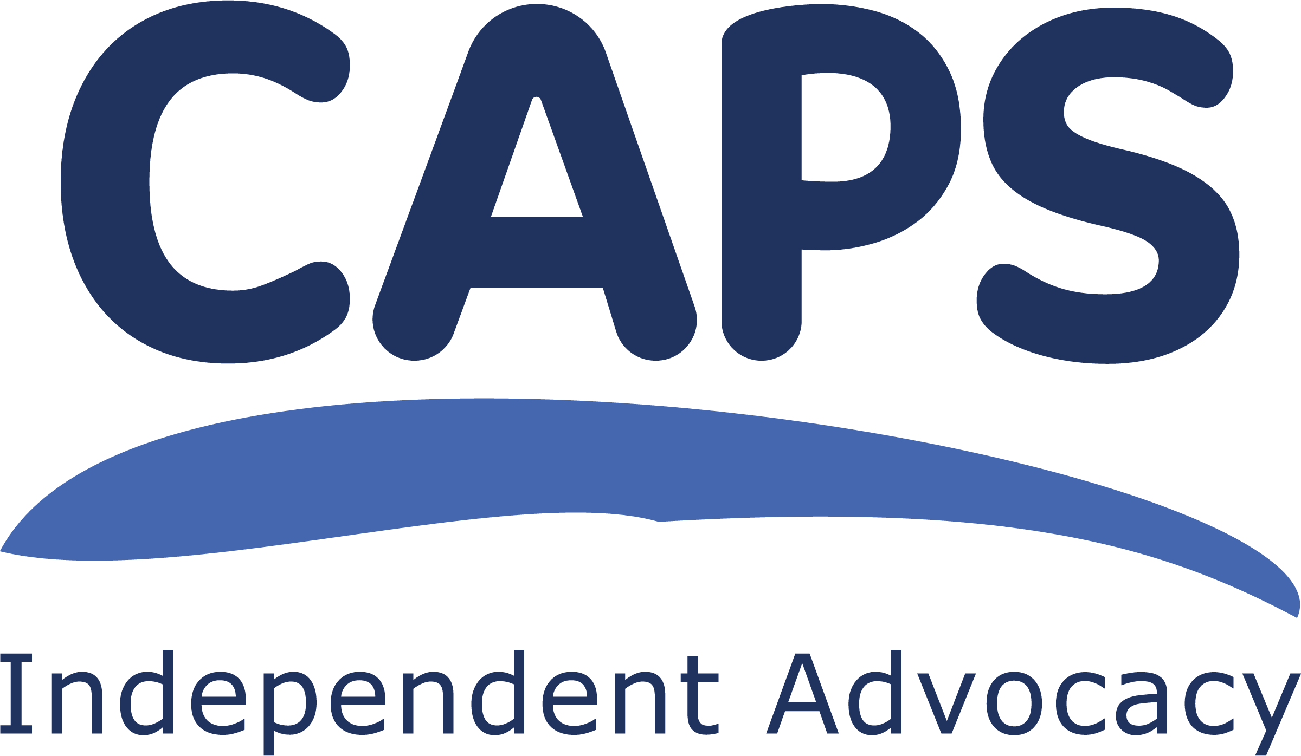
POST: Individual Advocacy Worker
(Mental Health)

GEOGRAPHICAL REMIT: East Lothian and Midlothian

LOCATION: CAPS Head Office, Musselburgh

HOURS: full time, 36.25 hours per week

SALARY: Grade AP4, £25,778 – £28,533 per annum FTE.

LINE MANAGER: Individual Advocacy Team Leader

GENERAL PURPOSE OF THE POST

The principal function of this post is to provide direct individual advocacy to adults living in the community in Midlothian and East Lothian who use mental health services.
The post-holder will work alongside our team of individual advocacy workers. The focus of the work will be the provision of independent advocacy in the community on a variety of issues of concern to the person.
The post holder will be expected to provide support for Mental Health Tribunal work. The post-holder will be expected to manage their own case load and monitor and report on progress in their work.

TASKS

Advocacy

- to provide independent advocacy to people meeting the criteria for using our adult mental health service;

- to provide cover, if required, within the drug and alcohol individual advocacy service;

- to respond quickly and efficiently to requests for independent advocacy;

- to accompany people to appointments, assessments and other meetings to provide the advocacy the person requires;

- to record advocacy work in line with Data Protection and other relevant legislation for the purposes of monitoring the work of the project;

- to use case management software in accordance with CAPS procedures, ensuring accurate information is available for casework as well as monitoring and reporting purposes;

- to make documents related to their advocacy issues understandable to the people we work with;

- to liaise with other professionals involved in a person’s care from point of referral onwards and assist that person to express their wishes and views;

- to make contact with specific support agencies e.g. Citizens Advice Bureau, Welfare Rights Teams and solicitors who can offer expert advice and guidance;

- to liaise with other advocacy services to ensure continuity of advocacy provision to an individual;

- to promote and safeguard the rights and welfare of the people we work with;

- to work flexibly within the Individual Advocacy team to ensure that all referrals to the service are dealt with promptly and effectively.

Development Work

- to promote CAPS and the role of independent advocacy to people who use mental health services;

- to attend relevant meetings where appropriate;

- along with the Individual Advocacy team, to monitor, assess and review the effectiveness of advocacy work undertaken;

- to liaise with other advocacy services supporting people experiencing mental health issues

General
- work independently, prioritise workload and meet deadlines;

- work alongside other Individual Advocacy staff as required as part of the CAPS staff team and contribute to the smooth running of the service;

- have a commitment to and ensure the practical application of CAPS’ policies and procedures;

- be aware of boundaries in all the relationships established in carrying out this work;

- ensure that your actions and work behaviours meet the standards set by CAPS;

- ensure all your work behaviours display an anti-racism approach and challenge any prejudice and discrimination shown to people with protected characteristics.

- any other duties deemed relevant to the post.

Contacts

- people who use mental health services;
- mental health service providers and commissioners;
- members and staff of support agencies;
- other advocacy organisations and their staff;
- CAPS’ Management Committee, staff and volunteers.

MANAGEMENT

You will be line managed by the Individual Advocacy Team Leader through regular supervision sessions. You will be ultimately accountable to the Management Committee and will be expected to report to them when required.

You will also take part in team meetings with other CAPS staff.

LOCATION

CAPS office is based in Musselburgh. You will also be expected to travel within East Lothian, Midlothian and Edinburgh and occasionally outside these areas. In work travel expenses will be reimbursed in line with CAPS’ Expenses Policy. Some home working will be permitted.

FUNDING

This post is dependent upon recurring funding from East Lothian and Midlothian Health and Social Care Partnerships.

EMPLOYER

Your employer will be CAPS’ Management Committee.

TRAINING
You will be expected to participate in training and personal development as identified through supervision with your line manager. You may also ask for particular pieces of training. It may not be possible to approve a particular piece of training if we do not have the resources.

WORKING HOURS

Your working hours will be 36.25 hours per week (full-time) worked over five days. Evening or weekend work is unlikely but, if required, would be accommodated into the contractual hours. Hours will be split equally between East Lothian and Midlothian.

HOLIDAYS

30 days annual leave plus 5 fixed and 6 floating public holidays, pro rata.

ABOUT CAPS
CAPS is an Independent Advocacy Organisation which provides Individual Advocacy to adults from East Lothian and Midlothian who have mental health issues or are using drugs and alcohol as well as the LGBTQIA+ community. We provide individual advocacy for children and young people going through the Children’s Hearings process, in these areas. We also provide Individual Advocacy for adults, and for children and young people, experiencing Eating Disorders who live anywhere in Lothian.
We provide Collective Advocacy to groups of people across Lothian with mental health issues, and Veterans across Scotland, so they can come together and voice their experiences in order to bring about change for others or improvements in services.

The main purpose of CAPS’ work is therefore to assist people, through advocacy, as individuals or as members of a group, to set their own agenda, make their wishes known and to have a say in how they live and what services they use. Visit our website for more details www.capsadvocacy.org

We are set up so that the organisation and its staff are as free as possible from any conflicts of interest. We are independent from the people who fund us and those who provide other services to the people we work with. CAPS is a member of the Scottish Independent Advocacy Alliance (SIAA) and we adhere to the Principles and Standards of Independent Advocacy. CAPS was established in 1991.

CAPS’ main office is in Musselburgh, East Lothian.

MISCELLANEOUS
For the good of CAPS, all staff have a duty to be flexible enough in their working practice to support the work of other functions within the organisation.

This post will be subject to membership of the Protecting Vulnerable Groups Scheme (PVG Scheme) and appropriate check.

CAPS is a Scottish Charitable Incorporated Organisation.
Scottish Charity number SC021772

CAPS Independent Advocacy
Old Stables
Eskmills Park
Station Road
MUSSELBURGH
EH21 7PQ

Phone: 0131 273 5116
www.capsadvocacy.org

CAPS Independent Advocacy is a Scottish Charitable Incorporated Organisation.
Scottish charity number: SC021772

