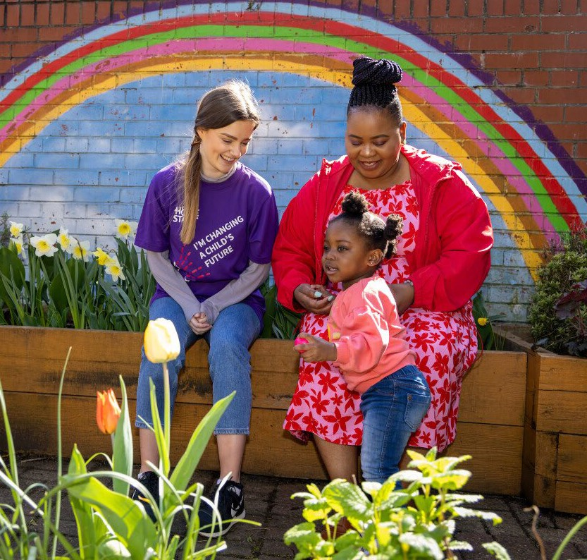

Group Worker - Glasgow

Candidate Information

Company Registration SC280855

Registered Charity SC032736



# Hello

We are delighted that you are interested in working with us at Home-Start Glasgow North and North Lanarkshire (HSGNNL). Let us tell you a little bit more about the charity and our work with families, communities and volunteers.

HSGNNL is a federated organisation that works alongside families who have at least one child under the age of five living in North Glasgow or North Lanarkshire.

Parenting is not easy and can often be more challenging when coupled with other difficulties, such as isolation, trauma, physical disabilities, poverty, Adverse Childhood Experiences (ACEs), being a young parent or a single parent, bereavement, or coping with multiple births, e.g. twins/triplets.

Our core service is home-visiting volunteer support where dedicated volunteers work alongside parents in their own home to help them cope with the challenges they are facing. We also offer group support in local communities, which encourages and motivates families to participate in healthy, stimulating activities, reduces isolation, and promotes interaction between parents and children and other families. In addition, we offer bespoke intensive perinatal and infant mental health support, family support in schools, Video Interaction Guidance (VIG) and support and guidance to families navigating the complex and challenging asylum process.

We work closely with our communities ensuring our services meet the needs of local families, their children, and their new babies. We are here for all families and we are passionate about ensuring equal access to early years and family support for every pregnant person, parent, baby and child.

# Our Vision, Our Mission, Our Values

**Our Vision - What is our dream?**

Children and families are happy, thriving, confident and resilient.

**Our Mission - What will we do?**

To ensure children have the best possible opportunities to flourish, we nurture and support families to build confidence, improve health and well-being, strengthen relationships and connect with their communities.

**Our Values - How will we behave?**

**Respect -** We respect everyone’s rights, beliefs and feelings. We treat everyone with empathy, compassion and dignity.

**Integrity -** We are accountable for our actions and behaviours. We strive to build honest, trusting relationships with everyone.

**Inclusion -** We listen and respond to the voices of children and families. We acknowledge their unique needs, preferences and characteristics, ensuring our services are inclusive and accessible for all.

**Collaboration -** We value everyone’s contribution and explore different ideas. We are curious to learn from others and we build partnerships to bring positive change.

**Commitment -** We challenge ourselves to be our best and to deliver a meaningful and positive experience for our families, volunteers and staff.​

# Strategic Outcomes

**Our Outcomes - What does success look like?**

**Outcome 1 – IMPACT**

Through bespoke early intervention with practical and emotional support, families will demonstrate improved mental and physical well-being, increased self-confidence, positive relationships and engagement within their communities.

**Outcome 2 – CONNECTION**

Staff, volunteers and families feel valued, respected and recognised. Their emotional and physical well-being and life experiences are enhanced through support, development opportunities, training and increased connections.

**Outcome 3** – **GROWTH**

The voices and views of those involved in our service, together with research and experiences, will be the foundation of future growth and development.

# Home-Start GNNL Groups

# Groups are a core element of family support. Families referred or who self-refer to HSGNNL

# often enjoy family group as a standalone intervention or as part of a package of support.

# The groups are often popular because:

# Parents can benefit from peer support from others in a similar position. This support system helps families feel less isolated and more connected to their community.

# It provides an opportunity to learn and share new skills and opportunities for both the parents and child/infant, e.g. information on health and parenting.

# By participating in activities and discussions together, family bonds can be strengthened.

# It can give parents and their children a more rounded view of society by providing opportunities to socialize with different socio-economic groups.

Families often struggle to access services due to issues such as having to travel distances, living in poverty so unable to afford the travel costs, multiple births or anxieties leaving their house.

We currently run 4 groups across North Glasgow:

**Family Group** runs Thursday mornings from 10 – 11.30 am at Maryhill Community Centre and is facilitated by a Group Worker, who is supported by volunteers. Activities focus on health and well-being, reducing isolation, increasing bonding and attachment and peer support. Activities include storytelling, singing, arts and crafts, healthy eating/snacks, sharing experiences (cultural differences) and often have sessional workers providing other fun activities.

**Café Stork** is a perinatal group for babies 12 months and under which runs Thursdays from 10 – 11.30 am at Barrowfield Community Centre. The café element helps attract families to the drop in, where they can talk to our Group Worker or volunteers, make new friends and reinforce their parenting skills. Families can drop in once or come back on a regular basis. There are often sessional workers invited to the groups, such as Health Improvement Team for breastfeeding/weaning advice, paediatric first aid and baby massage.

**Heart of Scotstoun** runs Tuesdays 10 – 11.30 am and is a group for parents and children up to 3 years

of age. Delivered in Scotstoun Leisure Centre, activities are focused on improving bonding and attachment, socialisation for parents and children, reducing isolation and increasing confidence.

**Home-Start@Easterhouse** Parish Church is on Tuesdays from 10 – 11.30 am and is a group for parents/carers and pre-school children. Activities are focused on bonding and attachment through play, arts and crafts, storytelling and peer support.

We are looking to increase group activity in local communities as well as in our new Early Years Family Hub located in Maryhill.

**Holiday Programme**

During school holidays, HSGNNL offers families opportunities to explore local attractions such as teddy bear’s picnic at Botanic Gardens, Kelvingrove Park, and further afield to places like Blair Drummond Safari Park and Five Sister’s Zoo. These activities are free to supported families.

Our Group Workers and other staff members support our Christmas Giving which is supported by donated gifts and Christmas events.

-

# Job Description

Job Title: Group Worker

**Employer:** Home-Start Glasgow North and North Lanarkshire

Location: North Glasgow

Salary: £23,935 - £25,270 (pro rata) - starting salary dependent on relevant experience

**Hours of work:** 35 hours/week

**Responsible to:** Senior Group and Events Lead

**Purposes of the job**

To plan, develop and facilitate, with staff and volunteers, group sessions for parents and their

young children in communities across North Glasgow.

**Key responsibilities:**

**Supporting families through groups**

* Plan and deliver child-focussed play/educational activities to support child development, bonding, attachment, and socialisation in weekly support groups within the community.
* Plan weekly family programmes of activities during school holiday periods.
* To provide a safe, stimulating environment for children and their parents/carers.
* To welcome all parents/carers to groups, recognising the importance of their role as the prime educators of their children.
* To encourage the active participation of parents/carers in their child’s play and other activities as

appropriate.

* To be aware of group dynamics ensuring the groups provide a non-judgemental environment for

children and their parents/carers.

* To be vigilant about the upkeep of equipment ensuring good standards of safety and hygiene.
* To complete a risk assessment prior to each session/outing.
* To record any accidents/incidents in the Accident or Incident Book and report as appropriate.
* To respond, record and report appropriately all Safeguarding Children/Child Protection issues.
* Ensure suitable resources available for all families, e.g. culturally diverse, ASN.
* Ensure equality of opportunity, fairness, and diversity in all aspects of work.
* Guide and support volunteers attending group sessions.

**Working in Partnership**

* Network within the community; developing strong working relationships with partner organisations to

ensure our service is effective and inclusive.

* Develop partnerships with other services to provide opportunities for external agencies to offer advice/information to families within the group setting, and support families to increase their connections in the local community.
* To promote the use of local facilities such as libraries, groups, Bookbug etc.
* To promote the work of Home-Start Glasgow North and North Lanarkshire.

**Monitoring, evaluation and service development**

* + Maintain systems for monitoring and evaluation of group sessions.
  + To liaise with the Senior Group and Events Lead regarding small budgets.
  + Keep an attendance register at each session including parents, children, visitors/speakers.
  + Collect attendee evaluations and appraise groups as required.
  + To make observations, record, and report on children’s development.
  + Input information into HSGNNL’s CRM database – Charitylog.
  + Promote services and opportunities on social media platforms, eg Facebook, Twitter and Instagram.
  + Contribute to written and verbal reports to other agencies and for funders using Microsoft packages.
  + Contribute to and support the development of the Home-Start network locally, regionally, and

nationally, by sharing practice, participating in peer support groups and engaging with our national

network through our intranet or events.

**This role will require travel throughout North Glasgow so a driving licence and access to a car is**

**essential. There may be occasional evening and weekend work.**

The postholder may be required to undertake any other duties that fall within the nature of the

role and responsibilities of the post as detailed above.

This job description reflects the major tasks to be carried out by the postholder and identifies the

level of responsibility at which they will be required to work. In the interests of effective working,

the major tasks may be reviewed from time to time to reflect changing scheme needs and circumstances. Such reviews and any consequential changes will be carried out in consultation with the postholder.

# Person specification

### Essential

* Knowledge and experience
* Knowledge of the third sector; particularly around children and families and the challenges they

face

* Knowledge of legislation around Child Protection, GIRFEC and Shannari indicators
* Experience of Child Protection
* Experience of planning, developing and facilitating groups for children and families
* An understanding of children’s developmental needs and planning activities to develop them
* Understanding of the need for professional confidentiality
* Partnership working and stakeholder engagement
* Developing and managing impactful marketing and communications activity with demonstrable results

### Skills

* + Ability to organise appropriate activities and programmes
* Ability to maintain accurate records and provide reports from them
* Ability to organise and manage volunteers to provide support to the group

### Excellent interpersonal skills and the ability to manage relationships with a variety of internal and external stakeholders

### Highly organised and the ability to prioritise tasks

### Excellent verbal communication and persuasive skills, with the ability to present information on MS Teams and face to face

### A high standard of written skills with ability to complete reports to Senior Group and Events Lead, Board etc

### An adaptable and flexible approach

### The ability to work well as part of a team

### Strong record-keeping skills and a commitment to managing data

### Proficiency in using Word, Excel, Outlook and MS Teams

### Personal Qualities

### A commitment to our organisational values and behaviours

* Encouraging equality, diversity and inclusion in the workplace
* Treating with confidentiality any personal, private or sensitive information
* A passion for our work, helping families through compassionate, non- judgemental support and working with volunteers
* Visionary with the ability to inspire and motivate others with a positive mind-set
* Results-focused with the ability to personally deliver tangible outcomes
* Creative in solving problems and entrepreneurially seizing opportunities
* Resilient, collaborative, diplomatic and emotionally intelligent
* Ability to work flexibly as required

## The benefits of working for HSGNNL

|  |  |  |
| --- | --- | --- |
| A standard 35-hour work week | Hybrid working (including flexi-time) | Access to learning and development opportunities |
| 25 days annual leave plus 12 public holidays per year (pro rata for part-time hours)  Two weeks closure at Christmas and New Year. | Pension benefits – up to 8% employer contribution | Paid time off for volunteering (2 days) |
| Quarterly staff well-being activities | Employee/Volunteer Assistance Programme – confidential counselling service for staff member and immediate family members | Inclusive and supportive culture |
| Enhanced sick pay | Enhanced maternity and paternity benefits | Dependents Leave |

**The team that you will be joining**  
HSGNNL currently has 19 employees. Please see our organization chart below to see how your role fits into the wider organization.

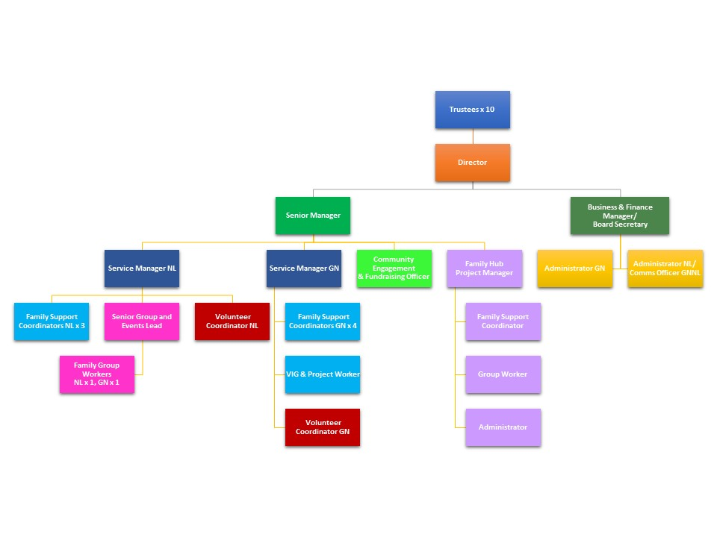



**Removing bias during the recruitment process**

In line with our commitment and desire to build a diverse workplace, we have put some processes in place to ensure a fair recruitment process.

### The application

* The recruitment process is blind. When you apply, your personal details are anonymised to avoid any unconscious bias and we use a standardised scoring system to ensure fair shortlisting of candidates for interview.
* Ask our recruitment team any questions or voice any concerns and the team will happily support you in overcoming any barriers that we may have missed.

### The interview

* We will be as flexible as we can to ensure you can attend your interview. Depending on the individual hiring manager’s flexibility, we can offer some interview slots in the evenings or at the weekend if necessary.
* We send out all the interview tasks and/or questions that you will be asked before your interview to give you time to prepare meaningful answers.
* We have a member of the recruitment team who is trained in Safer Recruitment on the panel for each interview to ensure a fair and safe process.
* We use a standardised scoring sheet for each interview with pre-agreed criteria based on the Candidate Pack and interview questions/task sent to you beforehand. At the end of the interview, each panel member gives their score and we take an average of these to reduce any risk of bias.