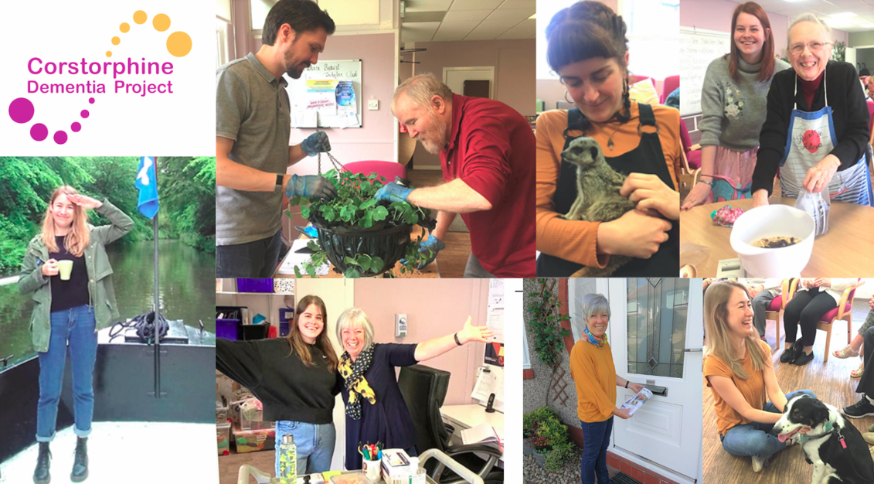

Application Form
THE INFORMATION YOU SUPPLY ON THIS FORM WILL BE TREATED IN CONFIDENCE

Section 1 Personal details

Last Name: |  | First Name:

Address:

Postcode:

Home Telephone Nº: |  | National Insurance Nº:

Mobile Telephone Nº:

E-mail address:

Are you free to remain and take up employment in the UK with no current immigration restrictions? | Yes |  | No

Section 2 Present Employment
Please provide details of your employment history in chronological order including any part time or voluntary employment.

Present Employment (If now unemployed give details of last employer)

Name of Employer:

Address:

Post Title: |  | Salary:

Start Date:

Brief description of duties:

Continue on a separate sheet if necessary

Period of Notice: |  | Last day of service  (if no longer employed):

Reason for leaving
(if no longer employed):

Section 3 Previous Employment
Most recent employer first

Name of Employer:

Address:

Position Held:

Summary of duties:

From: |  | To:

Reason for leaving:

Name of Employer:

Address:

Position Held:

Summary of duties:

From: |  | To:

Reason for leaving:

Name of Employer:

Address:

Position Held:

Summary of duties:

From: |  | To:

Reason for leaving:

Section 4 Further Education
Qualifications obtained from Colleges and/or Universities. Please list highest qualification first:

College or University | Course | Qualification obtained
Continue on a separate sheet if necessary

Section 5 Training and Development
Please give details of any training courses or non-qualification courses which support your application. Include any on-the-job training as well as formal courses.

Title of Training Program or Course | Duration of Course

Section 6 Supporting Statement

Abilities, skills, knowledge and experience.
Please provide a supporting statement of your personal qualities, values and experience which you believe are relevant to your suitability for this post and how you meet the requirements of the job description. Attach and label any additional sheets used. The information provided below will contribute towards the shortlisting selection.

Section 7 Protecting Vulnerable Adults

As this post involves regulated work with protected adults, PVG Scheme membership is mandatory.
Are you currently a member of the PVG Scheme? | Yes |  | No

Are you aware of any police enquires undertaken following allegations made against you, which may have a bearing on your suitability for this post? | Yes |  | No

Section 9 Interview Arrangements and Availability

If you have a disability, please tell us if there are any reasonable adjustments we can make to help you with your application or our recruitment process.

Please give details:

If successful, when could you start working for us?

Section 10 References

Please give the names and addresses of your two most recent employers (if applicable). If you are unable to do this, please clearly outline who your references are.

Reference 1 |  | Reference 2

Name: |  | Name:

Position: |  | Position:

Work Relationship: |  | Work Relationship:

Organisation: |  | Organisation:

Address: |  |  | Address:
 | Postcode |  |  | Postcode

Telephone Nº: |  | Telephone Nº:

E-mail: |  | E-mail:

Section 12 Declaration

I confirm that the information given on this form is, to the best of my knowledge, true and complete. Any false statement may be sufficient cause for rejection or, if employed, dismissal.

Signed: |  | Date:

(NB. Candidates selected for interview will normally be notified within one week of the closing date. Unfortunately, applicants who do not hear from us must conclude that their application has been unsuccessful on this occasion. Thank you for your interest in this post.

Data protection: Corstorphine Dementia Project is fully compliant with the UK General Data Protection Regulation (GDPR) and will only hold the information you opt to provide us with for the duration of the recruitment process unless you advise us otherwise. Following completion of this process all data you provide will either be securely destroyed, or if you are successful in your application, progress forward to form part of a personnel file.

CLOSING DATE FOR APPLICATIONS – MONDAY 22nd JULY BY 9AM

R E T U R N I N G T H I S F O R M
By Hand or Post:  The Corstorphine Dementia Project  c/o Carrick Knowe Church  118-132 Saughton Road North  Edinburgh  EH12 7DR | By E-Mail:  recruitment@cdp-edinburgh.org.uk  Enquiries:  Telephone: 0131 478 7784

