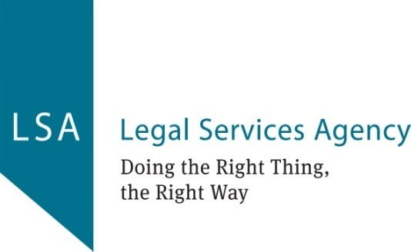

**JOB DESCRIPTION: Chair**

**REPORTING TO: The Board of Directors**

**Chair’s Role:**

To lead the Board, ensuring that it fulfils its responsibilities for the governance of the organisation, and to work in partnership with the Chief Executive, helping them to achieve the aims of the organisation; and to optimise the relationship between the Board and staff.

**KEY RESPONSIBILITIES:**

1. Leadership:

* Providing leadership for the Board in its role of setting the strategy and policy of the organisation.
* Foster a positive board culture, promote open communication, and encourage active participation and collaboration among Board Directors.

1. Governance Oversight:
   * Chair Board and Executive Committee meetings, ensuring they are conducted efficiently, effectively, and in accordance with regulatory requirements.
   * Ensure the Board operates in compliance with its governing documents and evolves taking into consideration best practices.
   * Ensure the Board fulfils its governance responsibilities, including setting policies, monitoring organisational performance, and overseeing risk management.
2. Board Development and Engagement:

* Facilitate the recruitment, orientation, and development of Board Directors, ensuring a diverse and skilled governing body.
* Facilitate discussions and decision making processes during Board and Committee meetings ensuring a collaborative and productive environment.
* Leading the process of appraising the performance of the Board.

1. Strategic Planning and Performance Monitoring:

* To ensure the organisation has a clear mission, vision and values.
* Work closely with the Executive Committee to lead the development and implementation of the organisation's strategic plan, ensuring alignment with its mission, vision, and values.
* Monitor organisational performance against strategic goals, regularly reviewing progress in conjunction with the CEO and recommending adjustments as needed.

1. Financial Oversight:

* Ensure sound financial management, including oversight of budgets, financial statements, and compliance with financial regulations in conjunction with the Treasurer.
* Work closely with the Finance & Risk Committee and CEO to develop and monitor financial plans and ensure transparency and accountability in financial reporting.

1. Risk Management and Compliance:

* Work closely with the Finance & Risk Committee and CEO to identify and assess risks to the organisation's mission and operations, implementing appropriate risk management strategies and controls.
* Ensure compliance with legal and regulatory requirements, ethical standards, and organisational policies and procedures.

1. Advocacy and Public Relations:

* Support the CEO in advocating for the organisation's mission and priorities through raising the organisation's public profile and reputation, promoting awareness of its work and impact.
* Represent the organisation externally as required, advocating for its interests and fostering strategic partnerships and collaborations.

1. Support and performance management of Chief Executive Officer:
   * Ongoing regular check-ins, support and mentoring, offering guidance and assisting the CEO in navigating challenges and enhancing their leadership capabilities.
   * Facilitating opportunities for the CEO’s professional growth and development ensuring they have access to training and resources needed to succeed in their role.
   * Conduct CEO’s annual performance appraisal to evaluate progress against agreed objectives providing constructive feedback and agreeing future priorities.

**PERSON SPECIFICATION:**

* Integrity and commitment to the organisation’s mission and values.
* High ethical standards and integrity in all dealings.
* Experience in non-executive roles, tact and diplomacy.
* Understanding of governance principles and the role of the Board.
* Strong interpersonal skills, with the ability to build relationships and work collaboratively.
* Keen attention to detail, ensuring accuracy in documentation and communications.
* Ability to think critically and solve problems efficiently.
* Proactive in identifying and addressing issues before they escalate.
* Understanding of governance principles and the role of a Board.
* Familiarity with the legal and regulatory environment of charitable organisations.
* Previous experience in a similar role within a non-profit or voluntary organisation is an advantage.