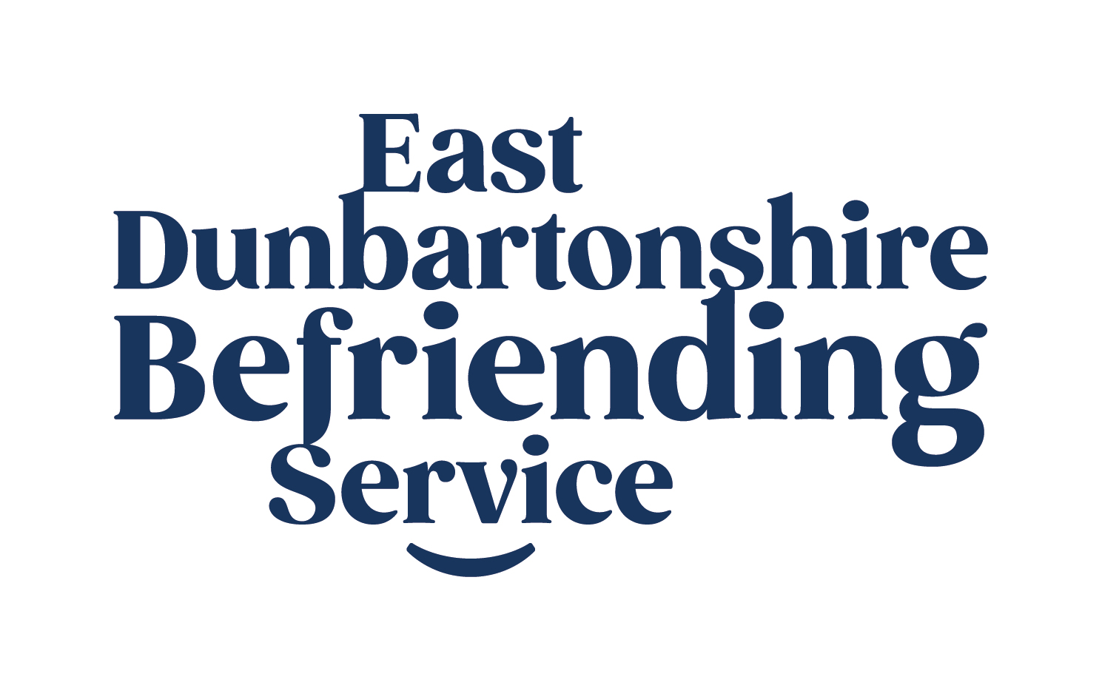

East Dunbartonshire Befriending Service

Job Description:

Service Manager

Job Title: East Dunbartonshire Befriending Service, Service Manager

Salary: £32,000 per annum

Pension: 6% of annual salary paid into pension scheme of your choice, which comes into effect only after 6 months of employment with EDBS.

Holidays: 20 days’ annual leave (increasing to 25 days after 1 year’s service), plus 12 public holidays (6 fixed 1st&2nd January, Good Friday & Easter Monday, 25th & 26th December and 6 floating).

Hours of work: Normally 35 hours per week. However, there will sometimes be a requirement for evening or weekend work for which a Time-Off-In-Lieu system operates.

Probationary Period: Six months, with a three-month review.

Line Manager: Responsible to the Board of Trustees.

Working with: EDBS Community Link Workers, Admin Officer, Fundraiser and Board of Trustees.

Screening: EDBS is committed to ensuring the safety of vulnerable people and our recruitment process is designed to support this.
The post-holder will be subject to assessment for eligibility for membership of the Protection of Vulnerable Groups Scheme. Confirmation of appointment will be conditional on the satisfactory outcome of this process.

Purpose of Post: To lead the coordination, development and delivery of EDBS’s well-established high quality Befriending Service to vulnerable adults aged 18 and over across East Dunbartonshire to alleviate loneliness and social isolation.

Outcomes of the Service: EDBS’s Befriending Service provides services to increase the social connectedness of its service-users; reduce the isolation and loneliness of its service-users and ensure that its volunteers have access to high quality volunteering.

Overview: The job description will be supported by objectives agreed in consultation between the Service Manager and the Board of Trustees. This job description will be reviewed from time to time and may need to be revised according to the priorities of the current workload, organisational needs and funding. This review will be agreed by the Board and the post-holder.

Specific Duties:

- Manage the East Dunbartonshire Befriending Service and the quality of its outputs and outcomes in line with relevant strategic plans and policy contexts.

- Have line management responsibility for East Dunbartonshire Befriending Service staff team.

- Manage the Befriending Service budgets ensuring that income and expenditure is within agreed budgets and that appropriate records and accountability are maintained.

- Identify potential sources of income generation for the service, and take appropriate steps to ensure that the Befriending Service is financially sustainable.

- Ensure case management is completed satisfactorily and supports the effective monitoring and evaluation of the Befriending Service, and keep the Board of Trustees well informed and up-to-date on key issues and progress, including any matters of concern.

- Develop and ensure appropriate implementation of agreed eligibility criteria, assessment procedures and matching processes related to Befriending Service clients and volunteers.

- Manage the recruitment of new volunteers to the Befriending Service and facilitate their induction, training, vetting (PVGs) and post-training appraisal, ensuring that volunteering within the service is of high quality, appropriate and sustainable.

- Manage befriending service communication and information systems in line with best practice to ensure quality assurance and accurate reporting related to Befriending Service activity.

- Manage the monitoring and evaluation of the Befriending Service and provide appropriate reports as required for funders and the Board of Trustees.

- To work in partnership with funding bodies, the wider local third sector and statutory partners, and other stakeholders, for the benefit of the Befriending Service, and its clients and volunteers.

- To undertake Befriending Services quality assurance kite marks regarding Quality in Befriending Award, Volunteer Friendly Award and any other relevant quality assurance frameworks.

General Duties:

- To participate in EDVA staff meetings, performance and support sessions, training and development plans, and other relevant paperwork such as work plans to a high standard.

- To adhere to EDB’s policies and procedures.

- To work collaboratively towards the aims and objectives of the organisation as a whole, and assist with general office duties in the absence of other members of staff.

- To undertake any other duties that might be reasonably required which are in line with the post, and in agreement between the post-holder and the Board of Trustees.

Person Specification –East Dunbartonshire Befriending Service Manager :
Qualifications
Essential | - Relevant professional qualifications  - Evidence of managing/supervising staff and volunteers within health & social care context  - Experience of partnership working, and working across a broad range of multi agency networks & organisations and/or within communities and third sector
Desirable | - A full driving licence

Experience
Essential | - Experience of project management and managing quality outcome delivery  - Experience of managing budgets and financial decision-making  - Successful delivery against targets within a voluntary/not for profit/public  Organisation  - Knowledge of national and local policy affecting the health & wellbeing of older vulnerable adults  - Experience of befriending services and volunteering  - Ability to make use of a range of information and communication technology  - Experience of motivating and managing team members  - Excellent oral and written communication skills  - Effective problem solving and analytical skills  - Excellent interpersonal skills  - Ability to organise, plan and prioritise project resources and manage competing deadlines/priorities
Desirable | - Ability to be sensitive, responsive and flexible to challenging situations as they arise  - Demonstrate passion and enthusiasm for working with older people, volunteers and communities  - Personal commitment to organisational excellence; displaying honesty,  integrity and a strong sense of ethics in all decisions and actions  - Local knowledge of East Dunbartonshire

