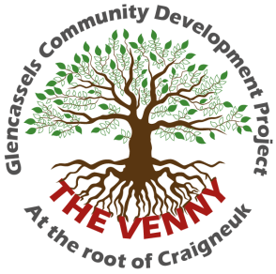

**Written Statement of Employment Particulars**

**Childrens Worker**

**Glencassels Community Development Project (SCIO)**

* This is a part-time post. Salary is £13,600 per annum. (£27,200 pro-rata).

* Normal hours of work will be 18 hours per week.
* The nature of the work calls for a degree of flexibility and will require some late afternoon and early evening sessions.
* The post will be based at Glencassels Community Development Project Neighbourhood Centre.
* There are twenty-five days paid annual leave (pro-rata) in each full holiday year, which runs from 1st January until 31st December. Entitlement is based on full weeks worked.
* The successful candidate will have the opportunity to join a pension scheme.
* Membership of Disclosure Scotland PVG Scheme will be required.
* The Children’s Worker will be responsible to the organisation’s Project Leader.