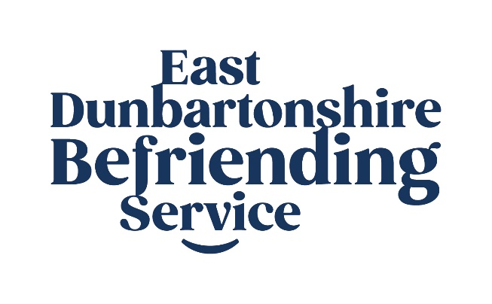

East Dunbartonshire Befriending Service

Job Description: Administration Officer

Job Title: Administration Officer

Salary: £22,000.00 full time equivalent £8,800.00 14 hours p.a. pro-rata paid monthly in arrears on or before the 25th of each month direct to your nominated bank or building society account.

Hours of Work: 14 hours per week, 2 days per week, 9.00-5.00pm. A TOIL System operates to compensate any additional hours worked as agreed with Business Support Team Leader.

Holidays: 20 days per year (increasing to 25 days after 1 years’ service), plus 12 public holidays (i.e. 6 fixed - 1 and 2 January; Good Friday and Easter Monday; 25 and 26 December - plus 6 floating) all pro-rata
Pension: East Dunbartonshire Befriending Service offer a 6% pension contribution after 6 months in post. Full terms and conditions will be given to candidates offered the position.
Probation: Three months
Responsible to: Service Manager

Working with: Service Manager and Community Link Workers.

Base: 18 Townhead, Kirkintilloch

Disclosure: Not required for this post.

Purpose of the Post To provide administrative support for the organisation to ensure a smooth interface between the Organisation and its clients and volunteers and to provide support to the staff, Board and Service Manager.

Overview East Dunbartonshire Befriending Service aims to reduce the negative impact of loneliness and social isolation by providing support and companionship to both adults and younger people who would benefit from this type of interaction. The Administration Officer will provide ‘back of house’ support to the organisation to ensure its effectiveness in completing its outcomes.

MAIN TASKS

- To be the “first point of contact” for telephone and email at East Dunbartonshire Befriending Service for all staff, volunteers and clients.
- To undertake administrative tasks as directed e.g. checking and redirecting emails, photocopying, stock control, and other duties linked to the job of administration as they present themselves.
- To help as required with any setting up before or clearing up after events, meetings and training.
- To assist in arranging meetings and diary management.
- To assist in the arrangement and administration of Board meetings with the Team Leader.
- Together with the Community Link Workers, to provide on-going support and information to volunteers and clients, including input to spreadsheets and database administration.
- To provide an agreed level of administrative support to projects as specified by the Team Leader.
- To work with the Team Leader and other relevant staff to post information to the East Dunbartonshire Befriending Service website, post photos, news updates, develop newsletters and feedback from users on social media sites in order to promote the Befriending Service and its activities.
- To input to the Befriending Service database and to update records as directed and required.
- Process invoices, expenses and petty cash.
- To assist the Service Manager in the production of statistical and evaluation reports as required through the maintenance and manipulation of the database and any other sources as necessary.
- To assist with the collation of information used to process staff salaries.
- To undertake other necessary duties as agreed between the Administration Officer and Service Manager.

Person Specification:
Essential | Desirable
Experience & qualifications  - Experience of general Clerical and Administrative tasks for 3 years and or an HNC in administration or equivalent.  - Ability to make use of a range of information and communication technology  - Computer literacy and knowledge of Microsoft packages  - Excellent oral and written communication skills  - Ability to organise, plan, prioritise workload and to meet tight deadlines  - Experience in developing newsletters and input to social media. | - local knowledge  - Volunteer Work in a community setting
Motivation & outlook
- Strong commitment to community development and business values and principles
- Strong supporter of the independence of the community and voluntary sectors
- Strong commitment to inclusion and equal opportunities
- Willingness to undertake training as required

Skills & aptitude
- Excellent communication and presentation skills
- Excellent interpersonal skills
- Friendly approach and helpful demeanour
- Competent in the use of IT/computer
- Ability to set and meet demanding deadlines

Personal qualities
- Excellent people skills
- Able to work independently, proactively and collaboratively
- Good team player

.

