
Head of Policy and Communications
Permanent post
Full time: 35 hours per week
Salary: £42,282
Base: Shared Care Scotland offices, Dunfermline. Hybrid working applies and a copy of our Hybrid (Remote) Working Policy is available on request.
Responsible to: Chief Executive, Shared Care Scotland
Job purpose
Shared Care Scotland’s mission is to improve the quality, choice and availability of short breaks for unpaid carers and cared-for people in Scotland. We aim to be the leading organisation people turn to for information and advice on all aspects of short breaks policy and practice.
The overall purpose of the Head of Policy & Communications role is to help us achieve this ambition by ensuring we have effective links between our policy, communications and evidence-related activities to optimise our impact, strengthen our reputation and increase our visibility.
The Head of Policy & Communications will lead on the development and implementation of our influencing and communication activities across all workstreams of the organisation and oversee policy-related work of the organisation. This will involve building relationships and engaging with government, policymakers, sector leads and influencers and developing joint working with strategic partners.
The work will include managing Shared Care Scotland’s wide range of communications to a broad audience using methods including newsletters, policy briefings, press and media releases, social media, information campaigns, presentations, surveys and website management. Another important aspect of the role is to enhance our connections at local, regional and national level.
To help shape Shared Care Scotland’s plans and priorities, the role will also involve ensuring that the organisation and its Board of Directors is aware of the relevant trends, opportunities and threats in the external environment, and any anticipated shifts in policy direction.
The Head of Policy and Communications will work closely with the CEO and the Head of Operations.
Key result areas
- To ensure Shared Care Scotland establishes and maintains a lead role in the sector through effective evidence-led policy and communications activity, working collaboratively with our stakeholders to achieve demonstrable improvements in short breaks policy and practice
- To maintain strategic oversight of the policy agenda related to short breaks and unpaid caring, ensuring we stay abreast of key policy changes and relevant external issues that could impact on our mission and vision
- To establish and maintain relationships with key influencers, including politicians, policy makers, the media, and other external agencies
- To oversee and develop Shared Care Scotland’s communications services, including digital development, learning networks and events
- To promote and raise the profile of the work of Shared Care Scotland
- To ensure a coordinated and consistent approach to our brand and communications across our areas of work, and supporting colleagues to achieve this

Tasks and responsibilities
The key responsibilities of the role are:
Policy influencing
- Lead Shared Care Scotland’s contribution to policy development, ensuring that our policy positions are informed by robust intelligence and evidence
- Develop, deliver and evaluate influencing campaigns, working closely with other external organisations and partners, as appropriate
- Using accessible and engaging media, produce and disseminate policy briefings and ‘think piece’ articles to inform and engage our key audiences and stakeholders in policy development
- Working with the Chief Executive, identify, develop and maintain strategic relationships with key external individuals and organisations (including MSPs, Cabinet Secretaries, Ministers, officials) enabling Shared Care Scotland to develop partnerships, gain intelligence and influence effectively

Visibility & impact
- Develop and implement a Communications Strategy, including digital development, to help promote our activities and services and grow Shared Care Scotland’s visibility in Scotland
- Manage Shared Care Scotland’s ‘brand’ to ensure we portray a consistent and positive image to all our audiences. This includes both the visual brand for Shared Care Scotland and the development of tone of voice and key messages that support this
- Build and maintain relationships with key stakeholders in the media, act as spokesperson for Shared Care Scotland, and prepare and support other spokespeople for media interviews
- Through review, data monitoring and evaluation ensure that our communications and influencing activity is effective and reaching our target audiences
- Provide analysis of our communications and influencing activity to the CEO and Board with assessment of any opportunities or risks

Information provision
- Work with the Head of Operations on the development and promotion of our information services including our online directory of Short Break services, our enquiry service, and our information events
- Oversee the development and delivery of our publications and digital content including social media
- Identify and promote best practices in the short breaks and respite care sector, facilitating the sharing of knowledge through events, publications, practice development tools and digital platforms
- Line management of the Communications Assistant and supporting their work to deliver on communications plans, activity and development
Learning and practice development
- Oversee the development and delivery of a learning and practice strategy that aligns with our strategic goals and respond to the needs of the short breaks sector
- Oversee the work of the Learning and Practice Development Officer to design and deliver programmes and initiatives that enhance the skills and knowledge of practitioners, carers and partner organisations
- Guide the Learning and Practice Development Officer to gather and disseminate research and evidence that informs practice, policy and service development

Other responsibilities include
- Keep informed of policy influences and emerging research in relation to short breaks
- Assist the Chief Executive and other colleagues with the development and delivery of events and conferences
- Contribute to the operational and strategic development of Shared Care Scotland
- Deputising for the Chief Executive as required
This job description is indicative of the nature and level of responsibilities associated with this job. It is not exhaustive, and the job holder may be required to undertake other duties and responsibilities commensurate with the grade.

Key contacts
Internal
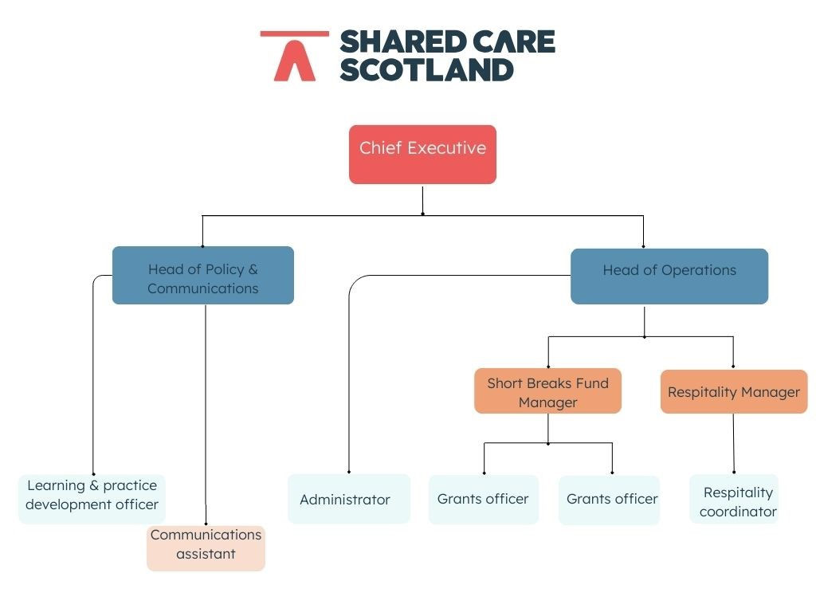
External
National Carer Organisations
Scottish Government
Other health and social care organisations in third and public sector
Media
Communications colleagues across the sector

Person specification
 |  | ESSENTIAL |  | DESIRABLE
QUALIFICATIONS
Educated to degree level or equivalent through experience |  | 
EXPERIENCE
Experience and proven track record in a policy role including undertaking policy analysis, briefings and responses
Able to work across different stakeholder groups to create proactive working relationships
Demonstrable experience of strategic communications and operational delivery of communications plans and campaigns
Proven experience in line management, including leading, motivating and developing a team, and demonstrated ability to plan and manage performance.
SKILLS
Excellent communication, presentation and interpersonal skills
High level of analytical skills with an ability to understand and interpret research information
Organisational and planning skills to manage own time to meet deadlines and objectives
Excellent written skills with experience of writing reports for different audiences
Strong IT skills including knowledge of Microsoft Office applications, content management systems and social media management tools
Sound understanding of brand standards and guidelines, and skills in ensuring consistent, high-quality communications
KNOWLEDGE
Understanding of good communications and engagement strategies
Understanding of the social care landscape and current challenges faced by unpaid carers
Awareness of evolving policies and trends impacting social care and public health in Scotland
Understanding of issues related to living with a disability and managing a long-term condition
PERSONAL QUALITIES
Enthusiastic, proactive and passionate approach to work
Innovative thinking with a focus on continuous improvement
Able to work on own initiative with minimal supervision and to self-motivate
Able to work effectively within a team and offer a hands-on approach
A creative and flexible approach to managing tasks and problem solving
OTHER REQUIREMENTS
Willingness to travel as required for meetings and other events
Flexibility in work hours to accommodate varying schedules of our stakeholders

