



Fife International Forum Area Coordinator
Applicants Information Pack

Dear Applicant,

Thank you for your interest in the Area Coordinator position at Fife International Forum.

If you are an internal applicant, you will already be familiar with the distinctive nature of Fife International Forum and our work. If you have applied outside the organisation, I would like to provide you with the background and context about this Area Coordinator opportunity.

Fife International Forum is a registered Scottish Charitable Incorporated Organisation Charity (SCIO) SC043053 founded in 2012 and based at Premier House, Randolph Industrial Estate, 29a Randolph Place, Kirkcaldy, KY1 2YX.

We are a leading, high-quality, and people-led charity with many years of experience working with migrant and refugee communities across the Fife region.

We seek to tackle poverty, low levels of social mobility, employment difficulties, and other issues often faced by people who move away from their usual place of residence.

Formerly Fife Migrants Forum, our new name and brand highlights our core values, model of service and our Building Bridges Strategy (2022-2027).

While this is an exciting time of change in the organisation, the core objectives of working with migrants and refugees celebrating cultural diversity in Fife remain unchanged.

We are a small but influential team, and everyone plays a crucial role in enabling us to collectively deliver our mission and vision.

Our Area Coordinators are based at our office at 29a Randolph Place, Randolph Industrial Estate, Kirkcaldy, Fife; however, they travel and work across a specific area of Fife. We also facilitate events at our venue in the Mercat Shopping Centre, Kirkcaldy. We operate a responsive, local, person-led programme of support and inclusive activities throughout the year delivered by a small team of staff and willing volunteers.

The Area Coordinator role is integral to helping shape and grow our future services, supporting and signposting the social, economic, employment and health needs of the local communities in which they work.

Fife International Forum values diversity and welcomes applications from across the communities in which we work.

If you wish to find out more about the organisation and the Area Coordinator position as part of your application process, please email Valerie.Menhlebei@fifeinternational.uk. She will arrange a mutually convenient time for someone from the management team to call you.

Thank you again for your interest in working at Fife International Forum; we look forward to receiving your application.

Yours sincerely

Alison Jardine,
Chief Executive Officer
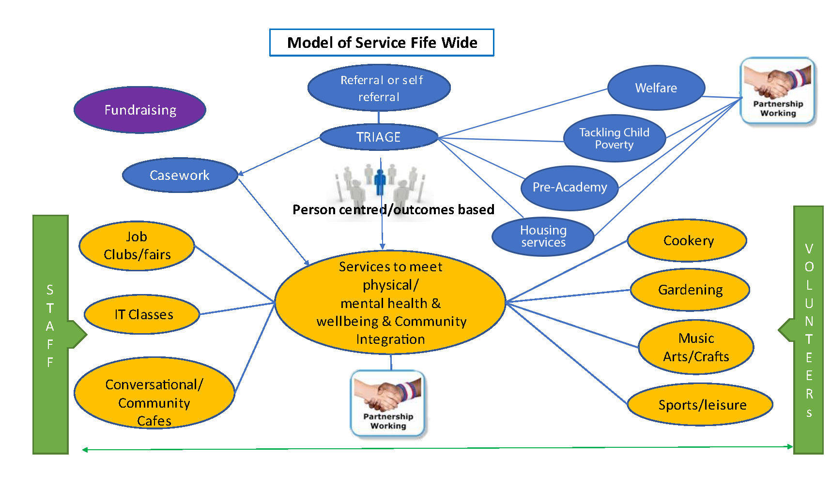

Fife International Forum – Organisation Structure – April 2024
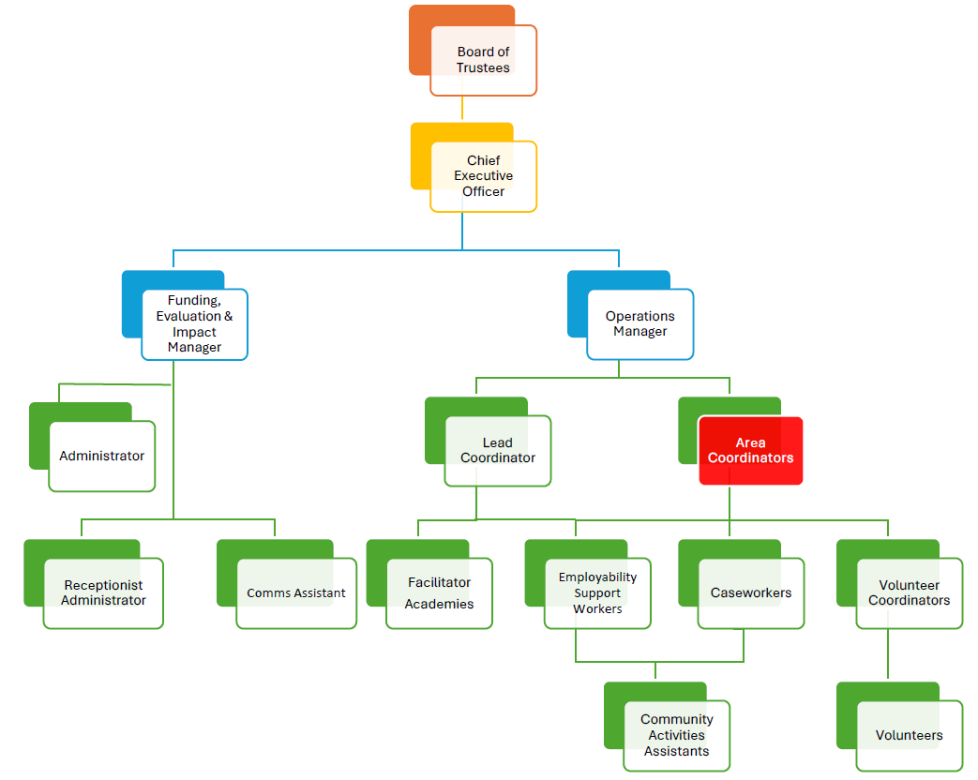

AREA COORDINATOR - JOB DESCRIPTION

JOB TITLE: | SERVICE AND LOCATION:
Area Coordinator | Fife International Forum – Fife Areas
REPORTS TO: | CONTRACT TERMS:
Operations Manager | Permanent
ROLE PURPOSE:
The Area Coordinator is responsible for planning, organising, coordinating and delivering services, training, events, and activities in the local area to achieve our charitable purpose and deliver the philanthropic benefits set out in our constitution. The Area Coordinator role is all about managing teams and programmes of work, workshop facilitation, volunteer team collaboration, awareness-raising, coordination and engagement with all local groups and communities. The Area Coordinator is a key member of the management team and will lead a team of caseworkers to deliver services.
DELIVERABLES:
As Area Coordinator, you can expect your role to involve but not be limited to the following:

- Collaborate with the Operations Manager to develop the programme of services and activities and establish programme budgets.
- Lead and manage a team of caseworkers, develop and train staff to ensure that they have the necessary skills and experience to carry out their roles effectively.
- Undertake supervision and provide regular feedback on performance for all staff under their management control to maintain professional competencies and ensure an effective and positive service for individuals that use our services.
- Prepare detailed and relevant reports on allocated projects, ensuring accuracy and attention to detail for all information presented
- Establish and maintain work plans and programme schedules to deliver the programme of services and activities.
- Coordinate locations, logistics, facilities, safety and security, correspondence, materials, and equipment, staffing and volunteer resources, ensuring all details are considered and executed effectively.
- Prepare and facilitate our Pre-Academy Employability Skills Programme on a cyclical basis as required throughout the year in collaboration with Skills Development Scotland (SDS) and English to Speakers of Other Languages (ESOL)
- Manage the Volunteer Coordinator in attracting and engaging local volunteers to ensure that there are adequate volunteering resources to help run groups and activities safely and effectively.
- Support the development of volunteers throughout their work with the organisation.
- Liaise with the Operations Manager and share your knowledge of how best to communicate and raise awareness of services and activities across all marketing and social media channels.
- Liaise with external partners and community contacts to support optimum attendance and engagement in our activities and events.
- Establish and maintain systems and processes that ensure the safety and security of all employees and service users.
- Maintain your knowledge of the local community and multidisciplinary teams who can offer different types of help and support.
- Attend and run various groups and activities, planning, and launching new services initiatives that improve and meet the changing needs of our service users.
- Maintain a detailed overview of service users’ engagement in all services and activities and liaise with the Operations Manager to share good news stories about the impact of our services on individuals and the local community.
- Prepare and present engagement and impact reports regularly as required.
- Act as Fife International Forum's point of contact in the local community, develop positive relationships, engage with external stakeholders and regulators, build trust, and enhance the organisation's reputation.

PEOPLE MANAGEMENT:
The Area Coordinator will manage a team of caseworkers responsible for the delivery of Fife International Forum’s services.

AREA COORDINATOR - JOB DESCRIPTION
FINANCIAL AND LEGAL MANAGEMENT:
The Area Coordinator must act in the best financial interests of the organisation in their decision-making, putting the quality and safety of services, cost control and the minimisation of loss at the centre of every activity.
CRITICAL COMPETENCIES:
The following competencies are crucial to your success in this role:

- Demonstrable leadership competence, including integrity, self-discipline, communication and interpersonal skills, trustworthiness, teamwork, conflict management, problem-solving, sound judgement, initiative, and decision-making.
- Ability to design and develop training and processes for staff, under the performance management framework. Provide regular feedback to staff on performance, dealing effectively with poor performance when required.
- As part of quality audits ensure casework is of a high standard for all services provided.
- The ability to communicate and have a positive impact on others to influence and gain their support. You are persuasive and engaging, and you can build buy-in from key people.
- The ability to facilitate interactive workshops and provide information in relation to the world of work and employment in Scotland that supports people to secure employment that fits with their career plans.
- Excellent organisational skills with attention to detail and the ability to move quickly and easily from planning to implementation.
- The ability to balance and meet the needs of different people in the solution of problems and issues.
- Advocating for and acting as an ambassador of the organisation continuously building new and developing existing community relationships.
- Reliability in complying with specific internally established control systems and rules, leading by personal example, and encouraging all employees to do the same.
- Conduct all activities in accordance with all applicable laws and the organisation's standards and policies, including its ethics, code of conduct and safety policies.

EXPERIENCE AND TECHNICAL KNOWLEDGE:
The following experience and technical knowledge will enhance your success in this role:
- A proven track record of successful services management in a similar field.
- Experience of managing staff in a diverse team.
- The ability to lead, facilitate, motivate, and manage groups and teams.
- Experience in writing reports and using databases to produce statistical information, with attention to detail a key element of the task.
- Excellent English speaking and writing skills with the ability to communicate effectively with people whose first language is not English.
- Work experience and demonstrable background in providing support to vulnerable community members including children, young people, and adults; ideally within international or ethnic minority settings.
- Experience in facilities management and establishing health and safety routines for groups and activities programmes.
- Experience in delivering projects and initiatives within agreed timescales and budgets.
- An in-depth understanding of the world of work in Scotland including culture, values, communication, employer expectations, the administration and governing system, employment policies and procedures.
- Knowledge and a passion for learning more about the benefits of migration, diversity and inclusion and the support we provide in education, upskilling, language support, employment opportunities and social activities that enable people to integrate and play an active part in community life.
- The ability to budget and manage finance for projects.

AREA COORDINATOR MAIN EMPLOYMENT TERMS & CONDITIONS

- SALARY: £28,118 pa, based on a 35-hour week.

- CONTRACT: Full-time.

- WORKING HOURS
A full-time working week is 35 hours. (Working flexibly on five over six days per week)

- OVERTIME:
A time off in lieu (TOIL) system is in operation per the policy.

- ANNUAL LEAVE ENTITLEMENT
All employees are entitled to the equivalent of 5.6 weeks of annual leave, including nine public holidays in Scotland.
We are keen to enhance our annual leave entitlement and provide additional benefits as our services grow.

- DISCLOSURE SCOTLAND – PROTECTION OF VULNERABLE GROUPS (PVG) SCHEME
The Area Coordinator position is subject to an enhanced PVG background check.

- BUSINESS MILEAGE
Business mileage is reclaimed at HMRC rates.

- PENSION
Automatic enrolment. Employer contribution 3%. Employee minimum contribution 5%

- EQUALITY AND DIVERSITY
Successful applicants must understand equality, diversity and inclusion principles and comply with Fife International Forum’s equality and diversity policies.

- HEALTH AND SAFETY
All team members are responsible for implementing health and safety procedures in so far as it affects them, their colleagues, and others whom their work may impact. The successful applicant is also expected to monitor the effectiveness of health and safety arrangements relating to their work to ensure appropriate improvements are made.

AREA COORDINATOR

SELECTION PROCESS OVERVIEW

The Area Coordinator selection process will consist of two stages:
- The first stage will take the form of an informal meeting with members of staff. This will provide an opportunity for all candidates to ask questions about the organisation, our mission and vision, our strategic plan, and the role of the Area Coordinator.
- The second stage will take the form of a formal interview with the Chief Executive Officer, Operations Manager and Funding, Evaluation & Impact Manager.

- Please allow 2 hours for the complete interview process.

Following the selection process, we will complete a plenary session where the successful candidate will be decided.
As well as technical and competency-based questions linked to the organisation and the job description, there are also questions that we will be asking to assess you against the following criteria:

Delivering the role and growing the Area Coordinator role aligned to the strategic plan:
  - Understanding of the challenges faced by people and the resultant needs of the international community in Fife as well as current policy and practice.
  - Coordinating area services and maximising the return on available resources.
  - How to create people-led services and activities that meet the needs of the local community.
  - Building and sustaining relationships and stakeholder management.

Cultural fit with the organisation:
  - Understanding our mission and vision at Fife International Forum.
  - Being able to visualise the future of the Area Programmes and changes for improvement that you will deliver.
  - Your personal purpose vs the purpose of the role.
  - Your values vs organisational values.
  - Your achievements, failures, learnings, and mindset.
  - Self-awareness, genuineness, fair-mindedness, and ability to do the right thing.

AREA COORDINATOR APPLICATION PROCESS

APPLICATION FORM
To ensure that all applicants have equal opportunities to provide all information that is relevant to this position, we would appreciate it if you could complete and email the separate application form included with this pack rather than a CV.

Personal details
Please let us know if your contact details change between your application and the interview date.

Education and training
Please provide a list of formal certified and informal training you have completed. We will ask you to provide certificates or information to assess whether you meet the qualification or required experience requirements of the Area Coordinator position.

EQUAL OPPORTUNITIES
Fife International Forum is committed to a policy of equal opportunity for all. We will not discriminate on the grounds of gender, gender identity, race, disability, sexual orientation, religion or belief, age, those with caring responsibilities, part-time workers, or any other factor irrelevant to a person's work.

When applying, please note that personal details will be removed. The shortlisting panel will see only application information relating to your education, career history and personal statement.

APPLICATION CLOSING DATE
The closing date for all applications is 12.00 noon on Friday 22 November 2024. Please note that due to our recruitment practices, we cannot accept applications received after the deadline. Interviews will be held week beginning 2 December 2024.

EMAILING YOUR APPLICATION
Please email your completed application form to info@fifeinternational.uk

SHORTLISTED CANDIDATES
If you are shortlisted for an interview, we will contact you by email to invite you to meet with members of staff and attend a formal interview.

SELECTION PANEL
The selection panel will be comprised of three people. It will include the Chief Executive Officer, Operations Manager and Funding, Evaluation & Impact Manager.

FEEDBACK
All unsuccessful candidates who have attended an interview will be offered feedback which may be helpful for future interviews.

Feedback is a two-way process, and in the spirit of continuous improvement, we would appreciate your feedback on how the application and selection process felt for you.

We hope that this candidate information pack provides you with all the information you need; however, please let us know if you have any questions or require further information.
Wishing you all the best with your application.

GDPR PRIVACY NOTICE FOR JOB APPLICANTS

Under the General Data Protection Regulation (GDPR), Fife International Forum ('the Organisation, we, us') has implemented this privacy notice to inform you, as a prospective employee of our organisation, of the types of data we process about you. We also include within this notice the reasons for processing your data, the lawful basis that permits us to process it, how long we keep your data, and your rights regarding your data.
- DATA PROTECTION PRINCIPLES
Under GDPR, all personal data obtained and held by us must be processed according to a set of core principles.
In accordance with these principles, we will ensure that:
  - Processing is fair, lawful, and transparent.
  - Data is collected for specific, explicit, and legitimate purposes.
  - Data collected is adequate, relevant, and limited to what is necessary for processing.
  - Data is kept accurate and up to date. Data that is found to be inaccurate will be rectified or erased without delay.
  - Data is not kept for longer than is necessary for its given purpose.
  - Data is processed in a manner that ensures appropriate security of personal data, including protection against unauthorised or unlawful processing, accidental loss, destruction, or damage by using appropriate technical or organisational measures.
  - We comply with the relevant GDPR procedures for the international transference of personal data.

- TYPES OF DATA HELD
We keep several categories of personal data on our prospective employees to conduct effective and efficient processes. We maintain this data in recruitment files relating to each vacancy, and we also hold the data within our computer system, for example, recruitment logs.
Specifically, we may hold the following types of data:
  - Personal details such as name, address, and contact details, including email address and telephone number.
  - Your gender and marital status.
  - Whether or not you have a disability for which Fife International Forum needs to make reasonable adjustments during the recruitment process.
  - Right-to-work documentation, including your photograph.
  - Information on your race and religion for equality monitoring purposes.
  - Information gathered via the recruitment process, such as that of a CV or included in a CV cover letter.
  - References from former employers.
  - Disclosure Scotland or PVG Scheme checks information.
  - Details of your education and employment history.
  - Your driving licence details if appropriate.
  - Details of any unspent criminal convictions.

- COLLECTING YOUR DATA
You provide several pieces of data to us directly during the recruitment process.
In some cases, we will collect data about you from third parties, such as employment agencies and your former employers, when gathering references.
Should you be successful in your job application, we will gather further information from you, for example, your bank details and emergency contact details, once your employment begins.
- LAWFUL BASIS FOR PROCESSING
The law on data protection allows us to process your data for specific reasons only.
The information below categorises the types of data processing we undertake and the lawful basis we rely on:

Activity requiring your data | Lawful basis
Carrying out checks in relation to your right to work in the UK. | Legal obligation.
Making reasonable adjustments for disabled employees. | Legal obligation.
Making recruitment decisions in relation to both initial and subsequent employment,  e.g., promotion. | Our legitimate interests.
Making decisions about salary and other benefits. | Our legitimate interests.
Making decisions about contractual benefits to provide to you. | Our legitimate interests.
Assessing training needs. | Our legitimate interests.
Dealing with legal claims made against us. | Our legitimate interests.
Preventing fraud. | Our legitimate interests.

- SPECIAL CATEGORIES OF DATA
Special categories of data are defined as data relating to your:
  - Health.
  - Sex life.
  - Sexual orientation.
  - Race.
  - Ethnic origin.
  - Political opinion.
  - Religion.
  - Trade union membership.
  - Genetic and biometric data.

We carry out processing activities using special category data:
  - For equal opportunities monitoring.
  - To determine reasonable adjustments.

Most commonly, we will process special categories of data when the following applies:
  - You have given explicit consent to the processing.
  - We must process the data to carry out our legal obligations.
  - We must process data for reasons of substantial public interest.
  - You have already made the data public.

- IF YOU CHOOSE NOT TO PROVIDE DATA TO FIFE INTERNATIONAL FORUM
If you choose not to provide us with data, this may mean that we cannot fulfil our requirements to enter a contract of employment with you. This could include being unable to offer you employment or administering contractual benefits.
- CRIMINAL CONVICTION DATA
We will only collect criminal conviction data where appropriate, given the nature of your role and where the law permits us. This data will usually be collected at the recruitment stage; however, it may also be collected during your employment. We use criminal conviction data to determine your suitability or your continued suitability for the role. We rely on the lawful basis of our legitimate interests to process this data.
- WHO DO WE SHARE YOUR DATA WITH?
Employees within our organisation who have responsibility for recruitment, training and employment relations will have access to your data relevant to their function. All employees with such responsibility have been trained to ensure data is processed in line with GDPR.
Data is shared with third parties for the following reasons: delegated authority for recruitment, administration of payment and contractual benefits, conducting performance- related procedures and carrying out structural change procedures. We may also share your data with third parties as part of a sale or restructure of the organisation or for other reasons to comply with a legal obligation. We have a data processing agreement in place with such third parties to ensure data is not compromised. Third parties must implement appropriate technical and organisational measures to ensure the security of your data.
We do not share your data with bodies outside of the UK.
- PROTECTING YOUR DATA
We are aware of the requirement to ensure your data is protected against accidental loss or disclosure, destruction, and abuse. We have mechanisms in place to guard against this.
- RETENTION PERIODS
We only keep your data for as long as we need it, which is three to six months in relation to unsuccessful candidates.
If your application is not successful and we have not sought consent, or you have not provided consent upon our request to keep your data for future suitable job vacancies, we will keep your data for three months once the recruitment exercise ends.
If we have sought your consent to keep your data on file for future job vacancies, and you have provided consent, we will keep your data for six months once the recruitment exercise ends. At the end of this period, we will delete or destroy your data unless you have already withdrawn your consent to our processing of your data, in which case it will be deleted or destroyed upon your withdrawal of consent.

Where you have provided consent to our use of your data, you also have the right to withdraw that consent at any time. This means that we will stop processing your data, and there will be no consequences of withdrawing consent.
If your application is successful, your data will be kept and transferred to the systems we administer for employees. We have a separate privacy notice for employees, which will be provided to you.
- AUTOMATED DECISION MAKING
Automated decision-making means a decision about you using no human involvement, e.g., using computerised filtering equipment. No decision will be made about you solely based on automated decision making (where a decision is taken about you using an electronic system without human involvement), which has a significant impact on you.
- YOUR RIGHTS
You have the following rights concerning the personal data we hold about you:
The right:
  - To be informed about the data we hold about you and what we do with it.
  - Of access to the data, we hold about you. We operate a separate subject access request policy, and all such requests will be dealt with accordingly.
  - For any inaccuracies in the data, we hold about you; however, they become known to be corrected (known as 'rectification').
  - To have data deleted in certain circumstances. (Known as 'erasure') the right to restrict the processing of the data.
  - To transfer the data, we hold about you to another party (known as 'portability')
  - To object to the inclusion of any information.
  - To regulate any automated decision-making and profiling of personal data.

In addition to the above rights, you also have the unrestricted right to withdraw consent that you have previously provided to our processing of your data at any time. Withdrawing your consent means that we will stop processing the data you had previously given us consent to use. There will be no consequences for withdrawing your consent. However, in some cases, we may continue to use the data where so permitted by having a legitimate reason.
If you wish to exercise any of the rights explained above, please contact your recruiting contact at Fife International Forum.
- MAKING A COMPLAINT
If you think your data rights have been breached, you can raise a complaint in the first instance with your manager. If your complaint is not resolved to your satisfaction, you may then raise it with the Information Commissioner (ICO). You can contact the ICO at Information Commissioner's Office, Wycliffe House, Water Lane, Wilmslow, Cheshire SK9 5AF or by telephone on 0303 123 1113 (local rate) or 01625 545 745.
- DATA PROTECTION COMPLIANCE
Contact detail: info@fifeinternational.uk

