



Board Member
Applicant Information Pack

Dear Applicant,

Thank you for your interest in becoming a volunteer Trustee and joining our Board at Fife International Forum.

If you are an internal beneficiary, you will already be familiar with the distinctive nature of Fife International Forum and our work. If you have applied outside the organisation, I would like to provide you with the background and context of our organisation and the services we provide.

Fife International Forum is a leading high-quality, and people-led charity with many years of experience in working with migrant communities across the Fife region. We seek to tackle poverty, low levels of social mobility, employment difficulties, and other issues often faced by people who move away from their usual place of residence.

Our services are delivered by a small but influential team of seventeen highly skilled employees, and each individual plays a crucial team role in enabling us to achieve our mission and vision.

The Board of Trustees is integral to governing, shaping, and growing the future of our crucial organisation and services.

Fife International Forum values diversity and welcomes applications for our Board from across the communities in which we work. Inclusiveness is fundamental to our ethos, and we express this in our wholehearted commitment to the people we support and our employees.

At Fife International Forum, you'll find a close-knit team that cares about each other and works effectively and productively to deliver the best service to the people we support. Sharing your knowledge and growing your skills and experience in a supported and encouraging environment will sustain our success in delivering our mission and vision.

We are available if you wish to learn more about the organisation and our Board Member positions as part of your application process. To arrange an appointment, please email us at info@fifeinternational.uk and we’ll arrange a mutually convenient time.

For further information on Fife International Forum, please visit us at fifeinternational.uk

Thank you again for your interest in volunteering at Fife International Forum; we look forward to receiving your application.

Yours sincerely

The Board
For and on behalf of Fife International Forum

BUILDING BRIDGES STRATEGY 2022 – 2027
Our Vision
Our Vision is a sustainable, people-led and collaborative forum that enables individuals to make a difference in their lives. We will achieve this through engagement, participation and social cohesion and influencing policy and practice for the broader benefit of our migrant communities.

Our Mission

Fife International Forum is a not-for-profit, people-led organisation committed to working with partners and migrant communities by providing holistic, professional, and high-quality services across Fife. A human rights approach is at the heart of our work to foster positive and inclusive community development and integration.

Our Values

Our values are the core principles that we abide by no matter what. They reinforce our Vision and underpin both the strategic and everyday decisions we make in the organisation. Our values should inspire your best efforts and provide you with a consistent reference point, even in times of change.

Building Bridges Strategy – 2022 - 2027

We have based our Building Bridges strategy on the thematic priorities of:
- People and Partnership
- Sustainability
- Engagement, participation, and social cohesion
- Policy, influence, and communication.

We can provide further details of the strategy; however, in summary, our strategic plan and ambitions reflect our commitment to strengthen Fife International Forum as Fife's leading charity dedicated to:
- Supporting migrant communities and their integration with the broader community.
- Working collaboratively with people and other organisations.
- Addressing the challenges of the post-COVID and post-Brexit landscape for migrant communities in Fife.
- Empowering people to be active participants in their communities.

Our Model of Service

Our service model reflects the services we provide and how we support and enable people.

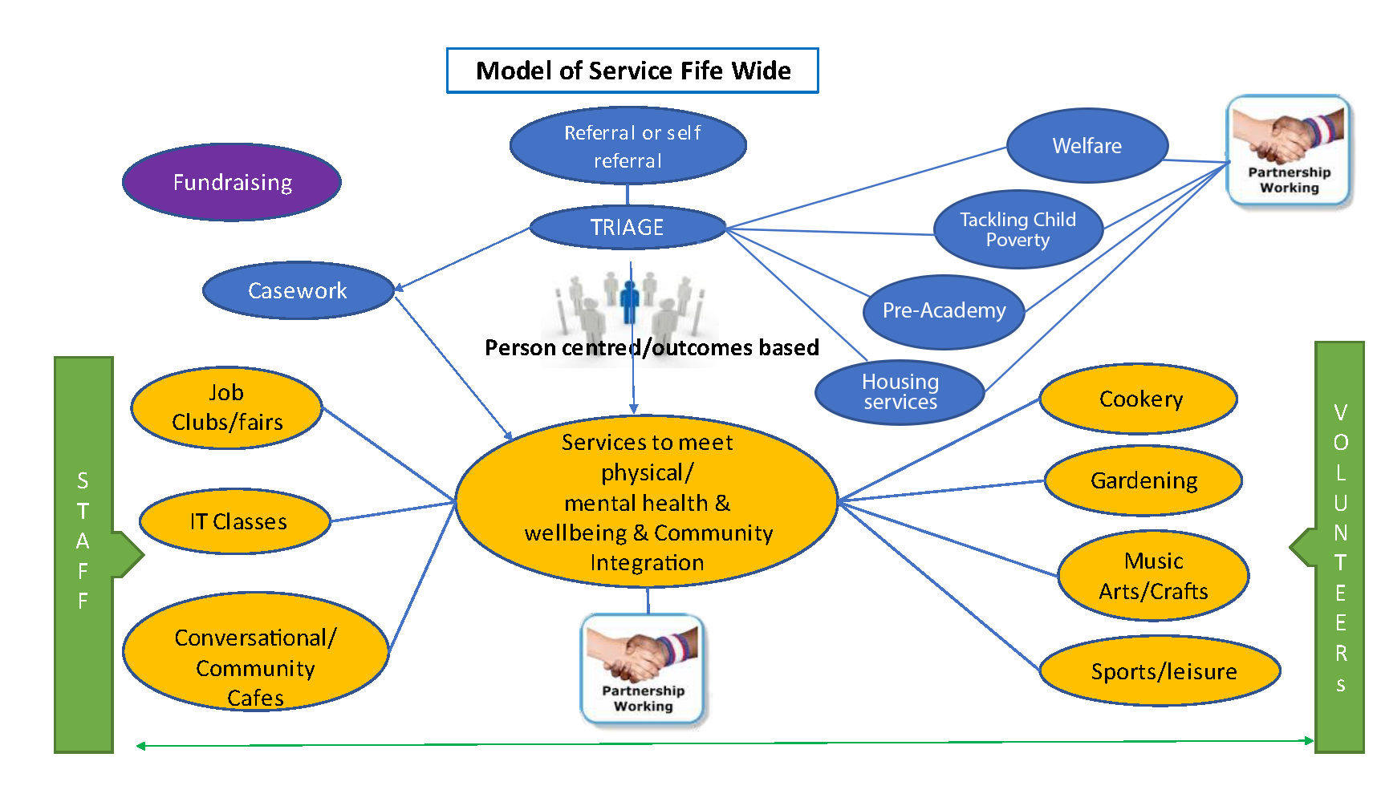

Our Structure

We have a small but competent and friendly team. As our services expand, our team will also continue to grow. As well as our operational team, we also have a group of dedicated people from all walks of life who volunteer to act as trustees in support of the governance and strategic direction of Fife International Forum and a group of volunteers who support the staff team in the delivery of our services. We’ll update you with any changes to the team or our structure as they happen.

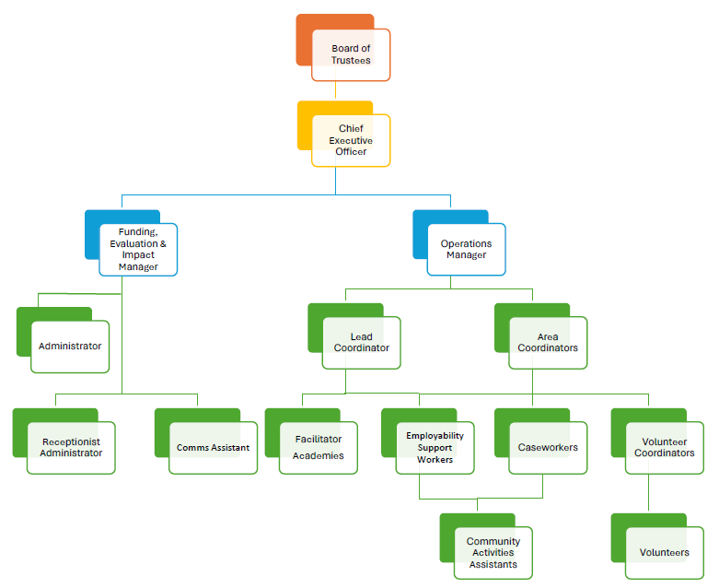

TRUSTEE ROLE DESCRIPTION
The statutory duties of a Trustee:
Main duty
Under charity law, Fife International Forum Trustees have and must accept the ultimate responsibility for directing the affairs of Fife International Forum and ensuring that it is solvent, well run and delivering the charitable outcomes for the benefit of the public for which it has been set up. In law, the Trustees of Fife International Forum have three main duties: care, compliance, and prudence — which are set out below following the wording given by the appropriate Charities regulator.
Duty of care — Trustees agree to:
- Use reasonable care and skill in their work as Trustees, using their personal skills and experience as needed to ensure that Fife International Forum is
well-run and efficient.
- Consider getting external professional advice on all matters where there may be material risk to Fife International Forum or where the Trustees may be in breach of their duties.

Duty of compliance — Trustees agree to:
- Ensure that Fife International Forum complies with charity law and with the requirements of the Charity Regulator; in particular, ensure that the charity prepares reports on what it has achieved and Annual Returns and accounts as required by law
- Ensure that Fife International Forum does not breach any of the requirements or rules set out in its governing document and remains true to its charitable purpose and objects.
- Comply with the requirements of other legislation and other regulators which govern the activities of Fife International Forum.
- Act with integrity and avoid any personal conflicts of interest or misuse of Fife International Forum funds or assets.

Duty of prudence - Trustees agree to:
- Ensure that Fife International Forum is and will remain solvent.
- Use Fife International Forum’s funds and assets reasonably and only to further its objectives.
- Avoid undertaking activities that might place Fife International Forum’s funds, assets, or reputation at undue risk.
- Take special care when investing Fife International Forum funds or borrowing funds for Fife International Forum to use.

Specific duties of Trustees of Fife International Forum:
Vision, values, and strategic direction
- Contribute actively to the Board of Trustees role in giving firm strategic direction to Fife International Forum, setting a vision, goals, policy and plans, and targets and key performance indicators.

- Ensure that Fife International Forum seeks and considers the views of beneficiaries and stakeholders in setting strategic direction and policy.
- Ensure breadth and diversity in the vision, values, policy, and strategy of the Fife International Forum
- Serve as an ambassador for the charity, promoting understanding, recognition, and support of Fife International Forum’s vision and values.
- Maintain awareness of current issues relating to migrants and international communities and the services provided by the organisation.

Progress monitoring and management
- Monitor and evaluate the organisation’s performance against plans, targets and key performance indicators and its wider impact on stakeholders.
- Support the board in appointing the Chief Executive and monitoring their progress and outcomes.
- Safeguard the good name and values of Fife International Forum.

Compliance
- Ensure that Fife International Forum complies with all legal and regulatory requirements.
- Ensure that key risks to Fife International Forum are identified and effectively managed and that professional advice is sought and considered where appropriate.

Prudent management of assets
- Ensure the financial stability of Fife International Forum through the creation of an effective fundraising strategy.
- Ensure the proper management of the charity’s assets, both physical and intellectual, and sound financial management.

Good governance
- Comply with the Board of Trustees Code of Practice and other Governance Policies.
- Uphold the principles and practice of good governance.
- Participate in Trustee development and training as appropriate.
- Prepare for and attend Board of Trustees meetings regularly and contribute to discussion and collective decision-making.
- To share personal knowledge, skills, and experience to help the Board of Trustees to further the objectives of the charity.

TRUSTEE PERSON SPECIFICATION
Fife International Forum works actively to ensure that its Board of Trustees has the right skills and experience to lead the charity effectively.
Personal competencies
Fife International Forum Trustees are expected to demonstrate the following personal competencies:
ESSENTIAL
Commitment
- Ability to understand and accept the duties and liabilities of being a Fife International Forum Trustee.
- Empathy with the vision, mission and aims of Fife International Forum.
- A willingness and ability to devote the necessary time and effort.

Focus
- Ability to think and apply knowledge strategically.
- Ability to think creatively.
- Ability to keep mission focused.
- Ability to analyse and evaluate management information and other evidence.
- Willingness to listen and learn.

Communication and team working
- Ability to communicate clearly and sensitively and to take an active part in discussions.
- Ability to influence and engage the Board and external stakeholders.
- Ability to work effectively as part of a team.
- Willing to express their own opinion in a reasoned way while also listening to the views of others.
- Ability to challenge constructively and ask questions appropriately.

Accountability
- Ability to exercise sound and independent judgement.
- Willingness to make and stand by collective decisions, including those which may be unpopular.
- Ability to manage difficult and/or challenging situations.
- Ability to maintain confidentiality on confidential and/or sensitive information.

Skills and experience
DESIRABLE
Fife International Forum wishes to see the following knowledge, skills and experience represented on its Board. All Trustees will be expected to meet at least one of these criteria.

During a particular recruitment, one or more of the following may be identified as priorities, depending on the needs of the Board at the time, as identified through a skills audit.
- Lived experience of supporting migrant and international communities.

- Lived experience of the issues faced by migrants and those who change their usual country of residence.

- Senior-level strategic management experience within a third, commercial or public sector organisation.

- Recent experience (within the last 5 years) fundraising for or in a third-sector organisation.

- Experience at a senior level of financial management.

- Experience at a senior level of strategic human resources or organisational development.

- A professional qualification and significant practitioner experience in an area relevant to Fife International Forum, such as accountancy, charity law, or project or programme management.

- Knowledge and experience in public policy formulation and influencing techniques across local, regional, or national government.

- Knowledge and experience in marketing or public relations in the third sector.

- Experience as a Trustee in a similar-sized or larger organisation, including the implementation of best practices in corporate governance.

- Experience providing senior-level services to people with profound and multiple learning disabilities in a health, education, or social care setting.

- Experience at a senior level in developing and delivering services to people within migrant and international communities that promote inclusion, equal opportunities, and diversity.

BOARD TRUSTEE INFORMATION

Duties and Responsibilities
Your role as a member of the Board of Trustees is to oversee the effective governance and accountability of Fife International Forum, ensuring that the company carries out its objectives, as set out in its Memorandum and Articles of Association.
The following guidance will enable you to effectively carry out your role as a Board Member at Fife International Forum.

1. Know Fife International Forum's purpose and history
It’s vital as a Trustee that you know about what Fife International Forum was set up to do, how it’s trying to achieve its aims and who it’s trying to help.
You can find this out by reading our Memorandum and Articles of Association. As a Trustee, it is your responsibility to follow the rules set out in the Memorandum and Articles.
You’ll also be provided with our Vision and Strategic Plan that sets out our broader organisational objectives, themes, and actions.

2. Take part in the induction process and meet your fellow Trustees
You should be able to understand what Fife International Forum does and the challenges we and our beneficiaries face. As part of Your induction, you’ll be provided with support to understand your roles and responsibilities our legal structure and any potential personal liabilities.
You’ll be encouraged to visit our various locations and be given the opportunity to meet your fellow Trustees and get to know them. As a Board, we are all collectively responsible and accountable for the overall governance of Fife International Forum, and we seek to build relationships across the Board that demonstrate integrity, openness, and mutual respect so that we can work as effectively and productively as possible.

3. Put the interests of your Fife International Forum and our beneficiaries first
In everything you do as a Trustee, we assume and appreciate that you’ll always put the interests of Fife International Forum first. We ask that you maintain an awareness of any matters that affect Fife International Forum where you may have a personal interest and identify any conflicts of interest so you can prevent them from affecting any decisions you make.

4. Prepare for meetings and make informed decisions
Attending regular meetings is an important part of being a Trustee, as this is where most of your work for Fife International Forum will be done. We appreciate that you’ll seek to attend meetings regularly and prepare thoroughly so you can contribute your views and ideas and play a full part in discussions and collective decision-making.

5. Learn about the finances
Find out about the current and future financial situation at Fife International Forum, including any savings and investments. We’ll provide transparent information about our banking arrangements and any contracts or debts. We’ll provide information on where our funds come from and how the organisation plans to spend its money.

6. Make sure you’re in control
We’ll provide you with copies of any key policies on areas such as risk, safeguarding and fundraising. This will help you direct and oversee Fife International Forum progress and results.

7. Get to know your Trustee's duties
It’s important that you know your legal duties as a Trustee, as they are relevant in all your activities and decisions. We’ll provide you with information on any regulators we work with, and we ask that you maintain an up-to-date awareness of any changes in the law that may affect Fife International Forum and our work.

Additional information
Time Commitment
The time commitment for Trustees is expected to be an average of 1 day per quarter, i.e., 4 Board meetings per year. For some roles, further days may be needed, up to a maximum of 8 per year. The Chair and Trustees will decide.
Remuneration
There is no remuneration for Fife International Forum Board members. However, all reasonable travel and subsistence costs and any childcare/dependent carer costs would be paid. This includes the costs associated with meeting the accessibility needs of the person travelling.
Location of meetings
Meetings are currently held virtually via Zoom or Teams. It is hoped that there may be a return to some face-to-face meetings, which will be made with consideration of the accessibility needs of attendees, and reasonable adjustments will be made as required. There may be occasions where travel is required to suit the requirements of the Trustee's role.
Additional information
Trustees must not be subject to any restrictions which prevent them from holding office as a Director of a Company Ltd by Guarantee.
A Trustee appointment is subject to our receipt of two satisfactory references.
Trustees may be required to hold a membership of the Protection of Vulnerable Groups Scheme. If this is the case, the costs will be met by Fife International Forum.

APPLICATION PROCESS

APPLICATION FORM
To ensure that all Board applicants have equal opportunities to provide all information that is relevant to the Trustee's role, we would appreciate it if you could complete and email the separate application form included with this pack. You may also provide a CV for further information.

Personal details
Please let us know if your contact details change between your application and the interview date.

EQUAL OPPORTUNITIES
Fife International Forum is committed to equal opportunity for all. We will not discriminate on the grounds of gender, gender identity, race, disability, sexual orientation, religion or belief, age, caring responsibilities, part-time workers, or any other factor irrelevant to a person's work.

APPLICATION CLOSING DATE
The closing date for all applications is 12.00 noon on Friday 29 November 2024. Please note that due to our recruitment practices, we cannot accept applications received after the deadline. Interview dates to be confirmed.

EMAILING YOUR APPLICATION
Please email your completed application to alison.jardine@fifeinternational.uk

We hope that this information pack provides you with all the information you need; however, please let us know if you have any questions or require further information.
Wishing you all the best with your application.

GDPR PRIVACY NOTICE FOR VOLUNTEER APPLICANTS

Under the General Data Protection Regulation (GDPR), Fife International Forum ('the Organisation, we, us') has implemented this privacy notice to inform you, as a prospective employee of our organisation, of the types of data we process about you. We also include within this notice the reasons for processing your data, the lawful basis that permits us to process it, how long we keep your data, and your rights regarding your data.
- DATA PROTECTION PRINCIPLES
Under GDPR, all personal data obtained and held by us must be processed according to a set of core principles.
In accordance with these principles, we will ensure that:
- Processing is fair, lawful, and transparent.
- Data is collected for specific, explicit, and legitimate purposes.
- Data collected is adequate, relevant, and limited to what is necessary for processing.
- Data is kept accurate and up to date. Data that is found to be inaccurate will be rectified or erased without delay.
- Data is not kept for longer than is necessary for its given purpose.
- Data is processed in a manner that ensures appropriate security of personal data, including protection against unauthorised or unlawful processing, accidental loss, destruction, or damage by using appropriate technical or organisational measures.
- We comply with the relevant GDPR procedures for the international transference of personal data.

- TYPES OF DATA HELD
We keep several categories of personal data on our prospective employees to conduct effective and efficient processes. We maintain this data in recruitment files relating to each vacancy, and we also hold the data within our computer system, for example, recruitment logs.
Specifically, we may hold the following types of data:
- Personal details such as name, address, and contact details, including email address and telephone number.
- Your gender and marital status.
- Whether or not you have a disability for which Fife International Forum needs to make reasonable adjustments during the recruitment process.
- Right-to-work documentation, including your photograph.
- Information on your race and religion for equality monitoring purposes.
- Information gathered via the recruitment process, such as that of a CV or included in a CV cover letter.
- References from former employers.
- Disclosure Scotland or PVG Scheme checks information.
- Details of your education and employment history.
- Your driving licence details if appropriate.
- Details of any unspent criminal convictions.

- COLLECTING YOUR DATA
You provide several pieces of data to us directly during the recruitment process.
In some cases, we will collect data about you from third parties, such as employment agencies and your former employers, when gathering references.
Should you be successful in your job application, we will gather further information from you, for example, your bank details and emergency contact details, once your employment begins.
- LAWFUL BASIS FOR PROCESSING
The law on data protection allows us to process your data for specific reasons only.
The information below categorises the types of data processing we undertake and the lawful basis we rely on:
Activity requiring your data | Lawful basis
Conducting checks in relation to your right to work in the UK. | Legal obligation.
Making reasonable adjustments for disabled employees. | Legal obligation.
Making recruitment decisions in relation to both initial and subsequent employment, e.g., promotion. | Our legitimate interests.
Making decisions about salary and other benefits. | Our legitimate interests.
Making decisions about contractual benefits to provide to you. | Our legitimate interests.
Assessing training needs. | Our legitimate interests.
Dealing with legal claims made against us. | Our legitimate interests.
Preventing fraud. | Our legitimate interests.

- SPECIAL CATEGORIES OF DATA
Special categories of data are defined as data relating to your:
- Health.
- Sex life.
- Sexual orientation.
- Race.
- Ethnic origin.
- Political opinion.
- Religion.
- Trade union membership.
- Genetic and biometric data.

We carry out processing activities using special category data:
- For equal opportunities monitoring.
- To determine reasonable adjustments.

Most commonly, we will process special categories of data when the following applies:
- You have given explicit consent to the processing.
- We must process the data to carry out our legal obligations.
- We must process data for reasons of substantial public interest.
- You have already made the data public.

- IF YOU CHOOSE NOT TO PROVIDE DATA TO Fife International Forum
If you choose not to provide us with data, this may mean that we cannot fulfil our requirements to enter a contract of employment with you. This could include being unable to offer you employment or administering contractual benefits.
- CRIMINAL CONVICTION DATA
We will only collect criminal conviction data where appropriate, given the nature of your role and where the law permits us. This data will usually be collected at the recruitment stage; however, it may also be collected during your employment. We use criminal conviction data to determine your suitability or your continued suitability for the role. We rely on the lawful basis of our legitimate interests to process this data.
- WHO DO WE SHARE YOUR DATA WITH?
Employees within our organisation who have responsibility for recruitment, training and employment relations will have access to your data relevant to their function. All employees with such responsibility have been trained to ensure data is processed in line with GDPR.
Data is shared with third parties for the following reasons: delegated authority for recruitment, administration of payment and contractual benefits, conducting performance-related procedures and carrying out structural change procedures. We may also share your data with third parties as part of a sale or restructure of the organisation or for other reasons to comply with a legal obligation. We have a data processing agreement in place with such third parties to ensure data is not compromised. Third parties must implement appropriate technical and organisational measures to ensure the security of your data.
We do not share your data with bodies outside of the UK.
- PROTECTING YOUR DATA
We are aware of the requirement to ensure your data is protected against accidental loss or disclosure, destruction, and abuse. We have mechanisms in place to guard against this.
- RETENTION PERIODS
We only keep your data for as long as we need it, which is three to six months in relation to unsuccessful applicants.
If your application is not successful and we have not sought consent, or you have not provided consent upon our request to keep your data for future suitable job vacancies, we will keep your data for three months once the recruitment exercise ends.
If we have sought your consent to keep your data on file for future job vacancies, and you have provided consent, we will keep your data for six months once the recruitment exercise ends. At the end of this period, we will delete or destroy your data unless you have already withdrawn your consent to our processing of your data, in which case it will be deleted or destroyed upon your withdrawal of consent.
Where you have provided consent to our use of your data, you also have the right to withdraw that consent at any time. This means that we will stop processing your data, and there will be no consequences of withdrawing consent.
If your application is successful, your data will be kept and transferred to the systems we administer for employees. We have a separate privacy notice for employees, which will be provided to you.
- AUTOMATED DECISION MAKING
Automated decision-making means a decision about you using no human involvement, e.g., using computerised filtering equipment. No decision will be made about you solely based on automated decision making (where a decision is taken about you using an electronic system without human involvement), which has a significant impact on you.
- YOUR RIGHTS
You have the following rights concerning the personal data we hold about you:
The right:
- To be informed about the data we hold about you and what we do with it.
- Of access to the data, we hold about you. We operate a separate subject access request policy, and all such requests will be dealt with accordingly.
- For any inaccuracies in the data, we hold about you; however, they become known to be corrected (known as 'rectification').
- To have data deleted in certain circumstances. (Known as 'erasure') the right to restrict the processing of the data.
- To transfer the data, we hold about you to another party (known as 'portability')
- To object to the inclusion of any information.
- To regulate any automated decision-making and profiling of personal data.

YOUR RIGHTS
In addition to the above rights, you also have the unrestricted right to withdraw consent that you have previously provided to our processing of your data at any time. Withdrawing your consent means that we will stop processing the data you had previously given us consent to use. There will be no consequences for withdrawing your consent. However, in some cases, we may continue to use the data where so permitted by having a legitimate reason.
If you wish to exercise any of the rights explained above, please contact your recruiting contact at Fife International Forum.
- MAKING A COMPLAINT
If you think your data rights have been breached, you can raise a complaint in the first instance with your manager. If your complaint is not resolved to your satisfaction, you may then raise it with the Information Commissioner (ICO). You can contact the ICO at the Information Commissioner's Office, Wycliffe House, Water Lane, Wilmslow, Cheshire SK9 5AF or by telephone on 0303 123 1113 (local rate) or 01625 545 745.
- DATA PROTECTION COMPLIANCE
Contact detail: info@fifeinternational.uk

