



Fife International Forum Caseworker

Applicants Information Pack

Dear Applicant,

Thank you for your interest in the Caseworker position at Fife International Forum.

If you are an internal applicant, you will already be familiar with the distinctive nature of Fife International Forum and our work. If you have applied outside the organisation, I would like to provide you with the background and context about this Caseworker opportunity.

Fife International Forum is a registered Scottish Charitable Incorporated Organisation Charity (SCIO) SC043053 founded in 2012 and based at Premier House, Randolph Industrial Estate, 29a Randolph Place, Kirkcaldy, KY1 2YX.

We are a leading, high-quality, and people-led charity with many years of experience working with migrant and refugee communities across the Fife region.

We seek to tackle poverty, low levels of social mobility, employment difficulties, and other issues often faced by people who move away from their usual place of residence.

Formerly Fife Migrants Forum, our new name and brand highlights our core values, model of service and our Building Bridges Strategy (2022-2027).

While this is an exciting time of change in the organisation, the core objectives of working with migrants and refugees and celebrating cultural diversity in Fife remain unchanged.

We are a small but influential team, and every individual plays a crucial role in enabling us to collectively deliver our mission and vision.

Our Case Workers are based at our office at 29a Randolph Place, Randolph Industrial Estate, Kirkcaldy, Fife; however, they travel and work across a specific area of Fife. We also facilitate events at our venue in the Mercat Shopping Centre, Kirkcaldy. We operate a responsive, local, person-led programme of support and inclusive activities throughout the year delivered by a small team of staff and willing volunteers.

The Caseworker role is integral to helping shape and grow our future services, supporting and signposting the social, economic, employment and health needs of the local communities in which they work.

Fife International Forum values diversity and welcomes applications from across the communities in which we work.

If you wish to find out more about the organisation and the Case Worker position as part of your application process, please email Ewa.Cios@fifeinternational.uk. She will arrange a mutually convenient time for someone from the management team to call you.

Thank you again for your interest in working at Fife International Forum; we look forward to receiving your application.

Yours sincerely

Alison Jardine,
Chief Executive Officer

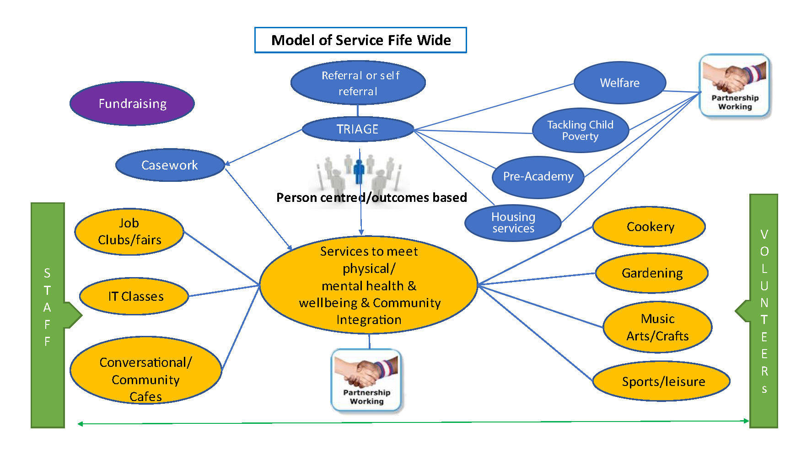

Fife International Forum – Organisation Structure – April 2024
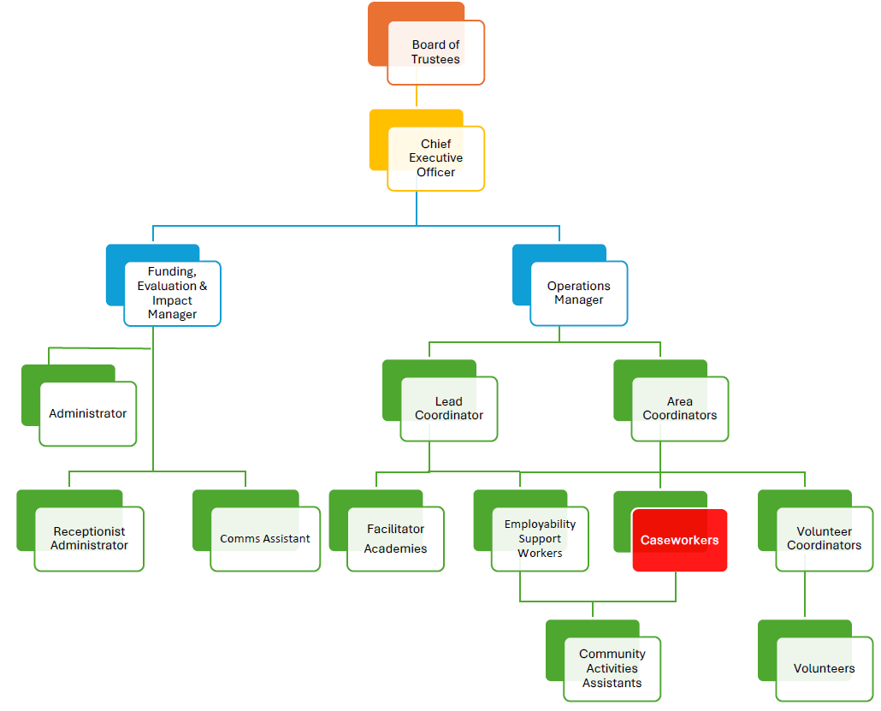

CASEWORKER - JOB DESCRIPTION

JOB TITLE: | SERVICE AND LOCATION:
Caseworker | Fife International Forum – Fife Areas
REPORTS TO: | CONTRACT TERMS:
Area Coordinator | Fixed-term contract
ROLE PURPOSE:
The Caseworker is responsible for assessing the needs of individuals and helping people in difficult situations achieve their goals for a better-quality life. Your work will be person centred, strengths-based focussing on individuals’ strengths, interests, resources, and capabilities. Caseworkers will manage a caseload listening to people’s concerns, solving problems to increase the individual and family’s self-confidence, self-esteem, and sense of empowerment. Caseworkers will also work with people to improve their overall health and wellbeing enabling families to avoid crisis situations. Our service delivery is focussed on enabling people to choose and shape their support.
This role is about delivering holistic information and support focussed on managing personal outcomes based on human rights principles. The team will work in partnership with individuals and other organisations for successful service delivery. Your work will enable us to achieve our charitable purpose and deliver the philanthropic benefits set out in our constitution.

DELIVERABLES:
As a Caseworker, you can expect your role to involve but not be limited to the following:

- Plan and manage a discrete caseload allocated by the Area Coordinator, providing information, advice and support to those individuals seeking to access support services.
- Deliver an effective and impactful person-centred holistic service (including employability, housing and welfare) tailored to the individual needs and desired outcomes of its beneficiaries.
- Develop case plans identifying the next steps needed to support the individual, referring people to a range of partner agencies where appropriate.
- Identify and implement solutions to improve the individual’s knowledge, isolation issues, confidence, integration, and participation in community life.
- Discuss timelines with individuals and closely monitor progress revising the case management plan appropriately.
- Plan support to ensure the best use of time and appropriate type of support is offered initially and throughout all casework activity empowering individuals and families to develop confidence and skills to advocate for themselves.
- Follow up on agreed actions, encouraging individuals to express their views in meetings or in writing tailoring support to individual’s needs to ensure equal access to support services, researching and signposting to other services, as necessary.
- Create and promote opportunities to engage with people, ensuring that casework is undertaken in a welcoming, safe, and caring environment for all.
- Caseworkers will have ownership of cases from beginning to end, coordinating casework processes in a timely manner and ensuring the individual’s journey is at the centre of service delivery.
- Keep the Area Coordinator up to date on your case load and seek advice where appropriate
- Maintain confidential case records and all relevant administration systems including Fife International Forum’s database. Ensure that the required information is accurate and accessible to the team and management at all times for continuity of casework provision. Ensure all qualitative and quantitative data is made available to the Senior Managers and contribute to outcome monitoring reports.
- Close cases effectively and efficiently, identifying and implementing individual action plans, attending advice appointments, coordinating language support, and providing assistance that includes external support agencies.
- Attend regulatory or legislative events when required and ensure that notes can be relied upon.
- Maintain positive and collaborative working relationships with all stakeholders, working in a conciliatory way to facilitate communication and understanding, keeping the people we support at the centre of the support process.
- Establish and maintain systems and processes that ensure the safety and security of all employees and beneficiaries.
- Maintain a detailed overview of engagement with individuals in all casework and liaise with the Area Coordinator to share good news stories about the impact of our services on individuals and the local community.

PEOPLE MANAGEMENT:
The Caseworker has no direct reports; however, they will work closely with Area Coordinators, other Caseworkers, Volunteers as well as Senior Managers to provide a seamless case work support service.

FINANCIAL AND LEGAL MANAGEMENT:
The Caseworker must act in the best financial interests of the organisation in their decision making, putting the quality and safety of services, cost control and the minimisation of loss at the centre of every activity.

CRITICAL COMPETENCIES:
The following competencies are crucial to your success in this role:

- Demonstrable leadership competence, including integrity, self-discipline, communication and interpersonal skills, trustworthiness, teamwork, conflict management, problem-solving, sound judgement, initiative, and decision-making.
- The ability to communicate, engage and work with individuals, to have a positive impact on others to influence and gain their trust and confidence. You are persuasive and engaging, and you can build buy-in from the people you support and those whom you collaborate with to provide extended support.
- Resilient and capable of managing potentially stressful situations whilst presenting a calm, capable and reassuring presence to individuals you are supporting.
- The ability to discuss sensitive issues with a range of individuals and provide options and choices that lead people to positive solutions.
- The ability to advocate and negotiate for people and act as an ambassador of the organisation continuously building new and developing existing community relationships.
- Excellent organisational skills with attention to detail and the ability to move quickly and easily from planning to implementation.
- Reliable in complying with specific internally established control systems and rules, leading by personal example, and encouraging all employees to do the same.
- Conducting all activities in accordance with all applicable laws and the organisation's standards and policies, including its ethics, code of conduct and health & safety policies.
- Ability to manage time effectively and work to deadlines is crucial in this role.

EXPERIENCE AND TECHNICAL KNOWLEDGE:
The following experience and technical knowledge will enhance your success in this role:

- Educated to SVQ level 3 in a subject relevant to this role or demonstrating the equivalent knowledge and experience.
- Experience of case working principles including conducting diagnostic interviews and providing information and advice on all social, health, wellbeing, housing, financial, education and employment matters.
- Work experience and a demonstrable background of providing support to vulnerable community members ideally within international or ethnic minority settings.
- Excellent English speaking and writing skills with the ability to communicate effectively with people whose first language is not English.
- Up to date understanding of issues related to welfare benefits, debt management and housing support.
- IT literacy, in particular Microsoft Word, Excel, Outlook, and Teams.
- Knowledge and a passion for learning more about the benefits of migration, diversity and inclusion and the support we provide in education, upskilling, language support, employment opportunities and social activities that enable people to integrate and play an active part in community life.

CASEWORKER
MAIN EMPLOYMENT TERMS & CONDITIONS

- SALARY: £25,535 pa, based on a 35-hour week and pro-rata for part-time

- CONTRACT: full-time and part-time

WORKING HOURS
A full-time working week is 35 hours. (Working flexibly on five over six days per week). Part time hours to be negotiated.

OVERTIME:
A time off in lieu (TOIL) system is in operation per the policy.

ANNUAL LEAVE ENTITLEMENT
All employees are entitled to the equivalent of 5.6 weeks of annual leave, including nine public holidays in Scotland.

We are keen to enhance our annual leave entitlement and provide additional benefits as our services grow.

DISCLOSURE SCOTLAND – PROTECTION OF VULNERABLE GROUPS (PVG)

SCHEME
The Caseworker position is subject to an enhanced PVG background check.

BUSINESS MILEAGE
Business mileage is reclaimed at HMRC rates.

PENSION
Automatic enrolment. Employer contribution 3%. Employee minimum contribution 5%

EQUALITY AND DIVERSITY
Successful applicants must understand equality, diversity and inclusion principles and comply with Fife International Forum’s equality and diversity policies.

HEALTH AND SAFETY
All team members are responsible for implementing health and safety procedures in so far as it affects them, their colleagues, and others whom their work may impact. The successful applicant is also expected to monitor the effectiveness of health and safety arrangements relating to their work to ensure appropriate improvements are made.

SELECTION PROCESS OVERVIEW

The Caseworker selection process will consist of two stages:
- The first stage will take the form of an informal meeting, this will provide an opportunity for all candidates to meet with members of the team and ask questions about the organisation, our mission and vision, our strategic plan, and the role of the Caseworker.

- The second stage will take the form of a formal interview with the Chief Executive and two Area Coordinators.

- Please allow 2 hours for the interview process.

Following the selection process, we will complete a plenary session where the successful candidate will be decided.
As well as technical and competency-based questions linked to the organisation and the job description, there are also questions that we will be asking to assess you against the following criteria:

Delivering the role and growing the Case Worker role aligned to the strategic plan:
  - Understanding of the challenges faced by people and the resultant needs of the international community in Fife as well as current policy and practice.
  - Coordinating services and maximising the return on available resources.
  - How to create people-led services and activities that meet the needs of the local community.
  - Building and sustaining relationships and stakeholder management.

Cultural fit with the organisation:
  - Understanding our mission and vision at Fife International Forum.
  - Being able to visualise the future of the Area Programmes and changes for improvement that you will deliver.
  - Your personal purpose vs the purpose of the role.
  - Your values vs organisational values.
  - Your achievements, failures, learnings, and mindset.
  - Self-awareness, genuineness, fair-mindedness, and ability to do the right thing.

CASE WORKER

APPLICATION PROCESS

APPLICATION FORM
To ensure that all applicants have equal opportunities to provide all information that is relevant to this position, we would appreciate it if you could complete and email the separate application form included with this pack rather than a CV.

Personal details
Please let us know if your contact details change between your application and the interview date.

Education and training
Please provide a list of formal certified and informal training you have completed. We will ask you to provide certificates or information to assess whether you meet the qualification or required experience requirements of the Volunteer coordinator position.

EQUAL OPPORTUNITIES
Fife International Forum is committed to a policy of equal opportunity for all. We will not discriminate on the grounds of gender, gender identity, race, disability, sexual orientation, religion or belief, age, those with caring responsibilities, part-time workers, or any other factor irrelevant to a person's work.

When applying, please note that personal details will be removed. The shortlisting panel will see only application information relating to your education, career history and personal statement.

APPLICATION CLOSING DATE
The closing date for all applications is 12.00 noon on Wednesday 22 November 2024. Please note that due to our recruitment practices, we cannot accept applications received after the deadline. Interviews will be held week beginning 09 December 2024.

EMAILING YOUR APPLICATION
Please email your completed application form to info@fifeinternational.uk

SHORTLISTED CANDIDATES
If you are shortlisted for an interview, we will contact you by email to invite you to meet with members of staff and attend a formal interview.

SELECTION PANEL
The selection panel will be comprised of three people. It will include the Chief Executive and two Area Coordinators.

FEEDBACK
All unsuccessful candidates who have attended an interview will be offered feedback which may be helpful for future interviews.

Feedback is a two-way process, and in the spirit of continuous improvement, we would appreciate your feedback on how the application and selection process felt for you.

We hope that this candidate information pack provides you with all the information you need; however, please let us know if you have any questions or require further information.
Wishing you all the best with your application.

GDPR PRIVACY NOTICE FOR JOB APPLICANTS

Under the General Data Protection Regulation (GDPR), Fife International Forum ('the Organisation, we, us') has implemented this privacy notice to inform you, as a prospective employee of our organisation, of the types of data we process about you. We also include within this notice the reasons for processing your data, the lawful basis that permits us to process it, how long we keep your data, and your rights regarding your data.

DATA PROTECTION PRINCIPLES
Under GDPR, all personal data obtained and held by us must be processed according to a set of core principles.
In accordance with these principles, we will ensure that:
  - Processing is fair, lawful, and transparent.
  - Data is collected for specific, explicit, and legitimate purposes.
  - Data collected is adequate, relevant, and limited to what is necessary for processing.
  - Data is kept accurate and up to date. Data that is found to be inaccurate will be rectified or erased without delay.
  - Data is not kept for longer than is necessary for its given purpose.
  - Data is processed in a manner that ensures appropriate security of personal data, including protection against unauthorised or unlawful processing, accidental loss, destruction, or damage by using appropriate technical or organisational measures.
  - We comply with the relevant GDPR procedures for the international transference of personal data.

TYPES OF DATA HELD
We keep several categories of personal data on our prospective employees to conduct effective and efficient processes. We maintain this data in recruitment files relating to each vacancy, and we also hold the data within our computer system, for example, recruitment logs.
Specifically, we may hold the following types of data:
  - Personal details such as name, address, and contact details, including email address and telephone number.
  - Your gender and marital status.
  - Whether or not you have a disability for which Fife International Forum needs to make reasonable adjustments during the recruitment process.
  - Right-to-work documentation, including your photograph.
  - Information on your race and religion for equality monitoring purposes.
  - Information gathered via the recruitment process, such as that of a CV or included in a CV cover letter.
  - References from former employers.
  - Disclosure Scotland or PVG Scheme checks information.
  - Details of your education and employment history.
  - Your driving licence details if appropriate.
  - Details of any unspent criminal convictions.

COLLECTING YOUR DATA
You provide several pieces of data to us directly during the recruitment process.
In some cases, we will collect data about you from third parties, such as employment agencies and your former employers, when gathering references.
Should you be successful in your job application, we will gather further information from you, for example, your bank details and emergency contact details, once your employment begins.

LAWFUL BASIS FOR PROCESSING
The law on data protection allows us to process your data for specific reasons only.
The information below categorises the types of data processing we undertake and the lawful basis we rely on:

Activity requiring your data | Lawful basis
Carrying out checks in relation to your right to work in the UK. | Legal obligation.
Making reasonable adjustments for disabled employees. | Legal obligation.
Making recruitment decisions in relation to both initial and subsequent employment,  e.g., promotion. | Our legitimate interests.
Making decisions about salary and other benefits. | Our legitimate interests.
Making decisions about contractual benefits to provide to you. | Our legitimate interests.
Assessing training needs. | Our legitimate interests.
Dealing with legal claims made against us. | Our legitimate interests.
Preventing fraud. | Our legitimate interests.

SPECIAL CATEGORIES OF DATA
Special categories of data are defined as data relating to your:
  - Health.
  - Sex life.
  - Sexual orientation.
  - Race.
  - Ethnic origin.
  - Political opinion.
  - Religion.
  - Trade union membership.
  - Genetic and biometric data.

We carry out processing activities using special category data:
  - For equal opportunities monitoring.
  - To determine reasonable adjustments.

Most commonly, we will process special categories of data when the following applies:
  - You have given explicit consent to the processing.
  - We must process the data to carry out our legal obligations.
  - We must process data for reasons of substantial public interest.
  - You have already made the data public.

IF YOU CHOOSE NOT TO PROVIDE DATA TO FIFE INTERNATIONAL FORUM
If you choose not to provide us with data, this may mean that we cannot fulfil our requirements to enter into a contract of employment with you. This could include being unable to offer you employment or administering contractual benefits.

CRIMINAL CONVICTION DATA
We will only collect criminal conviction data where appropriate, given the nature of your role and where the law permits us. This data will usually be collected at the recruitment stage; however, it may also be collected during your employment. We use criminal conviction data to determine your suitability or your continued suitability for the role. We rely on the lawful basis of our legitimate interests to process this data.

WHO DO WE SHARE YOUR DATA WITH?
Employees within our organisation who have responsibility for recruitment, training and employment relations will have access to your data relevant to their function. All employees with such responsibility have been trained to ensure data is processed in line with GDPR.
Data is shared with third parties for the following reasons: delegated authority for recruitment, administration of payment and contractual benefits, conducting performance- related procedures and carrying out structural change procedures. We may also share your data with third parties as part of a sale or restructuring of the organisation or for other reasons to comply with a legal obligation. We have a data processing agreement in place with such third parties to ensure data is not compromised. Third parties must implement appropriate technical and organisational measures to ensure the security of your data.
We do not share your data with bodies outside of the UK.

PROTECTING YOUR DATA
We are aware of the requirement to ensure your data is protected against accidental loss or disclosure, destruction, and abuse. We have mechanisms in place to guard against this.

RETENTION PERIODS
We only keep your data for as long as we need it, which is three to six months in relation to unsuccessful candidates.
If your application is not successful and we have not sought consent, or you have not provided consent upon our request to keep your data for future suitable job vacancies, we will keep your data for three months once the recruitment exercise ends.
If we have sought your consent to keep your data on file for future job vacancies, and you have provided consent, we will keep your data for six months once the recruitment exercise ends. At the end of this period, we will delete or destroy your data unless you have already withdrawn your consent to our processing of your data, in which case it will be deleted or destroyed upon your withdrawal of consent.

Where you have provided consent to our use of your data, you also have the right to withdraw that consent at any time. This means that we will stop processing your data, and there will be no consequences of withdrawing consent.
If your application is successful, your data will be kept and transferred to the systems we administer for employees. We have a separate privacy notice for employees, which will be provided to you.

AUTOMATED DECISION MAKING
Automated decision-making means a decision about you using no human involvement, e.g., using computerised filtering equipment. No decision will be made about you solely based on automated decision making (where a decision is taken about you using an electronic system without human involvement), which has a significant impact on you.

YOUR RIGHTS
You have the following rights concerning the personal data we hold about you:
The right:
  - To be informed about the data we hold about you and what we do with it.
  - Of access to the data, we hold about you. We operate a separate subject access request policy, and all such requests will be dealt with accordingly.
  - For any inaccuracies in the data, we hold about you; however, they become known to be corrected (known as 'rectification').
  - To have data deleted in certain circumstances. (Known as 'erasure') the right to restrict the processing of the data.
  - To transfer the data, we hold about you to another party (known as 'portability')
  - To object to the inclusion of any information.
  - To regulate any automated decision-making and profiling of personal data.

In addition to the above rights, you also have the unrestricted right to withdraw consent that you have previously provided to our processing of your data at any time. Withdrawing your consent means that we will stop processing the data you had previously given us consent to use. There will be no consequences for withdrawing your consent. However, in some cases, we may continue to use the data where so permitted by having a legitimate reason.
If you wish to exercise any of the rights explained above, please contact your recruiting contact at Fife International Forum.

MAKING A COMPLAINT
If you think your data rights have been breached, you can make a complaint in the first instance with your manager. If your complaint is not resolved to your satisfaction, you may then raise it with the Information Commissioner (ICO). You can contact the ICO at Information Commissioner's Office, Wycliffe House, Water Lane, Wilmslow, Cheshire SK9 5AF or by telephone on 0303 123 1113 (local rate) or 01625 545 745.

DATA PROTECTION COMPLIANCE
Contact detail: info@fifeinternational.uk

