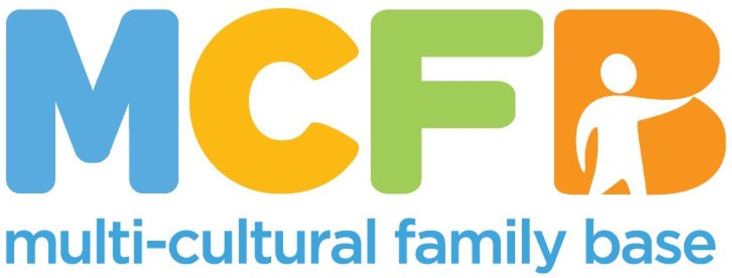
JOB PACK

This pack offers information on the role description and on our organisation. In order to apply, please complete the attached Application Pack.

ABOUT THE MULTI-CULTURAL FAMILY BASE
MULTICULTURAL FAMILY BASE is a unique, community based social work centre based in Edinburgh. Approximately 50% of our workforce are from a BME background.
The organisation’s key objective is to support Black and Minority Ethnic individuals, children and parents deal with important transition points - this can be the birth of a child, the move into primary school or the move to Edinburgh for families who are new migrants. In addition, we combine our service delivery with student learning by providing high quality and diverse placement opportunities for social work students from academic institutions across Scotland.
We are now seeking two qualified, skilled and motivated individuals to join our team:
Project Worker in Bright Choices project:
The Bright Choices Project offers practical and emotional support and advice to women, children and men from Black and Minority Ethnic communities who are experiencing, or at risk of, Honour-Based Violence (HBV), Female Genital Mutilation (FGM) and other harmful practices relating to cultural belief systems and pressures.
You will have a relevant professional qualification and experience of group and individual work with people affected by HBV who are likely to experience disadvantage or discrimination due to their race, ethnicity or cultural backgrounds.
You will be engaging service users in group work and will have knowledge of the key issues as well as relevant experience of working within a therapeutic, community development role in 1:1 setting.
You will be facilitating Creative Nurture Group in collaboration with an Art Therapist once a week, working with women affected by HBV.
A strong commitment to anti-oppressive practice and equal opportunities is essential. The posts require membership of the PVG Scheme.

For more information visit: www.mcfb.org.uk

ABOUT THE ROLE
Post Title: Bright Choices Project Worker
Hours: 30 hours a week
Pay: £27, 890 FTE
Base: Some flexibility/Hybrid
50 Coburg Street, Edinburgh, EH6 6HE

Reports to: Bright Choices Project Leader

EMPLOYEE PACKAGE & BENEFITS
✓ Flexible Working & Family Friendly – We offer flexible working hours to accommodate families, childcare and caring responsibilities.
✓ Pension – All eligible staff are auto-enrolled in our Royal London pension scheme with a minimum 1.27% contribution from you and minimum 6.73% contribution from MCFB.
✓ Annual Leave - Annual leave entitlement is ample with 30 days and 12 mandatory holidays per calendar (pro-rated for part-time positions).

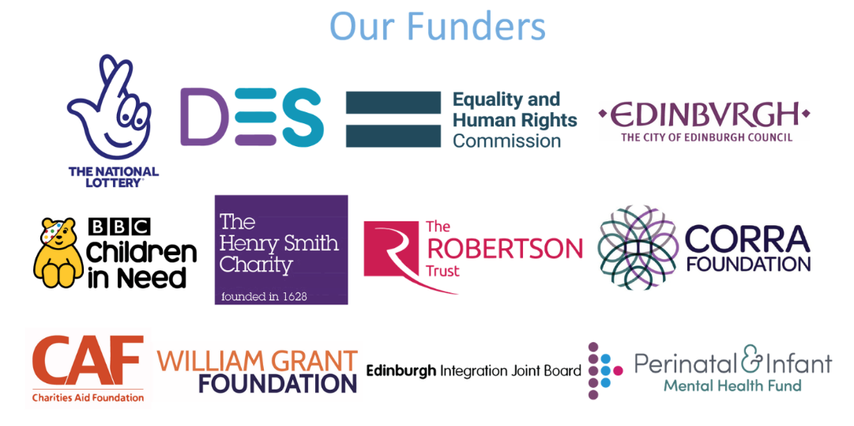

ROLE PURPOSE
The successful applicant will have a good knowledge and understanding issues of Honour Based Violence and its impacts, and a commitment to protecting children and young people by recognising, assessing and responding to risk.

KEY RESPONSIBILITIES
- To provide a range of practical and emotional support to individuals and families identified as being vulnerable
- To work with individuals and families in their homes as well as in the community or at MCFB
- To work with adults, children, young people and their families to assess needs
- To provide one-to-one and group work support as appropriate to children, young people and adults
- To ensure that the needs and progress of all service users are evaluated and recorded
- To provide progress reports on the work
- To maintain accurate and up-to-date records in accordance with MCFB’s Confidentiality and Recording Policy and other relevant policies
- To undertake initial assessments of service user’s well-being and to regularly review support in order to measure the impact of the provision
- To facilitate Creative Nurture Group once a week for Bright Choices service users in collaboration with an Art Therapist
- To maintain communication with service users and to promote their involvement in the project
- To work at all times in a respectful, collaborative and open way with service users
- To liaise with statutory and voluntary agencies who provide services, including schools, health services, police and social work services
- To liaise with other agencies providing services to Black, Asian and Minority Ethnic communities
- To signpost service users to other agencies where appropriate
- To raise any potential child protection concerns with the CEO/Deputy or appropriate Duty Senior
- To promote the work of MCFB and disseminate information about available services
- In conjunction with the Senior Project Worker to report on the progress of the project for funders and others
- Any other relevant duties which may be necessary including if relevant, the supervision of volunteers, sessional staff and students ( either as a link supervisor or as a practice teacher if the worker has an appropriate Practice Learning qualification)

All employees at MCFB are expected to carry out any other duties that support our service users’ wellbeing or are necessary to support the effective running of the organisation.

PERSON SPECIFICATION

Criteria | Essential | Desirable | Assessment Method
Education and Qualifications | * Secondary Level Education (HNC, HNQ, SVQ or equivalent)  * Relevant professional qualification e.g. social work/community work/community education | * S.V.Q. Level 4 (in Mediation) or equivalent standard  * Degree level Education  * Registration with appropriate professional body | *Application form
Experience and Knowledge | * Knowledge and understanding of the nature and impact of FGM/HBV  * Knowledge and understanding of Gender Based Violence  * Gendered understanding of domestic abuse and HBV  * Relevant experience in working with BAME communities/groups in a community setting  * Ability to carry HBV case work  * Having professional judgement about workload capacity  * Knowledge and understanding of the specific issues facing individuals and children from BAME communities in Edinburgh  * Experience facilitating group work with young people and adults  * Experience of supporting other workers/ volunteers/ students | * Experience of working within the field of Honour Based Violence, Gender Based Violence or FGM  * Knowledge of current legal and policy status of FGM  * Knowledge and understanding of child protection procedures  * Training in public protection, child protection (level 2), domestic abuse and/or coercive control or related  * Experience of interagency/ partnership working | * Application Form  * Interview  * References
Skills and Abilities | * Excellent communication skills (both written and verbal, including report writing)  * Confident user of IT  * Ability to communicate with young people and adults and build trusting relationships  * Ability to engage with families and individuals referred to Bright Choices individually and in groups  * Group facilitation skills  * Ability to evaluate outcomes and report-writing skills  * Ability to work effectively with relevant professionals (education, social work, police, health)  * Proven ability to organise own workload  * Excellent team working skills  * Ability to maintain highest levels of confidentiality and maintain work records up-to-date | * Ability to speak a relevant community language  * Ability to maintain a professional attitude in challenging and emotive circumstances  * Full, clean UK driver’s license and access to own vehicle  * Ability to recognise, risk of FGM/HBV and willingness to provide intervention to manage this risk  * Creative and forward-thinking approach  * Ability to present publicly to a range of different audiences. | * Application form  * Interview  * References
Personal Qualities and Attitudes | * Strong ethical commitment to the aims and values of MCFB  * Commitment to anti-racist practice  * Commitment to working with empathy, impartially and in a confidential manner  * Willing to travel as required in order to deliver the service within the community |  | *Application form *Interview  *References

Closing date: 25th November at 5pm
Interview date: 11th December
Start Date: 6th January 2025

To apply, please complete the application pack and email to hello@mcfb.org.uk

