Why ProjectChange Needs You

Hey there,

Let’s skip the formalities—I’m Adam, the CEO of ProjectChange. If you’re here, you’ve probably seen we’re looking for trustees, and I want to tell you why that’s such a big deal for us (and maybe for you, too).

ProjectChange started almost five years ago with a simple idea: care experienced people should have the tools, spaces, and opportunities to lead the changes they want to see. Not just talk about their experiences but shape the future. Since then, we’ve been building something special—a small but mighty charity that’s all about empowering voices, challenging systems, and making sure everyone feels like they matter.

But here’s the thing: we can’t do it alone.

Being a trustee isn’t about sitting in endless meetings or having years of experience in governance (we promise). It’s about bringing your ideas, your perspective, and your passion to the table. It’s about being part of a team that genuinely wants to make things better for care experienced people.

Our work is important because, let’s be honest, listening isn’t always done right. People might think they’re listening, but are they really? At ProjectChange, we’ve seen how powerful it is when care experienced people are not just heard, but actually supported to take the lead. That’s the change we’re trying to make, and trust me, it’s worth every second of effort.

So, if you’re someone who believes in lifting people up, challenging how things are done, and having a bit of fun while doing it, we want to hear from you. No CVs, no jargon—just tell us who you are, what you’re excited about, and why you want to join us. We’ll have a conversation with everyone who applies because we know that everyone has something valuable to bring.

This isn’t about being “qualified.” It’s about showing up and wanting to be part of something bigger.

Thanks for reading. I hope we’ll be chatting soon.

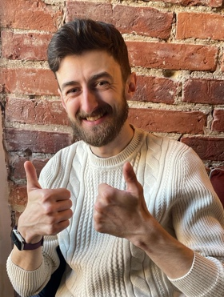
Adam Bennett
CEO, ProjectChange

Adam x

