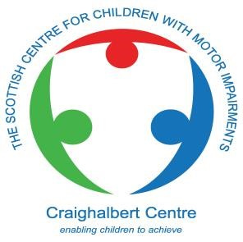

The Scottish Centre for Children with Motor Impairments (Craighalbert Centre)

Learning, Care and Therapy Practitioners (LCTP)

Working with Children with Neurological Conditions

Full-Time, Permanent Posts

£25,098 - £29,458 (DOE)

35 Hour Regular Working Week and 55 Days Paid Leave per Year

We are looking for a flexible, creative and child centred experienced Learning, Care and Therapy Practitioner to join our multidisciplinary team. This is an exciting opportunity to be part of a creative service that is remodelling integrated therapy, care and learning for children and young people affected by neurological conditions. The Centre includes an independent school for children and young people with profound and multiple learning disabilities and is one of Scottish Government’s seven Grant Aided Special Schools. Education provision includes early learning and childcare, primary and secondary provision. The Centre also provides a range of learning and therapeutic services that support families and practitioners throughout Scotland. The children and young people attending the school and nursery experience complex health and learning needs, while families supported through wider Centre services are affected by a broad range of disability impacting on motor function and learning. The Centre is highly resourced in terms of specialist staff, technology, and equipment to facilitate therapy and development. Our aim is simple; to support children, young people and their families to attain and maintain the highest level of holistic wellbeing possible. Multidisciplinary teams around the child work collaboratively alongside parents maximising the benefit from Centre and community resources to give children and young people exceptional experiences to achieve ambitious outcomes. You will have an opportunity to work across the range of Centre services with children of all ages from prenursery through to 18 years. Our ethos is to get it right for every child helping children and young people gain the knowledge, skills and attributes needed for life in the 21st century.

Successful candidates will be required to be registered with the Scottish Social Services Council (SSSC) within 3-months of appointment and maintain registration throughout the period of employment.

Successful candidates will be required to undertake a Disclosure Scotland (PVG) Check.

Successful candidates will be able to continue in or join the Strathclyde Pension Fund.

Closing date for applications: 17th January 2025

For informal and confidential discussions, contact: Caroline Glen, HR and Organisational Development Officer.
Email: HR@craighalbert.org.uk

The Scottish Centre for Children with Motor Impairments

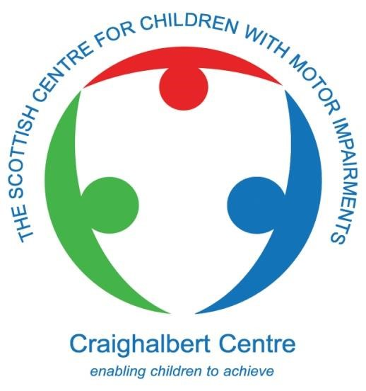

Learning, Care & Therapy Practitioner (LCTP)

Working with Children with Neurological Conditions

Further Particulars

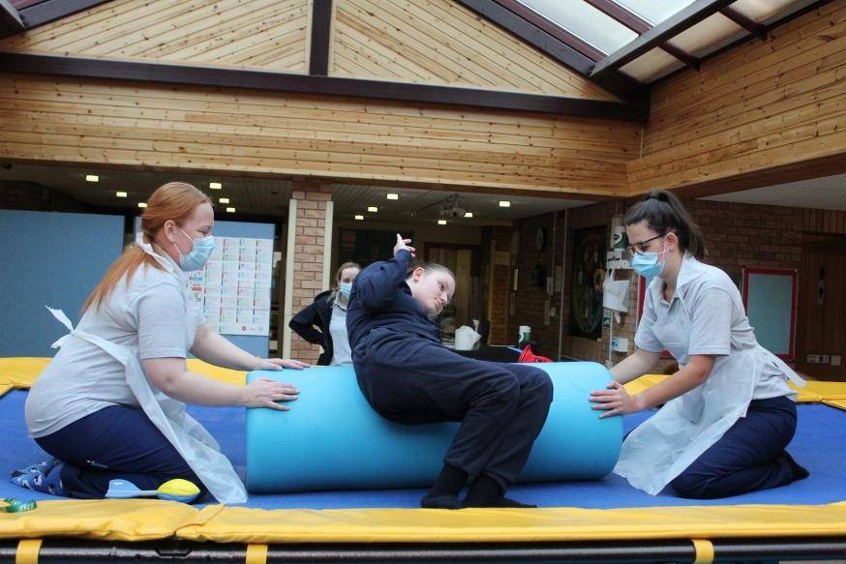

24

Learning, Care & Therapy Practitioner (LCTP)

Working with Children with Neurological Conditions

Further Particulars

Contents Page

- The Scottish Centre for Children with Motor Impairments 1
  - Introduction 1
  - Centre Management 1
  - Location 1
  - Physical Environment 1
  - SCCMI’s Quality Status 2
  - SCCMI’s Unique Working Methods: Integrated, Collaborative Working 2
- Meeting Children’s Needs 3
  - Characteristics of Children/Young People with Whom the Centre Engages 3
  - Nursery and School Provision 3
  - National Programmes and Services 3
- Role, Responsibilities and Requirements 4
  - Post Role and Requirements 4
  - Job Description 4
  - Person Specification 7
- Pay and Leave and other Conditions of Service 9
  - Pay 9
  - Pension 9
  - Annual Leave 9
  - Working Hours 9
  - After Hours/Evening Working 9
  - Twilight Working 9
  - Weekend Working 9
  - Continuing Professional Development 10
- Selection Arrangements 10
  - Prior to Submitting an Application 10
  - Initial Applications 10
  - Interview 10
- Start Date 11

1. The Scottish Centre for Children with Motor Impairments

1.1 Introduction
The Scottish Centre for Children with Motor Impairments (SCCMI) was purpose built as a national resource and continues to benefit from annual Scottish Government grant funding. The Centre provides learning, care, and therapy for children of all ages affected by neurological disorders. The Centre includes an independent school for children and young people with profound and multiple learning disabilities. Education provision includes early learning and childcare, primary and secondary provision including provision for senior phase. The Centre also provides a range of learning and therapeutic services that support families and practitioners throughout Scotland. Our aim is simple, to support children, young people, and their families to attain and maintain the highest level of holistic wellbeing possible. Multidisciplinary teams around the child work collaboratively alongside parents maximising the benefit from Centre and community resources to give children and young people exceptional experiences to achieve ambitious outcomes.

1.2 Centre Management
The Chief Executive, Bob Fraser, is supported by the Centre Leadership Team, who are overseen by the Board of Directors.

1.3 Location
The Centre is located in Central Scotland with motorway, trains and buses providing excellent transport links and easy access to Glasgow, Edinburgh, Stirling and beyond. The Centre is set in its own grounds that are linked to a country park providing a quiet and restful working environment. Walking and cycle paths connect the Centre to many residential and retail opportunities. For those wishing to live nearby there is a wide range of housing available including many options for modern urban town living through to village or country living within 10 minutes’ drive.

1.4 The Physical Environment
Learning, care, and therapy take place in stimulating environments within a welcoming, spacious, and pleasant building. Specialist play, therapeutic, educational and communication equipment is employed to promote the child’s engagement in and benefit from activities. Children receive aquatic therapy in the Centre’s custom- designed pool and use the grounds’ outdoor learning areas, therapeutic equipment, and play areas to support the provision outdoor activities.

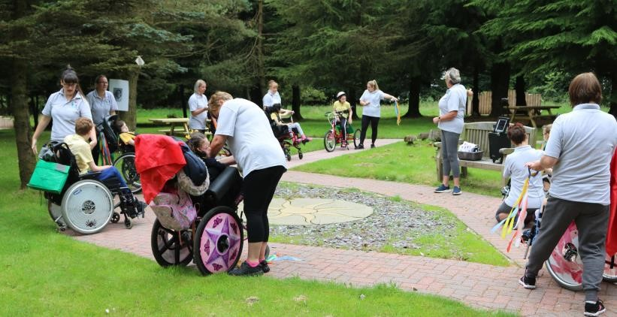

1.5 SCCMI’s Quality Status
The SCCMI has been subject to a range of external assessments of its work in recent years including: ▪ Education Scotland ▪ Care Inspectorate.

(i) Education Scotland
Following the inspection in June 2016, a highly positive report was received from Education Scotland, with the inspectors’ views confirming the high-quality education and therapy services and facilities offered by the SCCMI, with the inspectors using the terms, ‘outstanding, ‘excellent’ and ‘exceptional’ through the report.

(ii) Care Inspectorate
The SCCMI had unannounced inspections from the Care Inspectorate in March 2019, 2017 and 2014, with those inspections confirming the quality of the SCCMI’s care. Elements of the service were assessed as:
- Quality of Care and Support 6 - Excellent (2019 & 2017)
- Quality of Environment 6 - Excellent (2017)
- Quality of Staffing 6 - Excellent (2019 & 2014)
- Ensuring Children’s Health and Wellbeing Needs Are Met 6 - Excellent (2014)

1.6 The SCCMI’s Unique Working Methods: Integrated, Collaborative Working
At the SCCMI, as is the case in many organisations, the concept of the multi-disciplinary team around the child is established. However, SCCMI has taken this concept much further than occurs in most organisations. At SCCMI all activities are designed to be outcome focused improving holistic wellbeing. To do this in the most effective, person-centred, and enjoyable way often requires creative approaches that in turn require flexible, integrated, collaborative ‘co-professional’ working when planning and delivering therapy, care and learning.

Co-professional working therefore enables staff drawn from a range of appropriate professional disciplines including e.g., Teachers, Physiotherapists, Occupational Therapists, Speech Therapists and Learning and Therapy Facilitators, to work in an integrated and coprofessional manner that can offer a collective and cohesive approach but employ specialist knowledge when required. The objective of co-professional working is that staff operate as a cohesive group, delivering services in a holistic manner to individual children or a group of children, deliberately attempting to blur the edges between the professions; and ensuring that the whole of the SCCMI’s workforce is greater than the sum of the individual parts.

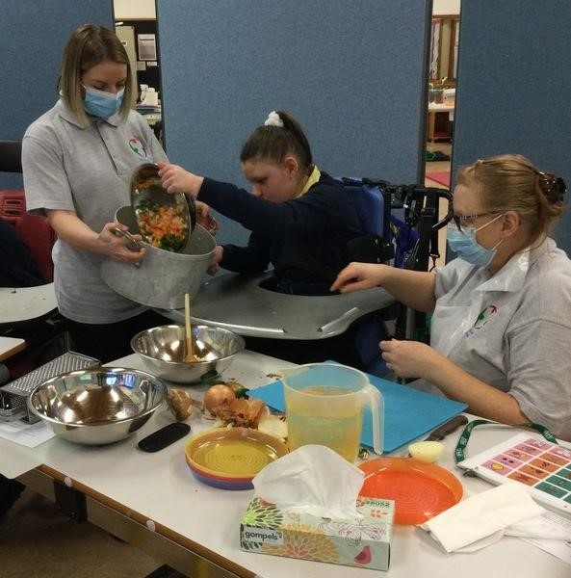

2. Meeting Children’s Needs

2.1 Characteristics of Children/Young People with Whom the SCCMI Engages
The children/young people with whom the SCCMI engages are those affected by neurological conditions who have abilities across a wide range of the severity and complexity, including some of those with ‘complex and exceptional healthcare needs’ and/or life-limiting conditions. These children/young people have an age range of birth to 19 years.

2.2 Nursery and School Provision
The Centre has facility to provide early learning (≈3-5years), primary schooling (≈5-12 years) and secondary schooling (≈12-18 years). All children currently attending the school have profound and multiple learning disabilities (PMLD). Group activities to improve health and wellbeing outcomes can be organised around chronological age however equally they are organised in the most efficient and effective way to: address barriers to learning; maximise on engagement with learning; provide for social interaction; maximise therapeutic benefit; and provide the most stimulating and enjoyable experiences.

2.3 National Programmes and Services

The SCCMI’s programmes and services are designed to reflect the ability, age, and developmental stage of children/young people with motor impairments, with key elements including:
- providing integrated learning, care, and therapy
- addressing the child/young person’s learning, movement, life skills and communication • maximising the potential of the child/young person
- enabling each person to establish their highest possible level of independence through developing cognitive, movement and functional abilities
- involving parents as partners in programme delivery.

The programmes/services currently offered include on a national basis are:

▪ Early Intervention Programme
This programme addresses the needs of pre-school children across the range of disability severity and complexity, attending with parents, incorporating assessment, therapeutic intervention, cognitive development, and parental instruction.

▪ Access to Education Programme
Designed for school age children/young people who are more able and are affected by less complex disability. The programme facilitates access to education within the mainstream school through developing physical abilities and life skills.

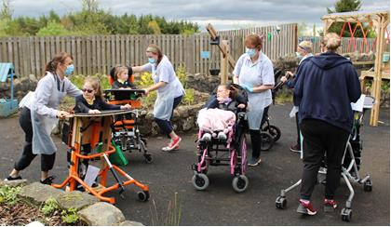

3. Role, Responsibilities and Requirements

3.1 Post Role and Requirements
Learning, Care and Therapy Practitioners (LCTPs) are accountable to the Head of Learning to provide support for Teachers and Therapists in the delivery of integrated education and therapies across SCCMI programmes and services and to provide care to children within the Craighalbert Campus and in other locations.

Under the direction of professional staff, i.e. Teachers and Therapists, LCTPs will support the participation of children in educational and therapeutic activities and be responsible for the preparation and maintenance of an appropriate, safe, motivating, well-organised, childcentred environment to maximise opportunities for learning and development. Under the direction of the Head of Learning, LCTPs will provide intimate care, including toileting, feeding and administering medication for children across all programmes.

3.2 Job Description

3.2.1 Responsibilities and Accountabilities
- Responsible for ensuring work is undertaken to a consistently high standard taking due regard of the direction of professional staff.
- Responsible for ensuring children are always treated with dignity and respect, in particular, when undertaking close physical work and intimate care.
- Directing, supporting, and engaging with children during purposeful indoor and outdoor activities which are part of the educational programme and therapy activities.
- Engaging with peers and with SCCMI Teachers and Therapists to ensure the needs of children and young people are met safely and effectively.
- Mentoring less experienced LCTPs in the subtleties of working effectively and empathetically with children affected by neurological conditions including cerebral palsy and Rett’s syndrome to address their learning, therapeutic and care needs.

Practice Responsibilities
- Under the direction and guidance of Teachers and Therapists, facilitate the delivery of education and therapy to children and support their participation in all programmes.
- Collaborate with colleagues in the planning and delivery of learning and therapeutic programmes.
- Participate in the evaluation of children’s progress and achievement tracking.
- Prepare learning and therapy resources as directed by Teachers and Therapists, including those associated with communication.
- Prepare and maintain an appropriate, safe, motivating, well-organised, child-centred environment to maximise opportunities for learning and development.
- Under the direction of Teachers, implement programmes and strategies to enable children to work towards identified goals.
- Under the direction of Occupational Therapists (OTs), enable children to actively engage in learning, therapy and care activities and support the development of their functional independence skills.
- Under the direction of Physiotherapist (PTs), enable children to participate in postural and movement activities and support their musculoskeletal wellbeing and development of motor abilities.
- Under the direction of Speech and Language Therapists (SLTs), communicate effectively with children using a range of strategies and support the development of their interaction and language abilities.
- Provide intimate care, including toileting, feeding and the administration of medicines to children across all programmes.
- Monitor and support the wellbeing of children with multiple and complex healthcare needs.
- Work collaboratively with others to ensure high quality service delivery and experiences for children.
- Comply with SCCMI’s safeguarding and child protection policy and procedures.
- Comply with Health and Social Care Standards.
- Under the direction of Teachers and Therapists, comply with education and therapy regulations and guidance.

Record-keeping
Under the direction of the PLQC, teachers and therapists, maintain accurate records.

Professional Development
- Undertake appropriate staff development.
- Maintain registration with statutory organisations.
- Participate in SCCMIs Personal and Professional Development System (PPDS)

Health and Safety
- Implement SCCMI’s and national Health and Safety, risk assessment and manual handling policies.
- Participate in training e.g. enteral feeding / managing epilepsy and others as directed.
- Establish and maintain a safe environment for children, staff, and visitors.

Other Duties
- Comply with all SCCMI policies and procedures.
- Undertake other duties associated with SCCMI’s work as determined by the Head of Learning and Chief Executive.

3.2.3 Responsibility to Parents and Families
- Build relationships based on mutual respect.
- Welcome parents and families as partners.
- Through consultation and involvement, encourage and value parents and families’ contributions to enhance School and wider Centre services and environment.
- Develop a secure profile and firm understanding of their child’s needs and barriers to learning.
- Contribute to reports to accurately reflect their child’s progress and development needs in a comprehensive and clear manner to share with them and other stakeholders.

3.2.4 Responsibility to Other Staff
- Plan collegiately to effectively meet the wellbeing needs of children. Children and young people will be grouped in a variety of ways in school and in programmes hence flexibility and adaptability will be necessary to plan for and meet the needs of these groupings and individual children.
- Work flexibly as part of a multidisciplinary team to plan and deliver services prioritising the holistic wellbeing needs of individual children and young people.
- Work collaboratively and cooperatively supporting compromise between disciplines, so that resources can be focused on whichever aspect of the child or young person’s needs have highest holistic priority.
- Contribute to the professional development, support, supervision, mentoring, education, training, and where appropriate lead on planning for and development of placements and/or the work of:

  - other Centre staff
o external professionals
  - students
  - visiting staff
o research staff
  - volunteers

- Fully support and welcome new staff during and following induction period.

3.2.5 Responsibility to Organisation
- Participate fully in personal and professional development activities, both in-house and those delivered by external agencies/trainers, including out with the Centre when appropriate.
- Implement, participate in, and support the development of systems, processes and practice related to monitoring and evaluation including specialist, standardised assessments tools with validated appropriate outcome measures.
- With other staff, undertake the ongoing evaluation of programmes; designing appropriate tools to enable measurement of quality, with involving stakeholders in the process.
- Expand and enhance professional skills to ensure delivery of SCCMI’s services comply with legislation and reflect current good-practice guidance.
- Participate in SCCMI’s appraisal, performance, and staff development systems.
- Meet the requirements of HCPC registration renewal.
- Be familiar with and promote SCCMI’s policies and procedures.
- Contribute, as appropriate, to development, implementation and updating of SCCMI’s policies and procedures.
- Working collaboratively with colleagues, contribute to the Centre Development Plan, including:
  - Undertake ongoing assessment and evaluation of education, learning and child development programme delivery.
  - Undertake development work relating to identified priorities.

- Adhere to organisational procedures, standards, protocols, and policies relevant to area of work.
- Contribute fully to an ethos that values children, parents, staff, and community.
- Carry out any other duties as reasonably required, determined by the Centre Management Team and/ or Chief Executive.

Learning, Care & Therapy Practitioner (LCTP) - Person Specification

CRITERIA | ESSENTIAL | DESIRABLE
Qualifications | At least one of the following qualifications to enable SSSC  Registration at Practitioner Level:  HNC in Childhood Practice/Childcare  & Education  SVQ Social Services (Children &  Young People) SCQF 7 / SVQ 3  Children’s Care, Learning &  Development  Applicants with an SNNEB/NNEB may be considered where they can evidence a record of on-going CPD during the past 5 years | Units in Additional Support Needs
Professional Registration | Registered Member of the Scottish Social Services Council (Practitioner level) or agreement to undertake qualification to enable full registration (self-funded) whilst in post
Experience | Working with children from age 3 years  Experience of Curriculum for Excellence | More than 3 years’ experience working with children with additional support needs  Planning & implementing early years learning programme for children with  ASN  Working with children with complex feeding & swallowing difficulties  Working with children with  communication difficulties  Working with children with complex  exceptional healthcare needs  Attending to intimate personal care needs of children
Professional Development | Awareness of and commitment to quality standards  Knowledge of professional ethics/standards/codes of conduct and their application | Knowledge of current policies in relation to ASN  Practice related education, training, knowledge or skills development specifically related to children with ASN in early learning settings and/or a setting that predominantly worked with children complex heath care needs.

CRITERIA | ESSENTIAL | DESIRABLE
Communication  Skills | Ability and willingness to  communicate clearly and effectively with the Centre community; children, parents and all staff, and other external partners who support the child or Centre.  Evidence of communicating with children, parents and other professionals to improve the wellbeing of children | Evidence of using a range of  communication techniques with children, parents and other professionals  Experience in using Augmentative and Alternative Communication (AAC) strategies  Evidence of using creative  communication techniques with children, parents and other professionals
Interpersonal  Skills | Curious  Resilient  Ability and willingness to work collaboratively with other staff as part of a team  Ability to compromise  Evidence of working as a part of a multi-disciplinary team | Demonstrate leadership qualities
Implementing Change | Willing enthusiasm to be involved in practice improvement  Ability to engage in professional dialogue to develop best practice  Evidence of problem solving | Evidence of working as part of a team to review practice, evaluate options for change, plan change or implement change.  Evidence of leading change to improve practice  Evidence of using negotiation and influencing skills to progress change  Evidence of using research, audit, service evaluation and/ or quality improvement tools to advance practice
Ethos | Child centred  Focus on holistic wellbeing  Outcome focused  Collaborative  Flexible  Learning is fun and exciting
Relationships with Children | Ability to engage and motivate children and young people  Strong commitment to improving the holistic wellbeing children within their community to improve their life outcomes | Evidence of engaging and motivating individual and/ or groups of children and young people to learn, achieve or improve their wellbeing
Relationships with Parents  and the  Community | Ability and willingness to establish positive relationships with parents and the community | Evidence of previous experience in establishing positive relationships with parents and the community  Evidence of working with children, young people, parents and community supports to achieve child led outcomes
CRITERIA | ESSENTIAL | DESIRABLE
Whole Centre Involvement | Commitment to improving outcomes for children and a willingness to participate in whole Centre improvement activities and groups | Evidence of participation in organisational improvement  programmes
Other | Commitment and willingness to develop children holistically by ensuring activities to improve health, communication and learning is fully child-centred and where possible, child-led | Evidence and willingness to participate in extra-curricular activities

4. Pay and Leave and other Conditions of Service

4.1 Pay
The salary range for the post is £25,098 - £29,458 dependent on experience.

4.2 Pension
The post holder can join or continue with the Strathclyde Pension Scheme.

4.3 Annual Leave
The leave year runs from April 1st to 31st March.
The annual leave entitlement is 55 days per year (pro rata for part time staff). These holidays are composed of:

- 45 days fixed holidays (4 weeks fixed holidays at summer, 1 week in October, 2 weeks at Christmas, 2 weeks at Easter);
- 5 days are allocated to long weekends placed throughout the year;
- 5 days to be taken at the individual's discretion, providing this is approved in advance by the line manager, providing there is no impact on the service delivery and the Centre’s efficient operation.

On moving on from the organisation, any balance of final payment will be calculated on pro rata leave taken/leave due, in the year and the balance made by way of a payment through final salary.

4.4 Working Hours
The regular working hours are 35 hours per week Monday to Friday, 8.30 am to 4pm with a 30-minute unpaid lunch break.

4.5 After Hours/Evening Working
You will be expected to work out with these hours for a maximum of 4 evenings throughout the year to carry out a variety of activities such as parents’ evenings, information sessions etc. An additional 15-minute break after 3.15 pm will be granted. No additional time off in lieu (TOIL) will be offered for evenings or other after-hours worked. Where there is a requirement to work evenings, the expected finishing time will be no later than 9pm.

4.6 Twilight Working
You will be required to work a maximum of six twilight sessions per year (pro rata) until 7pm at the latest, for service delivery. An additional 15-minute break after 3.15 pm will be granted. Time required for this twilight working will normally be gained from a reduction in the standard working week.

4.7 Weekend Working
Weekend services is a feature of our national programmes. Working at weekends is usually by mutual agreement however to maintain service continuity it may be necessary for you to be timetabled to work at the weekend. Where this is necessary you will receive 4 weeks’ notice. Time required for this weekend working will normally be gained from a reduction in the standard working week.

4.8 Continuing Professional Development
You will be expected to complete the equivalent of a minimum 1 working week’s Continuous Professional Development (CPD) to upskill and maintain professional knowledge in a way that actively contributes to the ongoing progress and development of the Centre. This will require to be evidenced and the Centre will supply a format for doing so. CPD that is not ‘on the job will be conducted outside of normal working hours and no additional time off in lieu will be granted. You will be required to participate in clinical supervision.

5. Selection Arrangements

Arrangements for the recruitment process are detailed below.

5.1 Prior to Submitting an application

Prior to submitting an application, applicants are welcome to make contact regarding the nature of the post by contacting Caroline Glen, HR and Organisational Development Officer by email HR@craighalbert.org.uk

5.2 Initial Applications

Applicants should submit a CV by email to HR@craighalbert.org.uk together with a supporting statement of no more than 600 words outlining how their knowledge, experience and attributes enable them to fulfil the responsibilities of this post. Details of 2 referees are required, one of whom requires to be the current or most recent employer. Referees will not be contacted until a formal offer of employment is made.

5.3 Applicants Selected for Interview

The interview selection process comprises two stages. In the initial stage, we will assess all applications by thoroughly reviewing each candidate's CV and accompanying personal statement. If you pass this stage, you will receive an invitation for an interview.

Applicants who are then selected for interview will be provided an opportunity to be taken round the Centre on the day of interview to meet prospective colleagues, some of the children with whom they would work with, and to meet some parents if available. This will also provide the opportunity to see the working environment.

5.4 Interview

The interview will be a 45-minute panel interview.

6. Start Date

The appointee is expected to take up the post as soon as possible.

