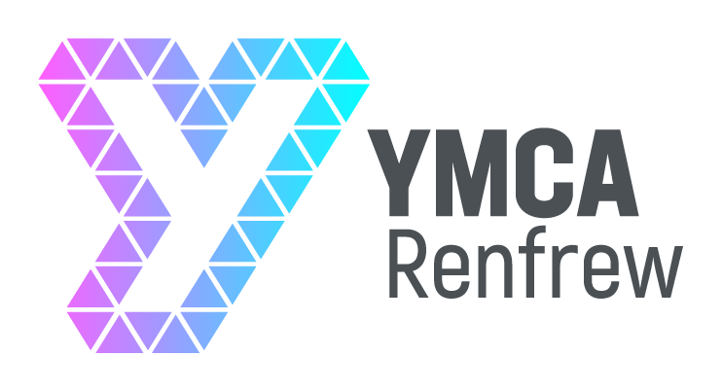

Background on Renfrew YMCA
Renfrew YMCA is a Christian, third sector youth work organisation who work with children and young people from across Renfrew and its surrounding areas, primarily aged from 5 years old to 24 years old, through early intervention projects and service provision for community issues. We work with all children and young people breaking down barriers in the community and building positive relationships with other community members and supporting them to reach their full potential through needs led strategies.

We run a wide range of activities that include mentoring, centre-based drop-ins, outdoor learning activities and young leader development.

Job Profile

JOB TITLE | Centre Manager
LOCATION | Renfrew
RESPONSIBLE TO | Board of Trustees (with a named Line Manager)
LENGTH OF CONTRACT | Permanent
HOURS OF WORK | Full or part time post (35/ 28 hours per week) to be worked flexibly
Salary | £38775.45

Purpose of the Role
The Centre Manager has overall responsibility for the organisation and will provide operational and strategic leadership for the organisation and supporting the governance of the organisation by the Board of Trustees. They are responsible and accountable to the Trustee Board for the development of Renfrew YMCA’s operating strategy, its policies and business planning alongside the continued delivery of high quality youth work. They will work in partnership with funders, regulators and other stakeholders; lead the staff team; oversee performance management and maintain a person-centred approach to the needs of young people and the community.

Duties and Responsibilities

Leadership of the Organisation
- Provide a motivational and inspirational leadership style to the staff, volunteers and service users of the organisation
- Identify new opportunities for the growth and development of the organisation such as new projects or new areas of work
- Develop and implement a strategy for the organisation that will:
  - Engage with young people and the community that are most in need of services that will support them to reach their full potential
  - Provide a range of learning opportunities suitable for young people across the age spectrum
  - Identify possible ways of collaborating with others in the third, private and public sector
  - Ensure a range of funding streams that will ensure the long-term financial sustainability of the organisation
- Provide thought-through imaginative, creative and realistic proposals for the development of the organisation to the Board of Trustees
- Promote the values of Renfrew YMCA
- Championing the values and ethos of the organisation including its Christian identity

Management
- Ensure the high quality of youth work services for young people
- Be responsible for the overall management of staff and volunteers including:
  - the recruitment and induction of appropriate staff and volunteers
  - the implementation of appropriate performance management measures such as setting targets, regular catch-ups and appraisals with senior staff and ensuring these are carried out throughout the organisation
  - providing appropriate opportunities for continuing professional development of staff and volunteers
- Ensure that all regulatory processes (e.g. submissions to OSCR) are completed in a diligent and timely fashion

Governance
- Provide timely and accurate reports to the Board of Trustees on the progress of current operational activities
- Propose new projects to the Board for the development of the organisation
- Attend and participate in regular board meetings and relevant sub-committees of the Board
- Provide the Board of Trustees with the necessary information in order to make informed decisions.

Person Specification

Position: Centre Manager
 | ESSENTIAL | DESIRABLE
QUALIFICATIONS | - Degree - We welcome applications from all those who can demonstrate the specific skills and experience outlined below. This level may have been attained through studying for a degree and/or from professional experience | - Youth & Community work / Community Learning & Development qualification
EXPERIENCE | - Significant experience of working in a youth work or community development role  - Financial management  - Proven ability in working within a networking role  - Proven ability to plan and manage youth work activities  - Developing new initiatives and creating opportunities  - Recruitment and management of staff and/or volunteers  - Achieving goals in collaboration with others  - Successful submission of funding bids | - Substantive strategic planning experience
SKILLS/  ABILITIES | - Good communication skills, including report writing  - Strategic planner – to ensure activities are planned and implemented strategically  - Ability to inspire and motivate a staff team  - Excellent networking skills  - Ability to engage with young people from a range of backgrounds  - Creative and innovative thinking  - Entrepreneurial and proactive  - Willingness and ability to work within organisational guidelines and to corporate objectives  - Ability to work as part of a team
PERSONAL QUALITIES | - Committed Christian  - Team player  - Highly credible  - Flexible  - Warm, persuasive, charismatic personality  - Commitment to inclusion and empowerment  - Results driven  - Self-starter  - Willing to work anti-social hours as required

