Inverkeithing Community Garden

Job description: Inverkeithing Community Garden Coordinator
Self-employed
Hours: 10/wk Mar-Oct, 3/wk Nov-Feb
Rate: £25/hour, per annum £9850
Contract Duration: 2 years, ending March 2027
PVG: A Scheme Membership Statement desirable
Location: Abbot Place, off Queen Street, Inverkeithing, United Kingdom, KY11 1PA

Tasks and Responsibilities
Organise and manage weekly sessions for volunteers including induction of new volunteers (March-Oct)
Engage with local groups to encourage their use of the garden and to inform activities and events
Organise seasonal events in the garden
Maintain and develop communication with the local community and businesses through social media and local events
Welcome visitors and potential volunteers to the garden
Manage resources and equipment including basic maintenance
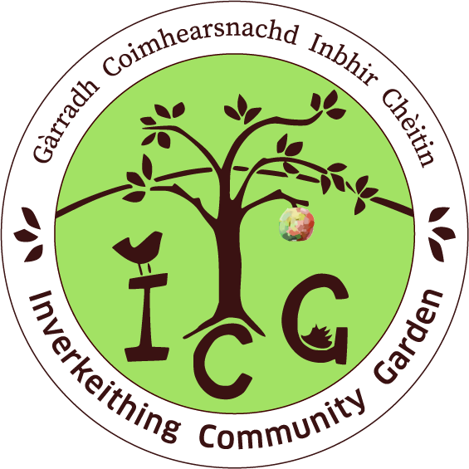
Work with the committee to forward plan, carry out monitoring, evaluation and reporting as required
Ensure that relevant policies and good practice are adhered to.
Maintain site in line with lease agreement, identifying any significant issues to the committee

Person Specification
Skills/Knowledge/experience
Ability to lead a team of volunteers and support their development, skills and confidence
Ability to network and develop links with community groups
Ability to develop activities and projects
Ability to work as part of a team
Ability to communicate effectively including through social media
Ability to work within a designated budget
Essential to have an interest in gardening, nature and the environment including organic growing techniques
Knowledge of current good practice/trends with the sector

Personal Qualities:
An enthusiastic and supportive attitude
Passionate about sharing knowledge of growing and nature
Proactive, self motivated and able to use own initiative

