JOIN OUR TEAM:
FINANCE & OFFICE MANAGER

We are Shetland Rape Crisis, based in The Compass Centre in Lerwick.

We believe in a Shetland free from sexual violence and equally safe for all.

We’re looking for women who share our values to help make this vision a reality.
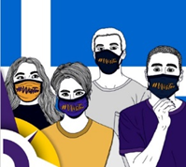
This is an exciting opportunity to join the team at Shetland Rape Crisis (SRC), based in The Compass Centre in Lerwick.

You will play a key role ensuring that we meet our priorities and invest in our people, culture, and systems to support the safe, sustainable, and effective delivery of our services - increasing the positive impact of our work across Shetland.

You will be supported to learn and grow in your own practice and values-base, and robust training and induction will be provided to ensure you are able to carry out the full responsibilities of the role.

We’re a close team united by a love of our island community and a shared vision of a future where every Shetlander is equally safe and respected, and where no-one lives with the threat of sexual violence or its impacts.

We provide free and confidential help to non-abusive people of all genders (age 13+) in Shetland who’ve been affected by sexual violence (that is: unwanted sexual behaviour), no matter what happened or when.
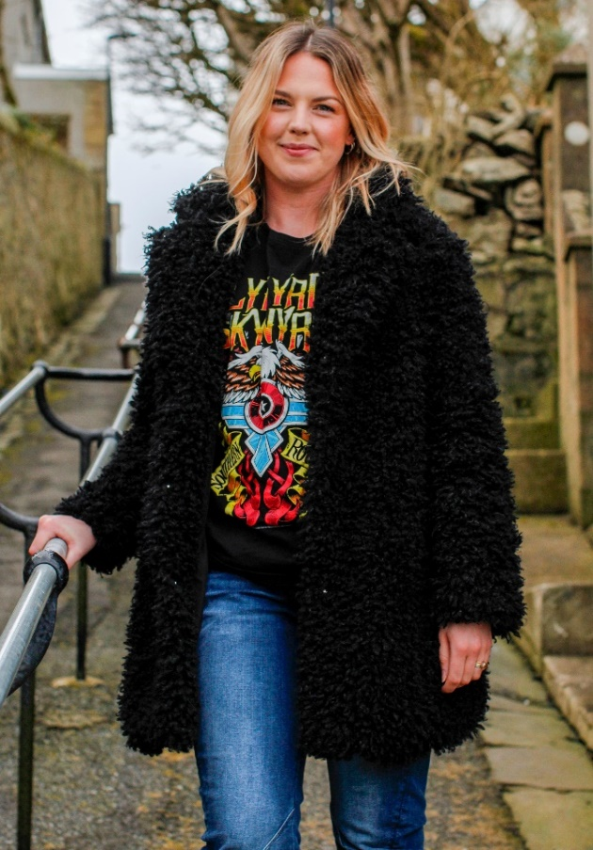
Our specialist services include:

- Sexual Violence Information & Resources
- Sexual Violence Support Service
- Sexual Violence Counselling Service
- Sexual Crime Advocacy Service
- Information & Support for Other Professionals
- Sexual Violence Prevention Programme
- Equally Safe at Schools Programme

“Being part of a feminist organisation committed to promoting equality and diversity, and working alongside women that share the same values, is an incredibly rewarding experience.”

Laura Hughes, Chair and Trustee since 2020

Although some sexual violence may result in physical injury, most sexual violence does not. We use the umbrella term “violence” because "violence" is the plural of “violation” and recognises that these behaviours are part of a spectrum of abuse that violates your right to safety, and wellbeing.

We also deliver specialist prevention education in secondary schools and college settings, lead on campaigns and community events, and take part in strategic partnerships with the local authority, health, and third sectors advocating for the inclusion of concerns relating to sexual and gender-based violence in Shetland.

Thank you for your interest in the post of: Finance & Office Manager
Please find below information relating to the organisation, our values and ethos, and details of our services. Please note that only information provided in the application form can be considered in the shortlisting process. CVs will not be considered. To apply, please see:

2. Job Description & Person Specification – Finance & Office Manager (SRC)
3. Application Form – Finance & Office Manager (SRC)

Applications will be shortlisted by scoring the information provided in the application from against the essential and desirable competencies in the job description and person specification. Please provide as much information as possible, together with examples, to show how you meet these competencies. All experience is relevant and need not be limited to paid employment situations.

Completed application forms should be sent to contact@compasscentre,org by:

Closing date: 9am on Monday 20 January 2025
Interviews: Week of 20 & 27 Jan (may be subject to change)

You will provided with an equal opportunities monitoring form upon application.

We welcome applications from a diverse range of candidates, in particular women of colour and those underrepresented in the workforce. Please note only women need apply under Schedule 9, Part 1 of the Equality Act 2010. Please note that a PVG Disclosure check will be carried out prior to employment commencing.

We are keen to ensure an accessible recruitment process; if you have any issues accessing this pack or require these materials in a different format please contact contact@compasscentre.org.
The Centre is closed until Monday 6th January, so we will not be able to reply to requests until re-opening, but we are willing to consider extension on deadline for applicants where accessibility is a consideration and we haven’t been able to meet a request during the festive break.

Our recruitment process is carried out in accordance with the Data Protection Act 1998. For full details on how your information will be used, please see our Privacy Notice.

About Us

Our Vision
Founded in 2016, Shetland Rape Crisis is an independent specialist charity working towards a Shetland where everyone is equally safe and respected; where women and girls thrive as equal citizens; and where no-one lives with the threat of sexual violence or its impacts. Based in The Compass Centre in Lerwick and delivering outreach work across the Isles, we’re a small team united by a shared love of our island community and the belief that sexual violence is not inevitable, it is preventable.

Our Mission
Until our vision is realised, we work in solidarity with survivors & allies to ensure that:
- Shetlanders affected by sexual violence can access the help they need when they need it.
- No-one in Shetland lives with the threat of sexual violence.
- Shetland embraces equity and mutual respect, rejects all forms of sexual and gender-based violence, and women and girls thrive as equal citizens – socially, culturally, economically and politically.
- People who share our vision are empowered to participate in it, have their voices heard, and influence positive change.

Our Approach
We believe that a Shetland free from sexual violence is a Shetland free from inequity, the root cause & consequence of harm
This is why, as an organisation, we take an active commitment to intersectional feminism and anti-racism.
We aspire to foster equity, diversity, accessibility, and inclusion in all that we do, and we actively advocate for the protection and promotion of the rights of women and girls, children and young people, the LGBTQIA+ community, people of colour, and survivors more generally; as well as reproductive rights, disability rights, and human rights overall.
We’re a member of Rape Crisis Scotland, working to the Rape Crisis National Service Standards. This is a framework that ensures the safety, quality, and effectiveness of our specialist services, as well as our values, ethos, and approach.

Our Values
In addition to the values we share with the Rape Crisis Movement, we spoke with survivors, staff, volunteers, & others in our community to help us set five key values specific to our centre & work in Shetland
1. Safe
Sexual harm is a profound violation of safety. This is why safety, both physical and emotional/psychological, is the first thing we consider in all aspects of our work. We work towards the creation of safer places, coping mechanisms, practice, and relationships, so that chances to heal, connect and thrive are made more available to all Shetlanders, and most especially to those who’ve been denied these opportunities through harm and marginalisation.
2. Trustworthy
Sexual violence is a betrayal of trust. We believe that trust is earned, not owed, and that it is our job to prove we are worthy of it through our actions. We work to build trust by communicating clearly about what we do and why; by actively seeking feedback and being open to change; and by doing what we say we will and, when we can’t, acknowledging our limitations and learning from our mistakes.
3. Equitable
As proud feminists, we believe that a Shetland free from sexual violence is, necessarily, a Shetland free from all forms of inequity. We choose to value equity rather than equality because this means respecting and considering individual differences rather than taking a ‘one size fits all’ approach. Our commitment to equity is also a commitment to challenging sexism, racism, antisemitism, ableism, islamophobia, homophobia, transphobia, classism, xenophobia, and other forces of oppression, because we recognise that you can’t be neutral on a moving train.
4. Empowering
The cause and consequence of sexual violence is an imbalance of power. This is why we believe empowerment is key to tackling it. We actively examine power dynamics so that we are better able to empower others by increasing access to information, meaningful choices, and opportunities to influence change. We take care to wield our own power responsibly and we advocate for the rights of all people to take informed decisions about their own lives and bodies, free from violation and coercion.
5. Courageous
Abuse thrives in darkness, and fear of doing or saying ‘the wrong thing’ can keep us frozen in silence and inaction. We’re committed to being courageous, even when we don’t feel it. We draw upon our values and expertise to maintain a visible presence in our community, and we speak passionately for our cause and the people affected. We strive to be agents of positive change; to speak authentically and truthfully; and we’re willing to risk getting things wrong sometimes because we see our mistakes as opportunities to learn and grow.

Our Priorities
In addition to the priorities we share with the Rape Crisis Movement, we spoke with survivors, staff, volunteers, & others in our community to help us set eight strategic goals to guide our work in Shetland between 2024-26
1. Our work sees Shetlanders affected by sexual violence experience improved access to high-quality specialist services, support, and information; and improved health, justice, and community responses.
2. Our work sees Shetlanders affected by sexual violence are safer; have increased understanding of the impacts of trauma; feel more able to manage the impacts of trauma; and feel more able to take part in their work, education, and/or social life.
3. We work proactively to identify, reduce, and remove barriers to accessing our services and enable active participation in service-improvement; recognising and accounting for the compounding inequities that survivors may experience because of their gender, class, race, ethnicity, ability, neurology, age, sexual orientation, and/or immigration status.
4. We work to stay well-connected, visible, and approachable at all levels in our community, contributing to positive change in attitudes and behaviours around sexual and gender-based violence in Shetland.
5. Our work sees young people in Shetland show decreased acceptance of stereotypes, harassment, abuse, discrimination, and violence; increased knowledge of how and where to access help and information; and increased support for gender equity, healthy sexual relationships, and consent.
6. Strategic approaches to sexual and gender-based violence in Shetland are made stronger and more effective through our ongoing active participation, willingness to share our specialist input, and openness to having courageous conversations with our partners and allies.
7. Shetlanders who share our vision of a future free from sexual and gender-based violence, and most particularly survivors and those marginalised due to existing inequities, are engaged; empowered; supported to have their voices heard; and enabled to influence meaningful change.
8. We invest in our people, culture, and systems to support the safe, sustainable, and effective delivery of our services for survivors, and to increase the positive impact of our work across Shetland as a whole.

