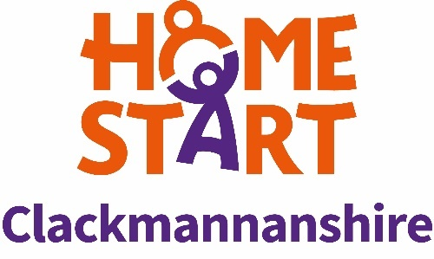

Job Title: Family Support Co-Ordinator (FSC)

Location: Home-Start Clackmannanshire, 92-94 Alloa Business Centre, Alloa, Clackmannanshire, FK10 3SA

Travel required throughout Clackmannanshire to carry out role.

Hours of work: 28 hours per week

Salary: £25,444 (pro rata)

Contract: 1-year fixed term, with intention of extension, funding dependent.

Responsible to: Assistant Manager

Home-Start Clackmannanshire is a long standing, dynamic charity, striving to ensure every young child (under 12) has the best possible start in life locally. Raising a family has never been easy; our trained volunteers and staff are there to support families through challenging times. In Scotland, Home-Starts have over 1,500 volunteers supporting over 3,500 families and 6,500 children each year through compassionate, confidential help to parents/carers when they need us most. The parents/carers we support are often overwhelmed and isolated. They may be struggling with mental health, illness, disability, multiple births, poverty, domestic abuse, separation and/or trauma. We provide a bespoke support package of 1:1 and group services for families, helping them to cope with the stresses and strains of daily life and encourage them to build the skills, confidence, and strength they need to nurture their children for years to come.
We are looking to welcome a new Family Support Coordinator to our team to allow us to meet the growing need for our services locally. This is a fixed term contract, with potential of extension dependent upon continued funding.

Purpose of the job
Our Family Support Coordinators are central to the support services we offer our local families. As a Family Support Coordinator, you, along with our other three Coordinators will be the first point of contact for a referred family, engaging them through initial visit, providing information, and helping them to shape their package of support. You will provide direct support to families on a 1:1 basis, whilst also recruiting, training, and supporting our team of home-visiting volunteers.
You will also:
- Contribute to the effective day to day operation of the scheme in accordance with the Home-Start Memorandum & Articles of Association, Home-Start, Standards & Methods of Practice, Home-Start Agreement and Quality Assurance Standards.
- To maintain high standards of practice in supporting families within the Home-Start model.
- To ensure equality of opportunity, fairness and diversity in all aspects of the scheme’s work.
- Implement good safeguarding practice in all areas of work.

Main Responsibilities
Supporting the work of Home-Start Clackmannanshire
- Undertaking work as delegated by our Assistant Manager and CEO to support the strategic management, development and future funding of the scheme.
- Supporting the implementation of, and upholding all Home-Start policies and procedures.
- Complying with the scheme’s administration, monitoring and financial systems.
- Promoting the work of the scheme, as required by the CEO.
- Contributing to and supporting the development of the Home-Start network locally, regionally and nationally.

Support for families
- Receiving referrals and assessing needs of families.
- Manage caseload of supported families and volunteers.
  - Including direct support of families.
- Ensuring support to families is reviewed at regular intervals and at the end of Home-Start support, in line with current Home-Start guidance.
- Ensuring support to families is of a high standard, in accordance with Home-Start’s model, policies and procedures
- To undertake designated responsibilities to safeguard and promote children’s welfare.

Supporting Volunteers
- Promoting for and recruiting suitable volunteers.
- Co-deliver the Home-Start volunteer preparation course with fellow Family Support Coordinators in full and to a high standard to all prospective volunteers.
- Matching and introducing volunteers to families.
- Providing support, supervision and (source) on-going training opportunities for volunteers.
- Ensure the scheme’s policies and procedures are fully implemented in all aspects of work with volunteers, including their recruitment, selection, preparation, support and supervision.

Working in Partnership
- Ensuring appropriate liaison with referrers and other professionals.
- Networking appropriately within the community.

The post holder may be required to undertake any other duties that fall within the nature of the role and responsibilities of the post as detailed above.

This job description is current as of January 2025.


This post is part funded by Trusthouse Charitable Foundation.

