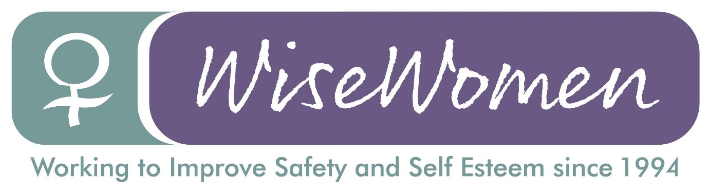

Application

Women’s Training Worker

Return to: Roselyn Smith, Wise Women, Wellpark Centre, 120 Sydney Street, Glasgow, G31 1JF or info@wisewomen.org.uk by Monday, 12th June, 5pm

Application to Wise Women

for the post of

Women’s Training Worker

To be returned to: Roselyn Smith
Information and Finance Worker
Wise Women
120 Sydney Street
G31 1JF

Email: info@wisewomen.org.uk

by: Monday 17th February 2025 at 5pm

Section 1: Personal details

Surname: | First name:
Address: | Tel:  Work tel (Optional. Only include if we can contact you at work):
Postcode: | Email address:

Section 2: Qualifications and training
(only enter those qualifications and/or training necessary or relevant to the job)

Completed Course | Learning Provider | Date (Approx)

Section 3: Present employer

Name & address of employer: |  |  | Date commenced employment:
Job title: |  |  | Notice required: | Current salary:
Brief description of your current main duties and responsibilities, with an emphasis, where possible, on those areas most relevant to the job applied for:

Section 4: Previous employment (list in order, with most recent employer first)

Please list all your previous employment, detailing any gaps between employments with reasons (continue on a separate sheet if necessary).
Dates |  | Name and address of employer | Job title and nature of work |  | Reason for leaving
From  DD/MM/YY | To  DD/MM/YY | Name and address of employer |  |  | Reason for leaving

Section 5: Relevant skills, experience and abilities

With reference to the job description and person specification, please outline how your work experience (including unpaid work) and your skills and abilities would enable you to carry out the duties of this post. Please include any information which you feel is relevant.
(continue on a separate sheet if necessary

Section 6: Knowledge and understanding

Wise Women is a violence against women service. Please tell us below what you believe to be the causes of violence against women.

Wise Women provides personal safety and confidence building based on a feminist perspective of male violence against women. Please give us your understanding of what this means?

Section 7: References

Wise Women require employment references to cover a three year period
– if necessary, please provide further referees covering the last 3 years.
Reference 1: Current / most recent employer
Name: | Position: |  | Tel no:
Company name: |  | Address:
May we, with discretion, contact your employer to discuss this reference:
Yes/no
Reference 2: Previous employer / supervisor
Name: | Position: |  | Tel no:
Company name: |  | Address:
May we, with discretion, contact your previous employer to discuss this reference:
Yes/no
Reference 3: Previous employer / supervisor
Name: | Position: |  | Tel no:
Company name: |  | Address:
May we, with discretion, contact your previous employer to discuss this reference:
Yes/no

Section 8: Declaration

I certify that all the information contained in this form and any attachments is true and correct to the best of my knowledge. I realise that false information or omissions may lead to dismissal without notice.

Signature:

Date:

