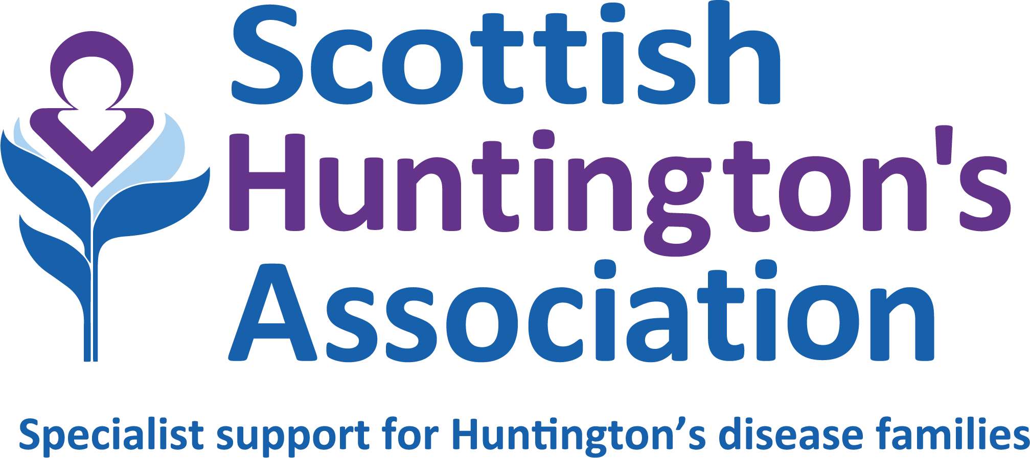

HUNTINGTON’S DISEASE SPECIALIST
PERSON SPECIFICATION

Region: West of Scotland
Base: Scottish Huntington's Association, Business First, Burnbrae Road, Paisley, PA1 2FB
Hybrid working model (combination of office/home-based)
Duration: Permanent
Hours: 30 (negotiable for right candidate/s)
Salary: £33,537 – £37,103 (pro rata as per 36 hour week)
Reporting to: Senior HD Specialist
Accountable to: Head of Services & Scottish Huntington’s Association Board

QUALIFICATIONS AND TRAINING | ESSENTIAL | DESIRABLE
Registered Nurse or other relevant health/social work qualification. | x
Qualified to 1st degree level. |  | x
Full membership of professional body relevant to qualification and able to work within the scope of registration guidelines. | x
KNOWLEDGE AND EXPERIENCE
Significant experience working in the community as a nurse or allied health professional. | x
PROFESSIONAL SKILLS
Clinical and interpersonal:  Ability to carry out complex specialist assessment and interpretation, followed by appropriate action.  Client care:  Ability to assess, develop and implement programmes of care with an inter/multidisciplinary approach.  Planning and organising:  Working as an autonomous practitioner, the HD Specialist must be able to manage own caseload whilst at all times being accountable for own professional actions.  Financial management:  - Management of inventories, payments and budgetary control as agreed by the direct line manager.  Education and training:  - Facilitation of learning for small groups including to paid and non-paid carers.  - Basic understanding of how adults learn.  - Ability to provide resources for service users.  - Production of literature for publication.  Research and development:  Ability to manage and undertake audits as necessary.  Supervision and support:  Ability to provide supervision and support to the admin/resource worker and students as agreed with the line manager in compliance with good practice.  Reporting:  Including carrying out audits, as necessary.  Staff/student supervision:  Supervising and supporting colleagues and students as agreed with direct line manager.  Knowledge of data protection and confidentiality:  Understanding and applying the principles of data protection and confidentiality across all areas of work.  IT skills:  Including Microsoft Office, PowerPoint and other relevant software programmes. | x  x  x  x  x  x  x  x  x  x  x  x
COMPETENCIES
Planning and organising  Will think ahead in order to establish an efficient and appropriate course of action for self and others, considering all relevant issues. | x
Analytical thinking  Can critically evaluate information and address limitations or errors. Has a good understanding of motives and behaviours. | x
Resilience  Maximises personal effectiveness by managing emotions in the face of pressure and complex situations. Demonstrates an approach to work that is characterised by commitment, motivation and energy. | x
Influence and persuasion  Presents sound and well-reasoned arguments to convince others, using a variety of techniques. | x
Developing others  Recognises and fosters the development potential in others. | x
Flexibility  Adapts and works effectively with a variety of individuals, groups and situations. | x
Teamwork/relationship management:  Building and maintaining relationships and working co-operatively and collaboratively. | x
ATTRIBUTES
A good communicator (face-to-face, online, virtual etc.). | x
Professional, diplomatic and able to maintain confidentiality. | x
Highly motivated and resilient with ability to maximise personal effectiveness by managing emotions when under pressure or facing complex situations. | x
Keen to share knowledge while learning from others. | x
Competence to plan, organise and manage multiple priorities and the ability to successfully prioritise tasks for yourself and your colleagues. | x
Effective time management skills and ability to meet deadlines. | x
Interest in developing and nurturing others to maximise potential. | x
OTHER
A clean driving licence and access to a vehicle daily. | x
Commitment to, and promotion of, equal opportunities and  anti-discriminatory practices at work. | x
Awareness of personal responsibility in relation to health and safety. | x
Willingness to undertake, and support others to, participate in professional development. | x

Jan 25

Registered with and regulated by the Office of the Scottish Charity Regulator No: SC010985, Scottish Huntington’s Association is a wholly Scottish charity and is registered in Scotland as a company No: 121496 Registered Office: Business First, Burnbrae Road, PA1 2FB

