

Organisational Profile

January 2025

www.communityenterprise.co.uk

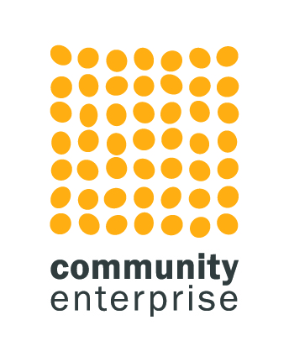

1. Background to the Organisation

1.1 Broader Context

Community Enterprise has been established for over 35 years and is one of Scotland’s leading social enterprise and community development consultancies and support providers. We provide support to third sector groups across Scotland and work with communities to build and sustain projects for the benefit of local people.

We have an expert team of 25 consultants and support staff and 10 accredited associates with a range of experience in the private, voluntary and public sectors. We take pride in the high quality of support we offer. We work with around 300 clients a year and build up close, and often long term, coaching relationships to help implement plans.

We are a social enterprise ourselves. 100% of our profits are re-invested in supporting the further growth and development of voluntary and community organisations. To do this we earn income from consultancy services.

We are involved in various national contracts, including Just Enterprise, the government-funded social enterprise development programme. We are on the HIE Support for Communities framework and run a national capacity-building programme called Accelerate. We are on the framework to support Community Ownership Fund bids for DTAS and the Architectural Heritage Fund. We are on the support framework for the National Lottery Heritage Fund and are contracted by The Robertson Trust to deliver business support to awardees. More recently, we are involved in offering crisis support to organisations in difficulties.

Our core work, however, is with community based organisations rooted in a geographical community seeking to create sustainable development and regeneration – our strapline is ‘helping people make good things happen’.

1.2 Our Services

Our focus is on developing sustainable communities through resilience using techniques including social enterprise, innovative fundraising and community empowerment. We have developed four interlinked divisions.

**The Group’s Services and Divisions**

1. Our **development team** develops enterprise, communities and organisations including strategic thinking, market research, business planning, evaluations, organisational reviews, community plans and investment readiness.

Our over-arching website has information about all our divisions, but this is a link directly to the work of the [development team](https://communityenterprise.co.uk/what-we-do/development).

1. We operate the first and biggest social enterprise strategic marketing and **creative design and branding agency**, called BOLD. Its services include branding, design and print, web design and build and creative marketing strategy. [Bold Studio - Community Enterprise](https://communityenterprise.co.uk/our-enterprises/bold-studio)
2. We deliver a social enterprise **digital agency**, soon to be launched as Breeze Digital. This will support the practical digitization of the sector from digital strategy to digital service design [Breeze - Community Enterprise](https://communityenterprise.co.uk/our-enterprises/breeze)
3. We have a research specific arm delivering pieces of work that respond to the big issues facing our sector [Research and Thinking - Community Enterprise](https://communityenterprise.co.uk/supporting-the-sector/research-and-thinking)
4. We are a strategic part of the sustainable third sector and provide **strength and capacity to the sector**. We were founding members of Social Enterprise Scotland and have a place on its Board of Directors. We are founding subscribers of the Voluntary Code for Social Enterprise and members of various national networks. We currently design and manage the [social enterprise support map](https://sesupportmap.scot/) and organise workshops and training and have a fast evolving research arm.

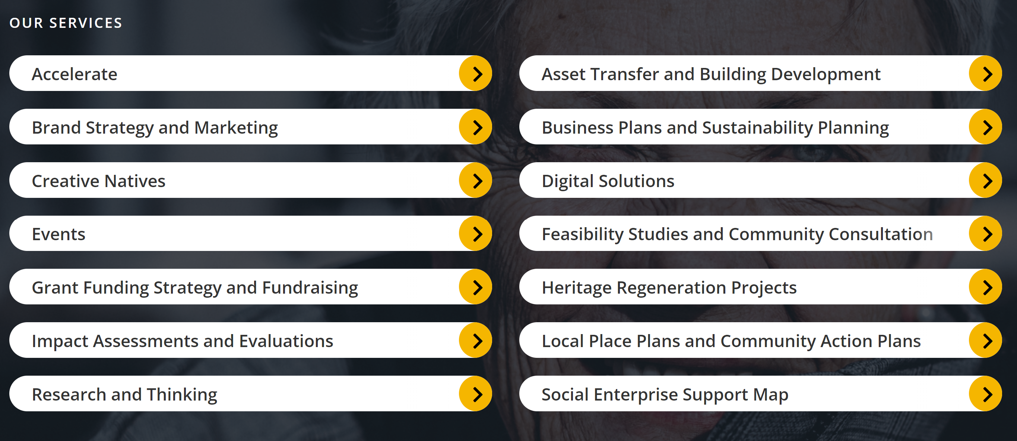

1.3 Company Details

|  |  |
| --- | --- |
| Company Structure | Community Enterprise is a company limited by guarantee with charitable status. CEL Trading is a company limited by shares that is a wholly owned subsidiary of Community Enterprise Ltd. |
| Registered Address | Main office: Suite 12a, Fleming House, Fleming Road Kirkton Campus Livingston EH54 7BN. Note: we have a studio in Glasgow but work is across Scotland. |
| CEL Trading Company number | SC142050 |
| Community Enterprise Ltd | Charity Number : SC006992  Company Number : 107265 |
| VAT number | 939 5323 95 |
| Insurance | We have full Public Liability and professional indemnity insurance up to £5m brokered by Keegan and Pennykid with Royal and Sun Alliance. We have £10m of employer’s liability, £5m of public liability and £5m of professional indemnity. |
| Website | [www.communityenterprise.co.uk](http://www.communityenterprise.co.uk) |
| Twitter | @CommEnterprise |

