

Dundee International Women’s Centre

Team Leader

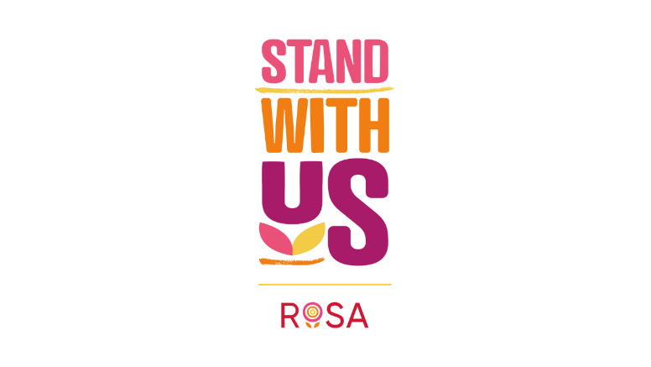

Dear Applicant

Thank you for your interest in applying for a post with Dundee International Women’s Centre (DIWC).

Please find enclosed the following documents:

- Background and History of DIWC
- Advice on completing the Application Form
- Job Description and Person Specification

Please do not send a curriculum vitae as this will not be considered.

Previous applicants need not apply.

Please note, all applications and relevant recruitment documents will be held confidentially and destroyed after 6 months, apart from application documents relating to the successful candidate.

Your completed application should be submitted via email by sending it to mail@diwc.co.uk.

Closing date for applications is Sunday 2nd March 2025 at midnight. Please note that applications submitted after this date and time will not be accepted.

Interviews will be conducted on Tuesday 11th March 2025

Please note this post is 20-hour post.

We look forward to receiving your completed application form.

Enquiries about this position are welcome by emailing mail@diwc.co.uk

Yours sincerely


Kristina Piggott
Manager Strategy and Operations

Dundee International Women's Centre
Unit 9B, Manhattan Business Park,
Dundonald Street, Dundee
DD3 7PY

Background of Dundee International Women's Centre (DIWC)

DIWC has been in existence for over 55 years and aims to promote and create opportunities for women's social, political, and economic inclusion and for the advancement of education. The Centre has developed an expertise in working with women, particularly those from black and ethnic minority communities, living in Dundee and surrounding areas and runs a programme of social, recreational, and educational activities.

DIWC reviews its aims and objectives on an annual basis, setting out clearly the work of the Centre for the forthcoming year. In order to ensure the effective implementation of these objectives each staff member is expected to contribute to the planning process and to prepare and work to an individual work plan in relation to their key areas of work.
Our values are: Trust, Respect, Support, Equality, Approachability

Post Title: | Team Leader
Responsible to: | Manager for Strategy and Operations
Salary: | £19,928 per annum (based on a 20-hour work week)
Hours of Work: | 20 Hours per week (funding secured for 12 months in the first instance, with a 6-month probationary period)
Location: | Office based in Dundee International Women's Centre. Remote working is not available due to the nature of the role.
Main purpose: | To inspire and lead a talented project team of 8 staff members, offering day-to-day guidance, motivation, and support while maintaining clear, accurate records of all supervision and appraisals. To review our Violence Against Women provision to enhance our services, helping more women make informed choices about their futures while ensuring they receive the support they need.
Closing Date: | Sunday 2nd March 2025 at midnight
Holidays: | 38 days annually for full-time employees, comprising 31 days of annual leave and 7 bank holidays (pro rata for part-time employees).
Pension: | Employer contribution at 3%

This post is exempt under Schedule 9 of the Equalities Act 2010 and is open to women only.

ADVICE ON COMPLETING YOUR APPLICATION FORM

As part of DIWC’s commitment to equal opportunities, candidates for each post are treated equally and fairly. Application forms are the only basis on which the first selection is made to decide who will proceed to the next stage of recruitment. Therefore, only information which appears on the form (and any continuation pages) can be considered. It is very important that your completed form contains both the information we need about your skills and experience and the information you want to give us to showcase your skills and experience.

The following advice notes are intended to help you to complete your form effectively.

1 Please read all the information provided, especially the job description, job tasks and person specification. These outline the key duties you would be expected to carry out in this post, and lists the skills, knowledge, and abilities that the short listing/interview panel will be looking for.

2 The ‘Why are you suitable for this position?’ section is your chance to explain why you are suitable for the job. It is not enough to say you have the experience – you must demonstrate experience and skills with specific examples. Relevant experience may be from your current or previous jobs or volunteering and life experiences.

3 Please do not send your CV in addition to or in place of a completed application form, as it will not be considered by the short-listing panel.

4 All applicants must complete all parts of the application form.

5 Application forms must arrive on time; forms arriving after the closing date and time will not be considered.

6 If you do not wish one or all references to be contacted before interview please indicate on the relevant page. It is our policy not to make a job offer without taking up references.

Please email any questions relating to the application form to mail@diwc.co.uk

JOB PURPOSE
To inspire and lead DIWC’s dynamic project team, driving excellence in service delivery and fostering a supportive, high-performing environment. This pivotal role will enhance the centre’s operational effectiveness, continuing to empower the team to make a meaningful impact in the community. By taking on key operational responsibilities, the Team Leader will enable the Manager to focus on strategic growth, securing funding, and ensuring DIWC’s long-term sustainability. This is an exciting new role created for the centre in 2025, offering a unique opportunity to make a significant impact.

MAIN DUTIES

- Team Leadership and Management
- Inspire and lead a talented project team of 8 staff members, offering day-to-day guidance, motivation, and support while maintaining clear, accurate records of all supervision and appraisals.
- Facilitate meaningful connections by organising regular team meetings, appraisals, and one-to-one sessions that priorities professional growth, effective communication, and shared goals.

- Drive impactful events, overseeing the planning and delivery of initiatives that reflect DIWC’s mission and address the needs of the community.

- Cultivate a thriving team culture by developing and implementing strategies that foster collaboration, innovation, and a supportive work environment.

- Build Manage HR functions for the team, ensuring all required documentation is accurately completed and maintained in line with organisational policies and procedures.

- Operational Support and Evaluation

- Monitor and manage daily workload, ensuring the smooth running of projects and services.

- Maintain and uphold the health and safety standards at the centre.

- Assist in preparing operational and financial reports that meet organisational and funder requirements in partnership with the Manager and Evaluation and Impact Officer.

- Oversee the induction process for new staff, volunteers, and students to ensure they are well prepared for their roles.

- Evaluate the success and achievements of the Project Team against agreed targets, identifying strengths, weaknesses, and areas for improvement.

- Ensure staff maintain accurate records and complete monitoring information on time.

- Provide regular reports and updates to the Manager and Board of Directors.

- Strategic Contribution

- Work closely with the Manager to develop and implements organisational strategies that strengthen DIWC’s impact.

- Act as a liaison between the team and external stakeholders, fostering strong partnerships with organisations across Dundee.

- Contribute to DIWC’s efforts to secure funding by supporting applications and helping demonstrate the effectiveness of the team leader role in collaborations with the Manager and Evaluation and Impact Officer.

- Community and Service Development

- Ensure the delivery of consistent and high-quality support and services for learners and participants, directly benefitting their learning outcomes and well-being.

- Collaborate with staff and learners to gather feedback, using insights to improve events, activities, and services offered by DIWC.

- Support the manager in developing a long-term fundraising strategy to reduce reliance on grants and secure sustainable funding.

- To review our Violence Against Women provision to enhance our services, helping more women make informed choices about their futures while ensuring they receive the support they need.

- General and Other Relevant Duties

This job description is a broad picture of the post at the date of preparation. It is not an exhaustive list of all possible duties, and it is recognised that jobs change and evolve over time. Consequently, this is not a contractual document, and the post holder will be required to carry out any other duties to the equivalent level that are necessary to fulfil the purpose of the job.

DUNDEE INTERNATIONAL WOMEN'S CENTRE

PERSON SPECIFICATION – Team Leader
All aspects are evaluated through the application form and interview.

 | Essential | Desirable
Professional Education and Qualifications | A Management/Leadership Qualification. | A Community Education qualification.
Relevant Work Experience | Clear understanding of management, leadership and supporting staff & volunteers. | Experience in the voluntary sector or working with marginalised communities.
 | Experience of writing reports. | Knowledge of funding applications and reporting requirements.
 | Experience of networking and liaising with agencies and other groups. | Understanding of health and safety standards in a community-based setting.
 | Knowledge of adult and child protection policies and procedure | Experience of chairing meetings and/or facilitating working groups.
 | Experience in conducting in-person service reviews and identifying the needs of beneficiaries | Experience of supporting women from BME communities affected by or experiencing Violence Against Women.
 |  | Experience of developing, delivering, and evaluating training.
 |  | Knowledge and understanding of issues for voluntary sector.
Skills and Knowledge | Strong planning and organisational skills and the ability to manage multiple priorities. | Monitoring, data analysis, and evaluation skills.
 | Excellent communication and interpersonal skills to build relationships with diverse stakeholders.
 | Good IT Skills including proficiency in Microsoft Office including SharePoint, TEAMS, and Outlook
Personal Qualities | Commitment to DIWC’s mission to empower women and support BME communities.
 | A resilient approach to the workplace and clear strategies for managing self.
 | A ‘can-do’ attitude, with the ability and willingness to problem solve, involving others when necessary.
 | High level of personal commitment to promoting equality and diversity.
 | Ability to be flexible and respond to crises in a calm and reassuring manner.
 | Strong team player, committed to an ethos of continuous professional improvement.
 | Fluency in written and spoken English | Bi- or Multi-lingual
Additional Job Requirements | Must be a member of the PVG Scheme or willing to join, with a satisfactory scheme record and/or an updated scheme record.
 | Ability to work from the centre, with flexibility to work evenings and weekends as needed to support the needs of DIWC.

