Job Profile: The Bank Dunblane Community Venture Project Lead
Position Title: Community Venture Project Lead
Location: Dunblane, Scotland, United Kingdom.
Base: The role will initially be home-based while the development of the building is done, with meetings and engagement being undertaken regularly in Dunblane and the surrounding areas. Once the venue is operational it is expected to be office-base.
Salary: £35,000 per annum, pro rata for part time hours.
Hours: Full time hours 37.5 hours per week. This role is proposed to start as part-time (22.5 hours per week), then move to full time in October 2025.
Contract: Permanent
Start Date: May 2025 (negotiable)
Annual Leave Allowance: 25 days + bank holidays
Reports To: Dunblane Square Ltd. Board Chairperson
Project Summary:
Dunblane Square has been established with the main aim of developing and operating a multi-functional arts, tourism, hospitality and community centre – The Bank.
Through a grant from the Government's Community Ownership Fund, a vacant ex-bank building in Dunblane town centre has been acquired by the community and grant money has been secured for the first phase of the development.
This is an exciting opportunity to join us to lead on planning for and managing operating The Bank, which will provide a much-needed central social arts area space for members of the community and visitors alike to visit and socialise. We will host a community cinema, music, talks, tourist information and different food events creating employment and volunteering opportunities focusing on young people.
Project Stage:
The project was launched in Nov 2022, and Dunblane Square was formalised in July 2023. We have developed links with community organisations and letters of support from local politicians and organisations. We have undertaken a community-led approach, gathering feedback and ideas for how The Bank should be run. This was developed into a detailed design which has gone through planning. We are currently undergoing the tender for the first phase of two for the building works, and the venue is planned to be operational in November. There is more information about the project on our website: https://thebankdunblane.org.

Job Summary:
The Community Venture Project Lead will be responsible for engaging the community, defining, and delivering a comprehensive community project that includes a hospitality offering, cinema, and music programme in a community-owned building currently under development. This role requires a dynamic individual with strong leadership, project management, and community engagement skills and has experience in Arts and running a multi-use community Centre with Commercial experience. Note, the development/construction is being overseen by others, but there will be an element of coordination. No experience in construction is required.
Where this role sits within The Bank planned/aspirational organisational chart:
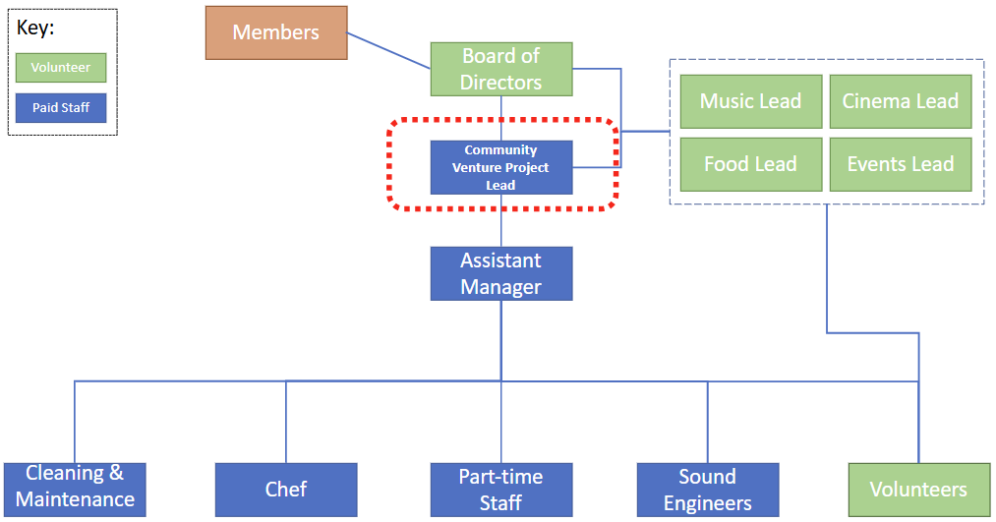

Key Responsibilities:
- Community Engagement:
  - Develop and implement strategies to engage the local community in the project.
  - Organize and facilitate community meetings, workshops, and events to gather input and feedback.
  - Build and maintain strong relationships with community members, local businesses, and stakeholders.

- Project Definition and Planning:
  - Define the scope, objectives, and deliverables of the community project.
  - Develop detailed project plans, including timelines, budgets, and resource allocation.

- Project Delivery:
  - Oversee the execution of the project with a focus on Programming of activities and offerings (not building works) , ensuring they are completed on time, within budget, and to the required quality standards.
  - Manage the hospitality offering, cinema, and music programme, ensuring they meet the needs and expectations of the community.
  - Monitor and report on project progress, addressing any issues or risks that arise.

- Marketing and Promotion:
  - Develop and implement marketing strategies to promote the community project and its offerings.
  - Create promotional materials, manage social media accounts, and engage with local media to raise awareness.

- Financial Management:
  - Develop and manage the project budget, ensuring financial sustainability.
  - Identify and secure funding opportunities, including grants, sponsorships, and donations.

- Evaluation and Improvement:
  - Collect and analyse feedback from the community and stakeholders to evaluate the success of the project.
  - Implement improvements based on feedback and lessons learned.
  - Provide regular reports to the Board
Skills Required:
- Education: Bachelor’s degree in project management, Community Development, Business Administration, or a related field. (Desired not essential)
- Experience: Minimum of 5 years of experience in project management, community engagement, or a related role.
- Skills:
  - Experience in Fundraising and bid writing
  - Strong leadership and organizational skills.
  - Excellent communication and interpersonal skills.
  - Ability to manage multiple tasks and projects simultaneously.
  - Proficiency in project management software and tools.
  - Knowledge of hospitality, cinema, and music programme management is a plus.
  - Networking and relationship building with other community groups and businesses.

Personal Attributes:
- Passionate about community development and engagement.
- Creative and innovative thinker.
- Strong problem-solving skills.
- Ability to work independently.
- Flexible and adaptable to changing circumstances.
Applications
Please apply by sending a CV and covering letter to Kirsty@thebankdunblane.org.
Deadline Friday 4th April

