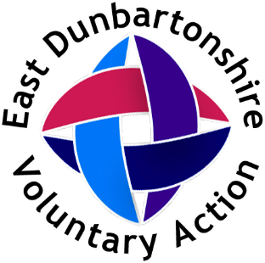

Recruitment Pack
Communications and Business Support Officer

Role Details:
Part-time (21 hours per week)
Permanent Contract
Salary £24260.60 per annum (pro-rated salary £14556.36 )
Base: EDVA office, 18 Townhead, Kirkintilloch G66 1NL (occasional hybrid working possible by arrangement with manager)

About East Dunbartonshire Voluntary Action:
East Dunbartonshire Voluntary Action (EDVA) is a charity. We are the Third Sector Interface (TSI) in East Dunbartonshire. Our main source of funding is from the Scottish Government, who fund a network of 32 TSIs across Scotand and we work to 4 key priority areas:
Building Capacity – We help community groups and organisations to become established, grow, and utilise good practice so they are well equipped to deliver their purpose.
Sharing Knowledge and Information – We help to share information about the sector and with the sector
Ensure Voice – we advocate for the Third Sector
Building Positive Connections – we help connect organisations and volunteers, help connect organisations with each other and with statutory partners, enhancing their ability to strengthen communities in East Dunbartonshire through collaboration, inclusion and involvement.
Our office in Kirkintilloch has 2 tenant organisations who sublet space and in addition we have meeting room space which can be hired by local organisations, statutory sector or businesses.

About the role:
We are looking to recruit a Communications and Business Support Officer who will perform a vital role in enhancing our visibility as an organisation and increasing our ability to achieve our aims through effective use of communications including social media and our website . The role also supports the smooth running of our office through some administration for our room hires and for our wider areas of work . More detailed information can be found in the job description. This role will suit someone with strong organisation skills and experience of using social media and websites for business purposes. Our business hours are generally 9-5, Monday to Friday with very occasional evening/ weekend work and we have some flexibility as to which days/ times could be adopted as the work pattern.

Job Description:
Production of social media posts using a variety of platforms including Facebook and Instagram
Production and distribution of a weekly electronic “noticeboard” sharing info of relevance to the Third Sector and partners
Production and distribution of a quarterly e-bulletin
Production and distribution of information about volunteering opportunities
Ensuring our website information is kept up to date, including our online training and information resources
Co-ordinating (along with the Business Support/ Finance Officer) the servicing of room hires – setting up/ clearing the rooms, arranging refreshments, taking bookings
Administrative support (this is minimal but may include data entry, production of data reports, production of letters etc.)
General reception duties – welcoming visitors, answering the general phone, checking and forwarding emails that come into the general email account, and opening /closing the office as part of shared duties with other team members
Any other relevant duties as required by the Chief Officer

Skills/ Experience:
Proficient in use of MS Office including Teams, Word, Outlook and Excel | Essential
Experience in Publisher/ Canva or other graphic design programmes | Desirable
Experience in using software such as Mailchimp and Cognito Forms | Desirable
Experience in using Facebook, Instagram, and X for business purposes | Essential
Experience in use of contacts databases such as Salesforce | Desirable
Experience in a customer/ client facing environment | Essential
Used to working as part of a team | Essential
Used to being a self- starter, requiring minimal supervision | Essential

To apply please complete the application for and return it to Ann Innes ann.innes@edva.org by Friday 21st March, midnight.
For an informal chat about the role please contact Ann Innes, Chief Officer, at the above email address.

