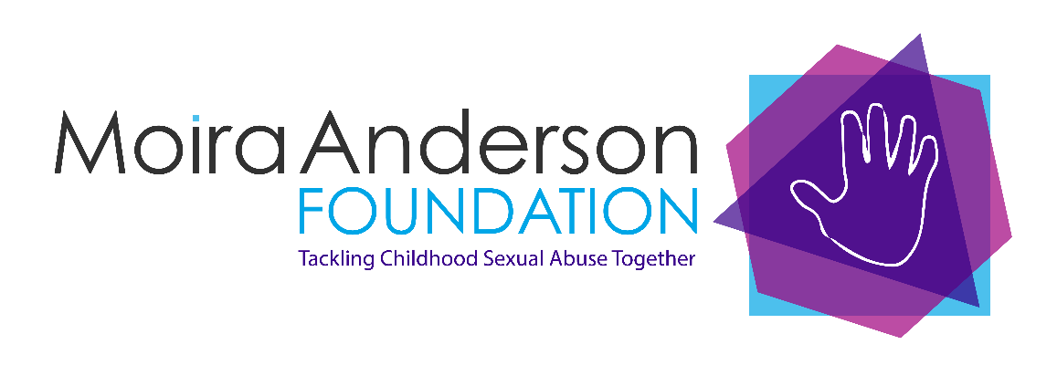

Moira Anderson Foundation

Administrator

Job Title: Administrator (Glasgow Hub)
Service: Moira Anderson Foundation – Glasgow Hub
Responsible to: Board of Directors
Reporting to: MAF Glasgow Hub Manager
Location: Buchanan Street, Glasgow

Terms of employment: April 2025 – March 2027 (continuation of contract dependent on future funding)
14 hours per week, over 3 days Wednesday - Friday (possible evening cover required)

Salary: £22,932 per annum pro rata
Pension: Excellent terms – After a postponement period of 3 months, dependent on eligibility, we will pay 8% of basic salary, employee contribution of minimum 1%. Opt out available
Benefits: Death in service benefit – after postponement period
Annual Leave: 23 days per annum, rising one per year (after first year) to a maximum of 26, plus 12 public holidays – pro rata

Purpose of Job: We are seeking a warm, enthusiastic, and committed person to provide administrative and reception support, for our Glasgow Hub service. You will be the first point of contact for people seeking support and referring organisations. Initial training will take place in our Glasgow Hub premises. You may be required to attend training and meetings in Airdrie on an intermittent basis.

Main duties and responsibilities:

- To uphold and integrate MAF values of trust, integrity, compassion and resilience into your work with clients, communications with colleagues and relationship building with external agencies.

- To welcome visitors to the premises in a warm and friendly manner.

- To operate a web-based telephone system

- To provide photocopying/filing/emails/word processed letters to support project staff

- To organise and co-ordinate client appointments via database/telephone

- To co-ordinate client appointments and room bookings

- To liaise with project staff and therapists as required

- To liaise with volunteers as required

- To set up rooms as required for project activities

- To organise catering as required for project activities

- To record petty cash/banking

- To record therapy hours and process therapists’ invoices for payment

- To record and collate client assessment and evaluation information

- To provide statistics and information for board and funding reports

- To be responsible for procurement and stock control

- To assist in promotional events and training

- To post on social media and update MAF’s website as required

- To provide any other ad hoc duties to support the Hub Manager

Person Specification

Qualifications:

Educated to Higher level. Previous experience of working in a role of this type will also be considered

Experience and Knowledge:

Experience and a good working knowledge of Microsoft Office packages

Previous general office experience

Experience of dealing with the public, ideally in a caring environment

Knowledge of the use of social media

Awareness of the sensitive and confidential nature of the charity’s work

Skills and Abilities

A good standard of English for communications, excellent organisational skills for database/record keeping

Excellent keyboard and IT skills

Ability to maintain diaries, schedule and coordinate meetings and appointments

The ability to work on your own initiative, as well as part of a team

Excellent inter-personal skills and a first class telephone manner which are essential to the ethos of the Foundation

The successful candidate will be subject to a Criminal Convictions check through Disclosure Scotland

The Moira Anderson Foundation is an Equal Opportunities Employer and a Real Living Wage employer. We encourage applicants with diverse backgrounds and experience to apply. If you have any specific access requirements, please let us know and we will do our best to meet your needs.

For an informal conversation regarding this post please contact Janine Lamont at janinelamont@moiraanderson.org or call 01236 602890

