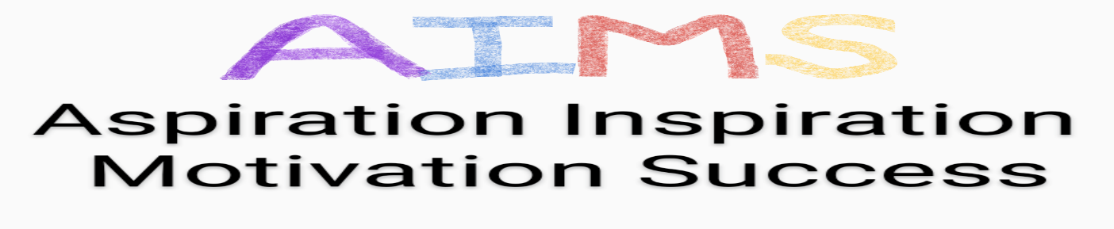www.aims-project.co.uk
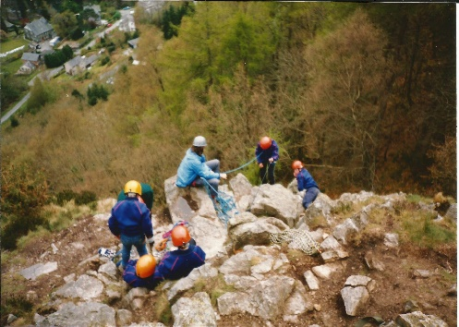

The AIMS Project is a new Project set up in Coatbridge to provide help to young people aged 14-18 years, who require a little extra support to enable them to flourish in Training, Education and Employment opportunities.

At AIMS, we will work with young people with;
- mental health issues
- difficulties attending school
- difficulties being in large groups
- caring responsibilities
- issues with confidence and self-esteem
- health difficulties
- family issues
- difficulties making friends
- communication issues
- anger-management issues
- limited aspiration
- few or no qualifications
- no direction in life
- literacy/ numeracy difficulties

The AIMS Project, Suite 30, Atrium Business Centre, North Caldeen Road, COATBRIDGE, ML5 4EF
At AIMS we believe in the potential of each young person. We believe in second chances and fresh starts. We believe that improved confidence, self-esteem, motivation, communication and trust will provide the foundations for further achievements.

Our Projects are “activity-based”, offering small group-work and intensive goal-setting support. Our support is tailored to individual young people.

At AIMS we believe we can maximise outcomes for each young person and help them to progress to appropriate Training, Education and Employment options, with ongoing support from the AIMS Team.


For more information, please contact:

Email: traceyataims@yahoo.com
Phone: 07510352769
Website – www.aims-project.co.uk


