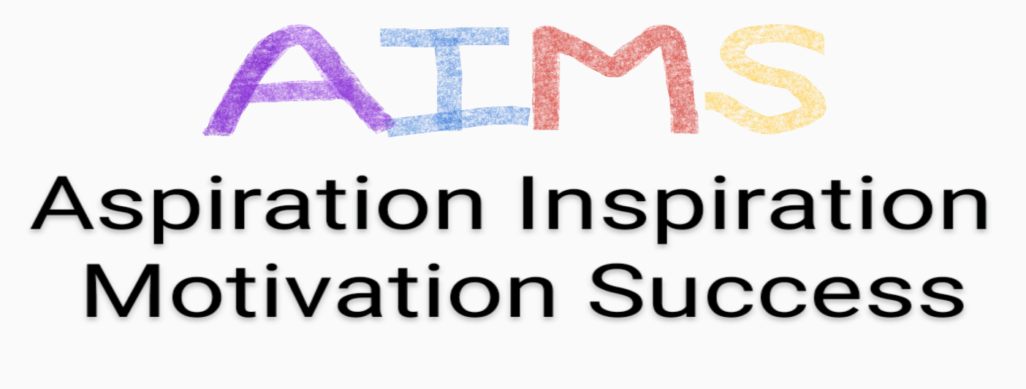

1. AIMS Project Manager

Main purpose of job
To provide individual, motivational, programmes of support to young people aged 14-18 years with a broad range of mental health and wellbeing development needs.
To support young people to have improved self-belief and from this point, the courage to embrace a broader range of options and have improved life chances and outcomes.
To encourage young people to take part in all activities and experiences offered by The AIMS Project.

Main duties
- To be non-judgemental, supportive, encouraging and nurturing to the young people engaged with AIMS, at all times.
- To support young people to achieve individualised Personal Goals.
- To facilitate the provision of a safe and supportive “listening space” for young people.
- To contribute to the staff team to encourage young people to take part in all aspects of the AIMS Project, activity-based, learning offer.
- To be motivated, nurturing, caring, inclusive and creative in the training sessions offered to young people.
- To maintain the highest standards of confidentiality, health and safety and risk assessment in all aspects of delivery.
- To lead in group sessions, facilitating involvement of all young people.
- To maintain professional relationships with all external Referral sources, Partner organisations and parents/ guardians.
- To complete all records and paperwork effectively and timeously, adhering to all standards of confidentiality at all times.
- To contribute positively to the AIMS Team, supporting colleagues and young people at all times.

The above, provides an outline of the duties of an AIMS Support Worker. By its’ nature a Job Description cannot describe all duties and expectations of the role given the fact that Project seeks to constantly evaluate the effectiveness of delivery and proactively pilot new approaches, Projects and activities as these are identified.
The postholder will be expected to constantly represent the organisation positively and to work constructively to meet the organisation’s key aims at all times and in doing so, maximise outcomes for our young people.

Reporting
The AIMS Support Worker will report directly to the Project Manager and in their absence the, Chair of the Board.

