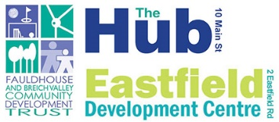

Fauldhouse and Breich Valley Community Development Trust
Aims to address issues, concerns, needs, aspirations which relate to the social, economic, physical, environmental health, well-being, and regeneration of our communities. Relieve poverty, advance education, address exclusion, and disadvantage.
We have a wide range groups & projects: Anti-Poverty Projects, Communication & Engagement, Range Community-Based Projects (Social Prescribing Model) education, skills development, advice, information, support, services, and volunteer led opportunities. We employ 4 full time members of staff, 5 part time.
We have conducted several community consultations and research projects since the Trust was established in 2006. This has allowed us to gather and disseminate essential information within our communities. This helps us to formulate community led, community driven responses to local issues and needs. We have further developed our services and resources to confront and address the lasting consequences and effects of the Pandemic, and the cost-of-living crisis.
It is through our community development work, our community consultations, and experience of working within the local community that we have identified the need for the Mental Health and Wellbeing Project.
For further information on our Services and Resources please see our website www.fauldhouse.org.uk
Or call Julie Smith on 01501 773 699
Email: julie.smith@fauldhouse.org.uk

