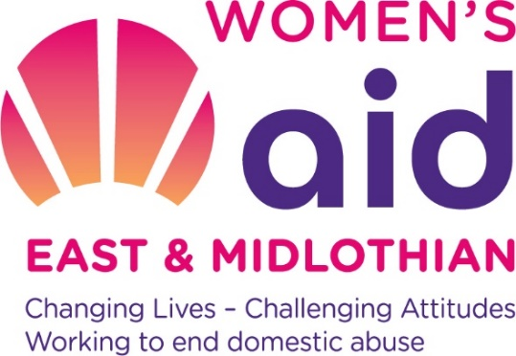
WANTED - Women who want to make a difference
Women’s Aid East and Midlothian (WAEML) aims to empower women until all women, children and young people are free and safe from domestic abuse. We want to invest in the future leadership of our organisation and are currently looking for new trustees to join our board of directors.
We’re looking for creative and innovative feminists who can add to the skills mix of our current trustees, share our core values, have a passion for women’s and children’s rights and uphold our commitment to equality, inclusion and opportunity for all.
We’re in an exciting new phase of growth as we develop our new empowerment centre in Eskbank, and particularly welcome applicants who can demonstrate skills and experience any of the following areas:
- Fundraising and income generation
- Property management
- Finance
- Marketing and PR
- Digital
We are always keen to improve the diversity of our Board and particularly welcome applications from women in black and ethnic minority and /or disability communities.
As a Trustee you will have:
- A full induction, training and mentoring
- The opportunity to decide if the role is right for you by attending 2-3 board meetings with other trustees and staff
- Reimbursable expenses
- The chance to develop new skills and make collective strategic decisions which will make a real difference to women and children’s lives.
The expected time commitment is full preparation for six trustee meetings per year (meetings are held on the first Wednesday of alternate months between 6.30pm-8.30pm, either in person at Eskbank, or online), plus one full day strategy/development meeting, and regular contributions to one of our four sub-committees.
Whether you’re an experienced trustee or wanting to take your first step at board level, we want to hear from you. If you’d like to find out more about what is involved in being a trustee at WAEML contact: info@womensaideml.org.
Application

Applications are welcome from women only, under Schedule 9, Part 1 of the Equality Act 2010. Please submit the Board of Director application form (attached) by email. Please write WAEML Board application in the subject line. Applications should be received by 5pm on Wednesday 16th April 2025 to Julie Watson: julie@womensaideml.org

Shortlisted applicants will be invited to an interview during April/May.

