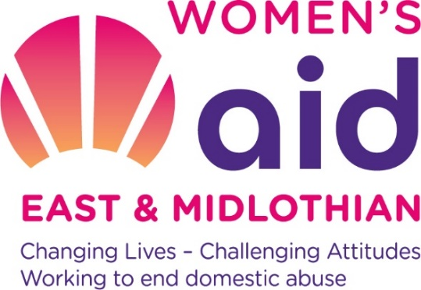
Info for Applicants
WANTED - Women who want to make a difference
Women’s Aid East and Midlothian (WAEML) aims to empower women until all women, children and young people are free and safe from domestic abuse. We want to invest in the future leadership of our organisation and are currently looking for new trustees to join our board of directors by the end of the year.
We’re looking for creative and innovative feminists who can add to the skills mix of our current trustees, share our core values, have a passion for women’s and children’s rights, and uphold our commitment to equality, inclusion and opportunity for all.
We’d like to thank you for your interest in becoming a trustee with WAEML and outline what will happen next.
- In order to progress with this, we now need you to complete the enclosed application form. After this we will arrange to have short interview where you can find out more about the role, we will send out our proposed questions to you beforehand.
- If successful in your application we will then need to check references and will invite you to attend 2-3 board meetings. Here you will get access to our board papers and observe board discussions but will have no voting rights. You will have the opportunity to have an informal chat with one of our trustees both before and after the meeting, and decide if the commitment is right for you and you’d like to take up the role of trustee with us during 2025.
- We will then discuss when you can start with us as a trustee during 2025, as some of our long-serving trustees step down and their roles become vacant on, or before our AGM on 3 December 2025.
As a Trustee you will have:
- A full induction, training and mentoring
- The opportunity to decide if the role is right for you by attending a board meeting with other trustees and staff
- Reimbursable expenses
- The opportunity to develop new skills and make collective strategic decisions which will make a real difference to women and children’s lives.
As an organisation we need:
Passion and commitment for our values and our work. The expected time commitment is full preparation for six trustee meetings per year (meetings are held on the first Wednesday of alternate months between 6.30pm-8.30pm, either in person at Eskbank, or online), plus one full day strategy/development meeting, and regular contributions to one of our four sub-committees.

