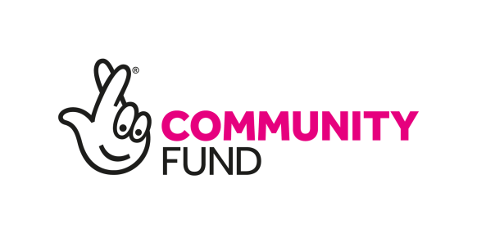
JOB DESCRIPTION

Job Title: IN-Ren Network Facilitator
Location: Based at Engage Renfrewshire offices with travel across Renfrewshire required
Salary: £34,602 per annum
Hours: 35 Hours per week (part-time considered, salary to be understood to be pro rata in such cases)
Contract: Funded post to July 1st 2026
Subject to: 2 references and a PVG check

Job Purpose:

Renfrewshire is committed to finding ways of reducing inequalities and improving quality of life for our diverse ethnic communities, through systemic change and cultural understanding.

IN-Ren (Integration Network Renfrewshire) is a forum acting to ensure that ethnically diverse communities’ voices are being heard and involved in local services and decisions.

The IN-Ren Network Facilitator (funded by The National Lottery Community Fund) will:

- support improvement and change through awareness of, and access to, services available to the ethnically diverse communities of Renfrewshire
- support the promotion and awareness of a wide range of programmes, developed and delivered by IN-Ren members, aimed at reducing barriers to employment, health and cultural activity
- support community cohesion by supporting cultural programmes including events and campaigns
- further develop the membership of the Integration Network for Renfrewshire (IN-Ren)

The IN-Ren Network Facilitator will support an approach that includes a commitment to developing strong, sustained advocacy by empowering participants to act as local advocates themselves, and their growing communities.

The IN-Ren Network Facilitator will be aware of the need to empower participants to build well-resourced structures that have confidence, skills, and trusted relationships with local statutory partners at their core.

Key responsibilities:

Community cohesion and integration

- Work on the ground to build cohesion between host communities and ethnic-led organisations/ organisations that work with ethnically diverse communities (IN-Ren members)
- Support third and public sector organisations in mainstreaming equalities by sharing appropriate guidance and training, and advocating for lived experience voices where possible
- Manage a micro-grants programme, to be accessed by IN-Ren members, to further promote cohesion, integration and capacity building
- Utilise Engage’s stakeholder networks to build relationships between local people from diverse backgrounds and colleagues from across a range of services, including health, employability and cultural services
- Empower IN-Ren members to build awareness and knowledge of civic responsibilities and means of civic participation

Supporting development and representation of members
- Act to increase the awareness of, and accessibility to public and third sector services
- Amplify the voice of the diverse ethnic community in Renfrewshire in community planning networks, health networks and employability networks
- Promote good news stories from around the network and encourage groups to collect and share data, stories and experiences to better inform services
- Availing the IN-Ren network of information, training/collaboration/funding opportunities, and networking opportunities within the third sector
- Build the capacity of ethnically diverse community members to engage with voluntary sector supports and advice groups
- Promote culturally sensitive leadership and advocacy training and opportunities, both from within the network, and from wider sources
- Support the growth of the IN-Ren Network

Reporting on outcomes and connecting with wider policy and inclusion initiatives
- Report quarterly and annually on outcomes and successes
- Build awareness and assess the impact of the existing IN-Ren Race Equality Toolkit
- Work as a member of Engage Renfrewshire’s Community And Voluntary Action (CAVA) team, promoting its existing services (Volunteering, Social Enterprise, and Funding and Organisation Development) to members of ethnically diverse communities
- Understand and connect with the aims of Renfrewshire’s Community Planning Partnership
- Connect with Scottish Refugee Council’s Integration Networks, and promote appropriate work to IN-Ren members

Additional Duties
It is in the nature of the work of Engage Renfrewshire that tasks and responsibilities are often unpredictable and varied.
All staff are expected to work in a flexible way when occasionally tasks arise which are not specifically covered by a job description. These additional tasks will normally be to cover unforeseen circumstances of changes in work or emerging local agendas and will normally be compatible with the job-holder’s regular area of work or previous experience. If the additional duties become a regular or frequent part of the jobholder’s duties it may be included in their job description in consultation with the member of staff.
Typical working hours are 9am – 5pm Monday to Friday but occasional evening and weekend work will be required to attend community based meetings and events or to meet with volunteer led groups.

Person specification

Essential:
- Experience of working with seldom heard groups
- Lived experience of ethnically diverse communities or experience working with ethnically diverse groups
- Experience of collaborative working with other organisations and/or cross-sector working
- Ability to work effectively remotely, and efficiently using online meeting tools
- Experience of contributing to and implementing network and communications plans
- Experience of working with volunteers and voluntary agencies
- Experience of recording and utilising data for reporting
- Experience of contributing to campaigns and/or running events
- Ability to represent Engage Renfrewshire at inter-agency meetings and events
- Ability to be well organised and to use initiative
- Excellent inter-personal, communication and problem solving skills

Desirable:
- An understanding of aims of the Race Equality Framework for Scotland
- Ability to use online platforms including social media to develop and promote campaigns and networking opportunities
- Experience of gathering and repurposing case studies, testimonies, photos and quotes

Application
To apply, please send CV and covering letter to info@engagerenfrewshire.com
Closing date: Friday 11 April 2025
Notification by: Wednesday 16 April 2025
Interview date: 24 April 2025 PM, in person at Engage Renfrewshire offices

For more information please contact info@engagerenfrewshire.com

