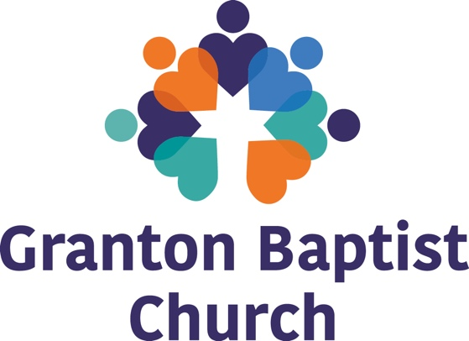

Application Form for Family and Youth Worker 2025
Once completed, please submit this form alongside your CV to admin@grantonbaptist.org
Closing date is 14 April 2025

- Please tell us why you are the best candidate for the position of Family and Youth Worker at Granton Baptist Church
- Please tell us about your Christian Faith and how you meet the occupational requirement of having an active Christian Faith.
- Do you have the right to work in the UK? YES / NO

