**Information for Candidates - About WPCC and how to apply**

# Introduction to the organisation

Westfield Park Community Centre SCIO (WPCC) is based in Falkirk, serving the Middlefield area, see map below:

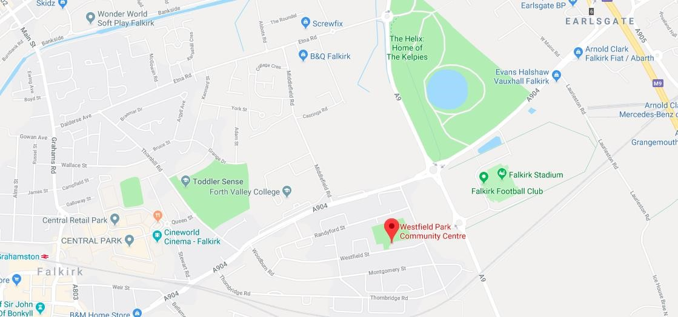

The centre has a large hall, a community café, an all purpose meeting room, football changing facilities and an office.

The WPCC offers a programme of activities and events, please see current schedule of the regular activities at the bottom of this document.

There is scope to increase the range of activities / services in the interests of reaching all sections of the community.

There is currently a staff team in place with a Centre Manager, Caretaker and Cleaner.

There are a board of 9 Trustees including a Chairperson, Secretary and Treasurer who oversees the organisation and community centre.

In addition, there are a team of regular volunteers running the youth club, the community café and other activities.

You can find out more on the [WPCC Facebook page](https://www.facebook.com/pages/category/Community/Westfield-Park-Community-Project-1010535109012947/).

# How to apply for the role

The closing date for applications for the role is 28th April 2025

Please fill out the application form. Applications returned by should be marked clearly with to with “Confidential - Job Application” in the subject line and sent to: **manager@westfieldparkcc.org.uk**

Alternatively, applications may be posted to, or handed in, to Westfield Park Community Centre, Westfield St, Falkirk FK2 9DX. Please mark the envelope “Confidential - Job Application”.

Any questions about the job vacancy and WPCC, please contact Angus on 01324619817 or **manager@westfieldparkcc.org.uk**

Interviews will be on Friday the 21st February 2025

Attached: typical schedule of regular activities.

