A Picture of Viewpark Church.

Viewpark Church seeks to follow Jesus’ command: ‘*love the Lord your God with all your heart, soul and strength and go into the world and make disciples.’* We seek to do this through the variety of our worship opportunities, nurture programmes, social gatherings and reaching out to our community.

Within this context Viewpark Church promises that everyone will be warmly welcomed and they will find their place within the church family. It is a place where everyone can find love, understanding, acceptance and hope. A place which ministers to the whole person; spiritually, emotionally, physically and socially.

We give everyone the opportunity to hear and understand the word of God and be transformed by his healing love. Everyone is encouraged to grow and develop to Christlike maturity by helping them discover the gifts and talents that God has given them. We aim to equip each member of our family for their ministry, empowering them to spread the good news throughout our community and beyond.

Here are some of the activities that enable us to achieve our aims:

On a Sunday:

Sunday Worship

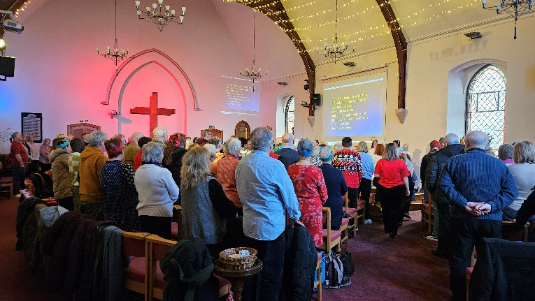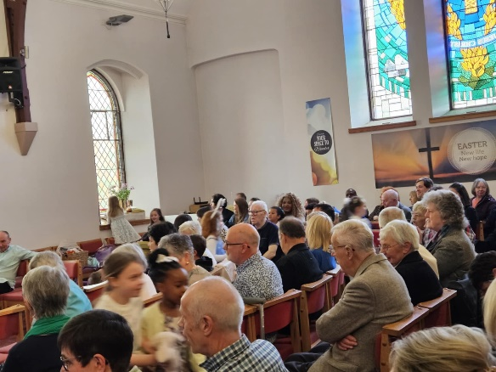

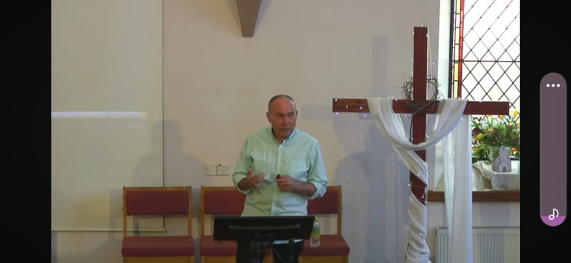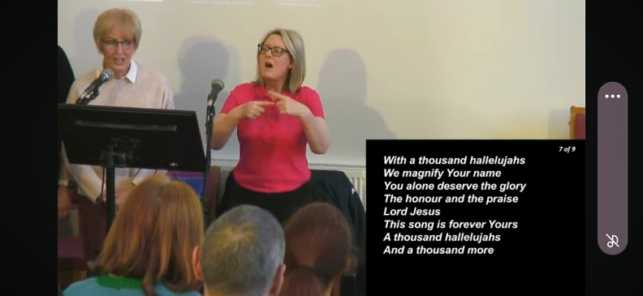

Messy Breakfast

Sunday Club

Junior Fellowship

Freedom Worship

Viewpark Parish Church building is a large multi-functional complex open to the public 7 days a week. The building contains a popular café open to the public 6 days a week 9.30am – 3.00pm.

In addition, the community outreach service ViewCare Project operates within the building complex.

The Sanctuary is open every day of the week

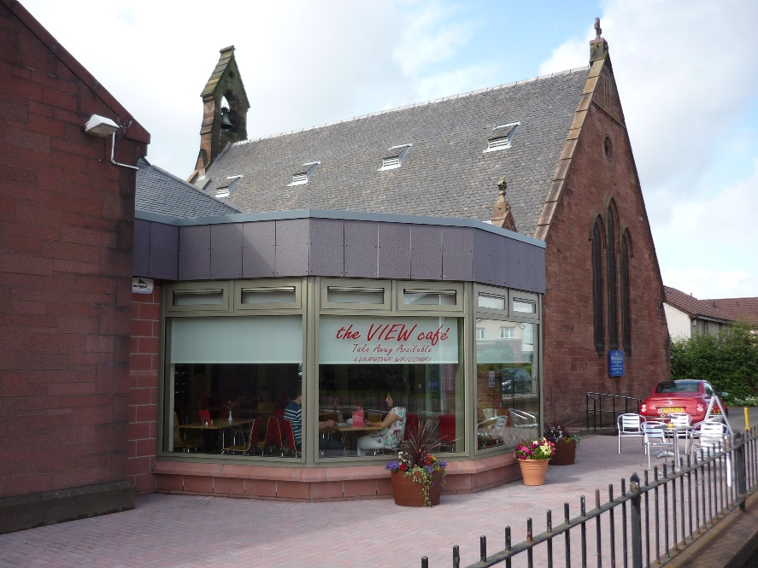**

The Prayer Room

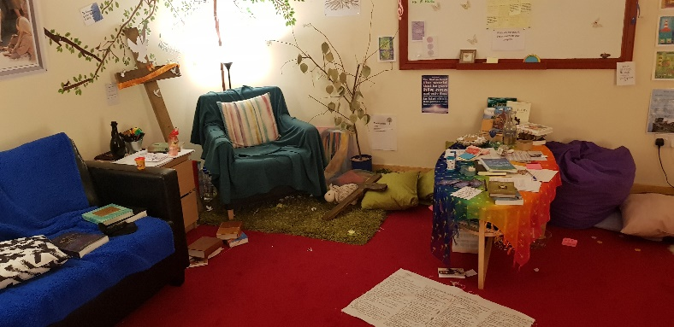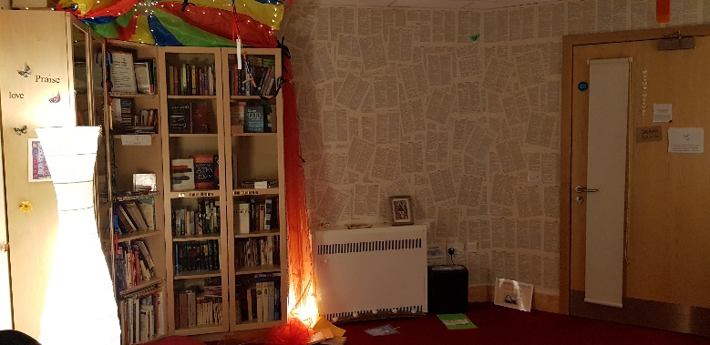

Teen Space

SPIRITUAL HEALTH

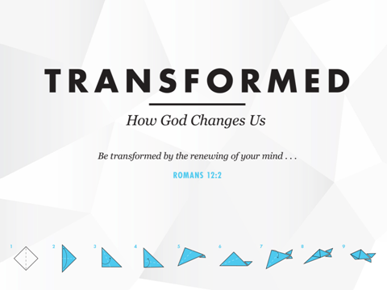

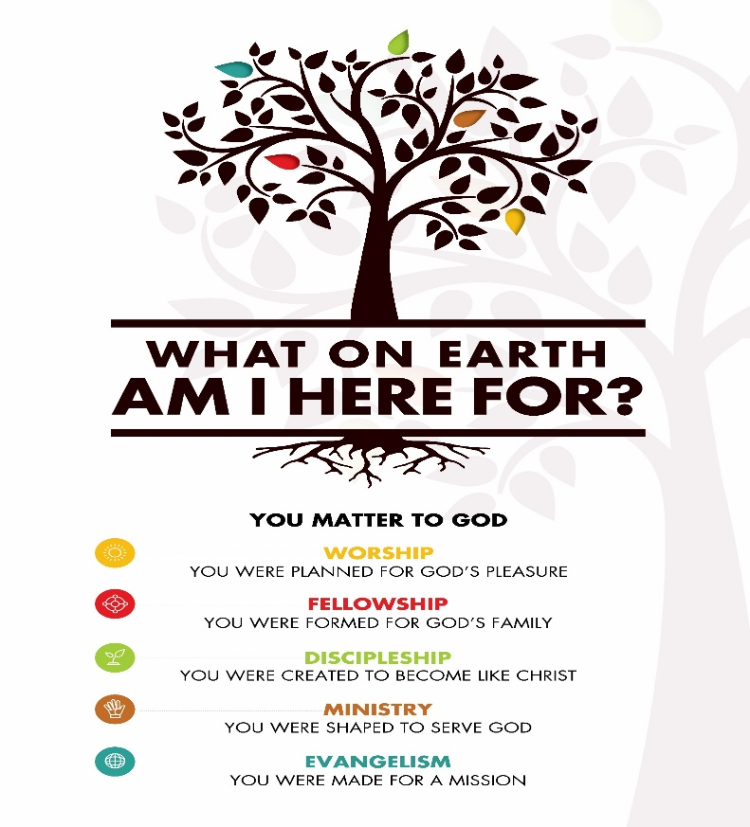





Messy Church

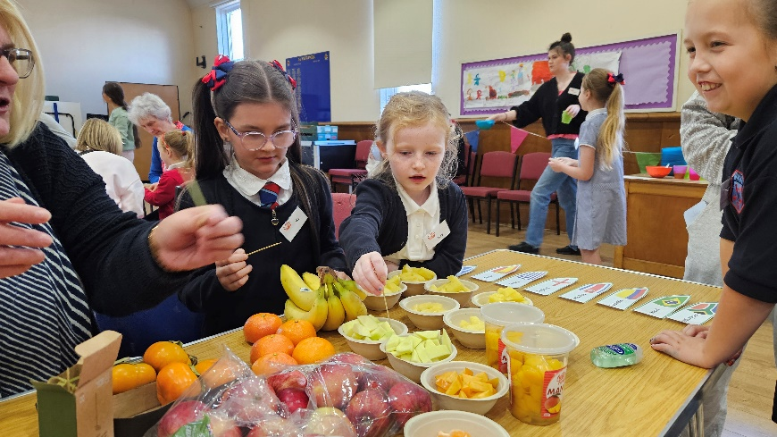**

The Viewcare Project

**