Equality and Diversity Monitoring 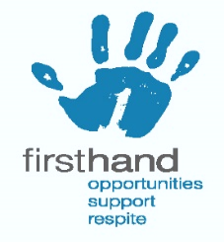

Which role have you applied for:

In what capacity? Delete as appropriate

Volunteering Paid
Gender - please state

Or prefer not to say ☐
How do you describe your sexual orientation?

Or prefer not to say ☐
How would you describe your ethnic identity / nationality?

Or prefer not to say ☐
How do you describe your religious belief / faith?

- Or prefer not to say

Do you consider yourself to be disabled? Yes No

Age

Please return completed form to diversitymonitoring@firsthand-lothian.org.uk

