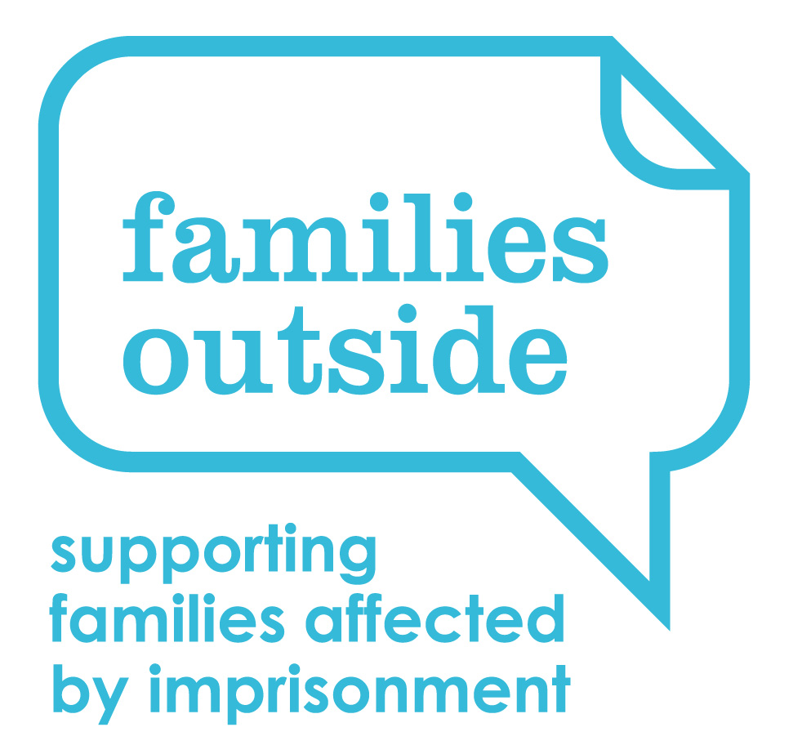

**Job Applicant Privacy Notice**

**Data controller:** Families Outside

17 Gayfield Square

Edinburgh EH1 3NX

Tel. 0131 557 9800

As part of any recruitment process, Families Outside collects and processes personal data relating to job applicants. Families Outside is committed to being transparent about how it collects and uses that data and to meeting its data protection obligations.

**What information does Families Outside collect?**

Families Outside collects a range of information about you. This includes:

* your name, address and contact details, including email address and telephone number;
* details of your qualifications, skills, experience, and employment history;
* information about your current level of remuneration, including benefit entitlements;
* whether you have a disability for which the organisation needs to make reasonable adjustments during the recruitment process;
* information about your entitlement to work in the UK; and
* equal opportunities monitoring information, including information about your ethnic origin, sexual orientation, health, and religion or belief.

Families Outside collects this information in a variety of ways. For example, data might be contained in application forms, CVs or resumes, obtained from your passport or other identity documents, or collected through interviews or other forms of assessment, including online tests.

Families Outside may also collect personal data about you from third parties, such as references supplied by former employer’s information from employment background check providers and information from criminal records checks. Families Outside will seek information from third parties only once a job offer to you has been made and will inform you that it is doing so.

Data will be stored in a range of different places, including on your application record, in HR management systems, and on other IT systems (including email).

**Why does Families Outside process personal data?**

Families Outside needs to process data to take steps at your request prior to entering into a contract with you. It also needs to process your data to enter into a contract with you.

In some cases, Families Outside needs to process data to ensure that it is complying with its legal obligations. We are required to check a successful applicant's eligibility to work in the UK before employment starts.

Families Outside has a legitimate interest in processing personal data during the recruitment process and for keeping records of the process. Processing data from job applicants allows Families Outside to manage the recruitment process, assess and confirm a candidate's suitability for employment, and decide to whom to offer a job. Families Outside may also need to process data from job applicants to respond to and defend against legal claims.

The organisation processes health information if it needs to make reasonable adjustments to the recruitment process for candidates who have a disability. This is to carry out its obligations and exercise specific rights in relation to employment.

Where the organisation processes other special categories of data, such as information about ethnic origin, sexual orientation, health, or religion or belief, this is for equal opportunities monitoring purposes.

For some roles, Families Outside is obliged to seek information about criminal convictions and offences. Where the organisation seeks this information, it does so because it is necessary for it to carry out its obligations and exercise specific rights in relation to employment.

**Who has access to data?**

Your information will be shared internally for the purposes of the recruitment exercise. This includes members of the HR and recruitment team, interviewers involved in the recruitment process, managers in the business area with a vacancy, and IT staff if access to the data is necessary for the performance of their roles.

Families Outside will not share your data with third parties unless your application for employment is successful, and it makes you an offer of employment. Families Outside will then share your data with former employers to obtain references for you, employment background check providers to obtain necessary background checks, and the Disclosure and Barring Service to obtain necessary criminal records checks if required for the role.

Families Outside will not transfer your data outside the European Economic Area.

**How does Families Outside protect data?**

Families Outside takes the security of your data seriously. It has internal policies and controls in place to ensure that your data is not lost, accidentally destroyed, misused, or disclosed, and is not accessed except by our employees in the proper performance of their duties. As such, all documents you submit will be stored electronically on a secure section of the server.

**For how long does Families Outside keep data?**

If your application is unsuccessful, Families Outside will securely destroy all personal data held on you on file following completion of the recruitment process. If you wish Families Outside to retain your personal data for the purposes of contact regarding future job opportunities, you must give us explicit consent to do so.

If your application for employment is successful, personal data gathered during the recruitment process will be transferred to your personnel file [and retained during your employment]. The periods for which your data will be held will be provided to you in a new privacy notice recorded on internal policies and within the terms and conditions of your employment contract.

**Your rights**

As a data subject, you have a number of rights. You can:

* access and obtain a copy of your data on request;
* require Families Outside to change incorrect or incomplete data;
* require Families Outside to delete or stop processing your data, for example where the data is no longer necessary for the purposes of processing;
* object to the processing of your data where Families Outside is relying on its legitimate interests as the legal ground for processing; and
* ask Families Outside to stop processing data for a period if data is inaccurate or there is a dispute about whether your interests override the organisation's legitimate grounds for processing data.

If you would like to exercise any of these rights, please contact Business Support on 0131 557 9800 or by email at [BusinessSupport@familiesoutside.org.uk](mailto:BusinessSupport@familiesoutside.org.uk)

If you believe that Families Outside has not complied with your data protection rights, you can complain to the Information Commissioner.

**What if you do not provide personal data?**

You are under no statutory or contractual obligation to provide data to Families Outside during the recruitment process. However, if you do not provide the information, the organisation may not be able to process your application properly or at all. You are under no obligation to provide information for equal opportunities monitoring purposes, and there are no consequences for your application if you choose not to provide such information.

**Automated decision-making**

Recruitment processes are not based solely on automated decision-making.