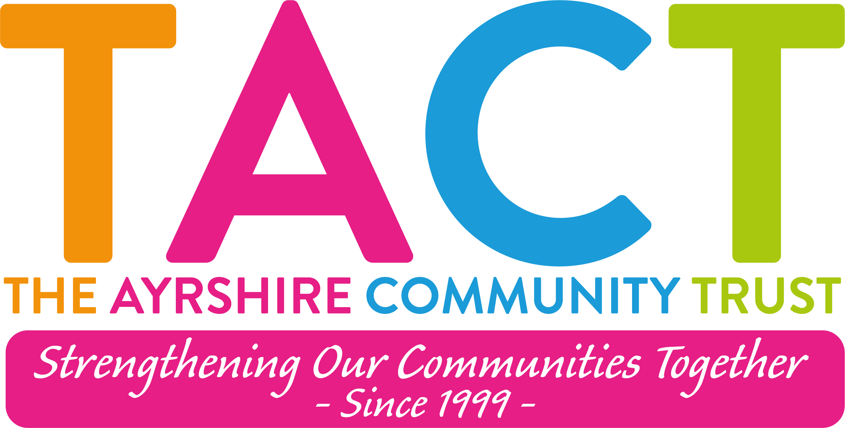

The Ayrshire Community Trust

Job Description

Post: Community Development Worker - Link Up
Responsible to: Link Up Manager
Salary: £25,000 per annum
Hours: 35 hours (Please Note: Normal working week Monday - Thursday with occasional evening and weekend work)
Location: Vernon Street, Saltcoats

Employee Benefits:
- Real Living Wage Employer
- Four Day Working Week (Monday to Thursday)
- 8% Employer Pension Contributions (after probationary period)
- Access to Employee Supported Volunteering
- Carer Positive Employer
- Disability Confident Employer
- Access to Flexible Working

About:
The Ayrshire Community Trust is a charity based in North Ayrshire that provides programmes and projects that make a difference to people’s lives by encouraging, supporting and promoting community action.

Purpose of the Role:
To develop and facilitate mutually beneficial activities that bring people in the community together, using this experience to increase the confidence and capacity of the individuals involved and to begin improving the community’s effectiveness in addressing its own problems.

Summary of Main Responsibilities:

The Community Development Worker will play a key role in supporting individuals and groups across Saltcoats to develop their confidence, skills, and capacity to shape local activities and services. This challenging role requires a person-centred, asset-based approach. Requiring a dynamic, compassionate, and self-motivated individual committed to strengthening community connections and promoting collective action.

Job Requirements and Additional Information:
- This role involves regulated work with children and vulnerable adults and requires membership of the PVG Scheme.
- The post is based in Saltcoats and may involve some evening or weekend work as required.

Key Relationships:
- Internal - You will work as part of the Saltcoats Link Up team reporting and to the Saltcoats Link Up Manager
- Internal - You will work as part of the wider team of The Ayrshire Community Trust
- External – Local people who volunteer and/or participate in TACT groups and activities, and staff from other local partner organisations.

Main Duties and Responsibilities:
- Engagement & Support: Reach out to local people, helping them identify their strengths, interests, and talents to build confidence and participation.
- Group Development: Support the creation and sustainability of community-led groups, based on residents' needs and aspirations.
- Family Work through Community Development Model: To deliver family-based activities during the school holiday periods engaging and supporting families, fostering inclusive, strengths-based relationships that empower families to identify their needs, build on their assets, and actively participate in local opportunities.
- Dignified Food Provision tackling food insecurity: Support a team of volunteers to operate the Argyle Community Shop and associated activities, with the aim of achieving full independence and autonomy by March 2026. This includes providing administrative support and offering one-to-one support to shop members as required.
- Emotional & Practical Support: Provide consistent encouragement and guidance to individuals, helping them actively engage with Link Up and the wider community.
- Community Empowerment: Foster collective action and shared purpose among residents to drive positive change in the community.
- Monitoring & Evaluation: Collect data, prepare reports, and contribute to learning and evaluation processes.
- Partnership Working: Build strong relationships with local organisations, public services, and community stakeholders to support collaboration and coordinated delivery.
- Planning & Administration: Maintain records, support evaluation frameworks, and help ensure effective delivery of programmes and services.
- Policy Awareness: Stay informed about relevant national and local policies related to poverty, inequality, place-based working, and community empowerment.
- Fundraising and Development: Support Link Up groups in their progression toward independence by March 2026, including identifying relevant funding opportunities and assisting with the preparation and submission of funding applications.
- Team Support: Work closely with colleagues and volunteers, contributing to ongoing learning and co-designed responses to local issues.

Key Competencies:
- Strong Communicator: Ability to engage with people at all levels and build trust-based relationships.
- Empathy and Emotional Intelligence: Respectful, non-judgmental, and genuinely curious about people’s experiences.
- Self-Motivation: Proactive, solution-focused, and capable of working independently.
- Team Player: A proactive approach to work and confidence in working independently and as part of a team to deliver quality results.
- Analytical Thinking: Able to reflect on impact, learn from practice, and link insights to policy and systems thinking.
- Organisation & Time Management: Demonstrates the ability to effectively plan, prioritise, and manage a varied workload. Capable of working in a flexible and responsive manner, adapting to changing priorities and emerging community needs while maintaining high standards of delivery.

Skills & Experience required:
The Community Development Worker will be able to demonstrate a range of qualities, abilities and experience such as:
- Minimum of 3 years’ experience in community development or similar roles.
- Experience in asset-based and community-led approaches.
- Proven ability to motivate and empower individuals and groups.
- Experience working in a food provision project tackling food insecurity.
- Skilled in building relationships, conflict resolution, and supporting participation.
- Strong organisational and ICT skills.
- Experience in monitoring and evaluating community outcomes, including ‘soft’ indicators like confidence and belonging.
- Excellent communication and interpersonal skills to work effectively with staff, service users, external stakeholders and partners.

Desirable skills and experience:
- Experience in regeneration.
- Experience working with families.
- Familiarity with social media for engagement purposes.
- Fundraising experience.
- Full UK driving licence and access to a car.

Because of the changing nature of our business your job description will inevitably change. You will, from time to time, be required to undertake other activities of a similar nature that fall within your capabilities as directed by the Board of Directors.

