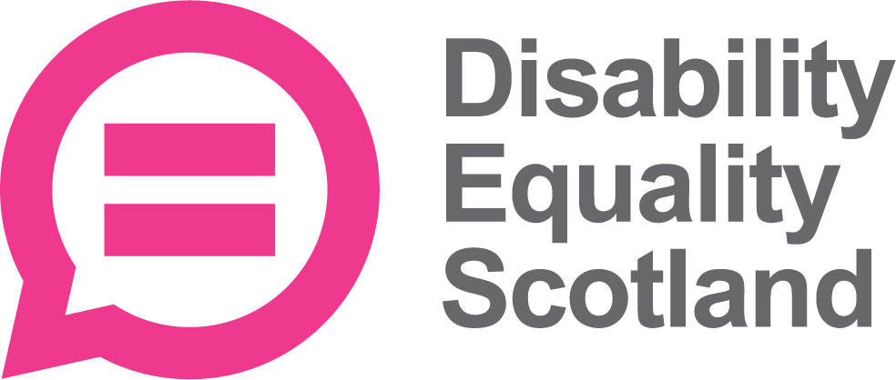
Training and Development Worker
Job Description

Job Title: Training and Development Worker
Salary: £24,300 per annum (pro rata £14,600)
Hours: 21 Hours per week
Location: Office based or Hybrid
Reporting to: CEO
Closing date: 5 pm on Tuesday 13 May 2025
Interview: Week commencing 26 May 2025
About Disability Equality Scotland
Disability Equality Scotland is a membership organisation for disabled people, disabled people organisations, Access Panels and disability groups/organisations. It is our mission to work towards being as inclusive and accessible as possible for all disabled people.
We promote access in its widest sense, including access to our built and natural environment and access to the same and equal opportunities as enjoyed by others in our communities, promoting a life of dignity, respect, choice and independence. This extends beyond physical access to include access to information, access to inclusive communication and inclusion in decision-making, whether with planners over inclusive design or transport providers about accessible and safe travel.
Main purpose of this role

The Training and Development Worker will continue to develop and expand our suite of training courses including Easy Read, Inclusive Communication and Disability Equality Training. The post holder will deliver the training and could also support our Easy Read Creators with some translation tasks. The post will contribute to the promotion and marketing of our Training Service. This post has a high level of responsibility for designing, delivering, evaluating and reporting on the training work. The postholder is expected to manage their own workload in conjunction with other Trainers and work with a significant degree of autonomy.

Knowledge and Experience
The post has responsibility for delivering specific training offerings.
There is a high level of communication skill required for this post in order to engage with staff and key stakeholders and develop communication and training materials suitable for the needs identified.
This post also requires a high level of training skills. The postholder should hold a strong understanding of planning and delivering training sessions with the important principles of training other people. They require knowledge and understanding of the practical elements that accelerate the learning experience. The postholder will be able to deliver a training session and put the theory into practice, in a safe environment which helps candidates build confidence. Getting positive and constructive feedback from candidates is a central part of the course.
The postholder will be required to represent the organisation at an operational level.
This post has no line management responsibility, however as part of a small team within Disability Equality Scotland, effective communication is key and balancing ongoing commitments with workloads and deadlines.
This post will require a Train the Trainer qualification or qualification in an area relevant to training or alternative recent relevant experience.

Main Responsibilities of this Post

Project Management
This post will operate with a significant degree of autonomy and so this post will design the parameters of their work from start to finish, including the qualitative and quantitative elements, the monitoring mechanisms and evaluation to deliver on its outcomes. The CEO will provide day-to-day support, along with members of the training team.

Training Delivery
This post will agree the monitoring and evaluation mechanisms and undertake a full training validation. This will require updating and designing of course content, facilitation and delivery of training, and monitoring and evaluation of surveys and feedback. This post therefore needs a high degree of communication and training skills to present information in accessible ways, and to a publishable standard.

Reporting
The postholder will support the Training Team to provide quarterly reports of activities and impact to the CEO, the Board and our funders. This post will also be expected to represent the organisation at meetings, events and conferences as required.
Role Duties

- Designing and developing training modules covering disability equality, Easy Read, Inclusive Communication and others, ensuring best practice in inclusive communication is applied

- Deliver training to a high standard, using multiple platforms (digitally) and face to face (as required).

- Provide quarterly reports on training service.

- Analyse survey responses and make relevant changes to this based on effectiveness of training feedback.

- Prepare training plans and realistic delivery timelines, monitoring progress and devising strategies to avoid risk (for enhanced training package).
- Design and implement monitoring and evaluation practices, identifying the most suitable research methods (both qualitative and quantitative)

- To support training team members with delivery as required.

- Support Easy Read Workers with translation work as required.

Demands of this post
This is a demanding post that requires flexibility and the ability to manage a heavy workload with competing demands and deadlines.
The post requires a high level of communication skills and interpersonal skills, displayed both internally and externally.
The post is flexible and can be office based with some working from home available. Our offices are in Edinburgh City Centre.
Equal opportunities
We are committed to being disability confident and an employer of choice irrespective of race (which includes colour, nationality and ethnic or national origins), sex, sexual orientation, gender reassignment, religion or belief, marital or civil partnership status, age, disability, or pregnancy and maternity. The ethical and business case of ensuring that our workforce is representative of wider society is at the heart of what we do. When we are recruiting, disabled candidates who meet 60% of the essential criteria will be guaranteed an interview.

Person Specification

Selection Criteria | Essential (E)  Desirable (D) | Where Evidenced  Application (A)  Interview (I)  Presentation (P)  References (R)
Qualifications
Recent, relevant experience in training or facilitation OR  Training qualification | E | A
Experience
Experience of equality initiatives | E | A / I
Experience of Inclusive Communication. Have an understanding on the importance of inclusive communication for disabled people and delivering information in inclusive formats. | E | A / I / P
Have an interest in / or understanding of disability | D | A / I
Easy Read experience | D | A / I
Skills and Knowledge
Excellent analytical skills | E | A / I
Good working knowledge of Microsoft Office applications including Word, Excel, PowerPoint, Good knowledge of WordPress and Zoom | E | A / I / P
Excellent organisational, interpersonal, influencing and communication skills to effect and maintain good partnership collaboration | E | A / I / P
Excellent written communication, including the ability to write reports | E | A / I
Ability to prioritise own workload and work to specified deadlines under pressure | E | A / I
Ability to communicate complex subjects orally | E | A / I / P
Competencies and Personal Attributes
Ability and flexibility to react effectively to changes in the project plan | E | A / I
Flexible approach to workload | E | A / I
Ability to work independently and as part of a team | E | A / I
Enthusiasm and commitment | E | A / I / P
Ability to plan for and work to tight deadlines | E | A / I
Calm and efficient approach to meet project and partner demands and deadlines | E | A / I / P
Business Requirements
Occasional travel across Scotland will be necessary | E | I

Essential Requirements are those, without which, a candidate would not be able to do the job. Desirable Requirements are those which would be useful for the post holder to possess and will be considered when more than one applicant meets the essential requirements.

