



Fife International Forum

Operations Manager

Applicants Information Pack

Dear Applicant,

Thank you for your interest in the Operations Manager position at Fife International Forum.

If you are an internal applicant, you will already be familiar with the distinctive nature of Fife International Forum and our work. If you have applied outside the organisation, I would like to provide you with the background and context about this Operations Manager opportunity.

Fife International Forum is a registered Scottish Charitable Incorporated Organisation Charity (SCIO) SC043053 founded in 2012 and based at Premier House, Randolph Industrial Estate, 29a Randolph Place, Kirkcaldy, KY1 2YX.

We are a leading, high-quality, and people-led charity with many years of experience working with migrant and refugee communities across the Fife region.

We seek to tackle poverty, low levels of social mobility, employment difficulties, and other issues often faced by people who move away from their usual place of residence.

We rebranded in 2022 and developed our strategic plan - Building Bridges (2022-27) - this highlights our core values and way forward. We have continued to review our model of service to ensure that it focusses on delivering an effective, quality service.

While this is an exciting time of change in the organisation, the core objectives of working with migrants and refugees celebrating cultural diversity in Fife remain unchanged.

We are a small but influential team, and everyone plays a crucial role in enabling us to collectively deliver our mission and vision.

Our Operations Managers are based at our office at 29a Randolph Place, Randolph Industrial Estate, Kirkcaldy, Fife; however, they travel and work across Fife. We also facilitate events at our venue in the Mercat Shopping Centre, Kirkcaldy. We operate a responsive, local, person-led programme of support and inclusive activities throughout the year delivered by a small team of staff and willing volunteers.

The Operations Manager role is integral to helping shape and grow our future services, supporting and signposting the social, economic, employment and health needs of the local communities in which they work.

Fife International Forum values diversity and welcomes applications from across the communities in which we work.

If you wish to find out more about the organisation and the Operations Manager position as part of your application process, please email Ewa.Cios@fifeinternational.uk. She will arrange a mutually convenient time for someone from the senior management team to call you.

Thank you again for your interest in working at Fife International Forum; we look forward to receiving your application.

Yours sincerely

Alison Jardine,
Chief Executive Officer

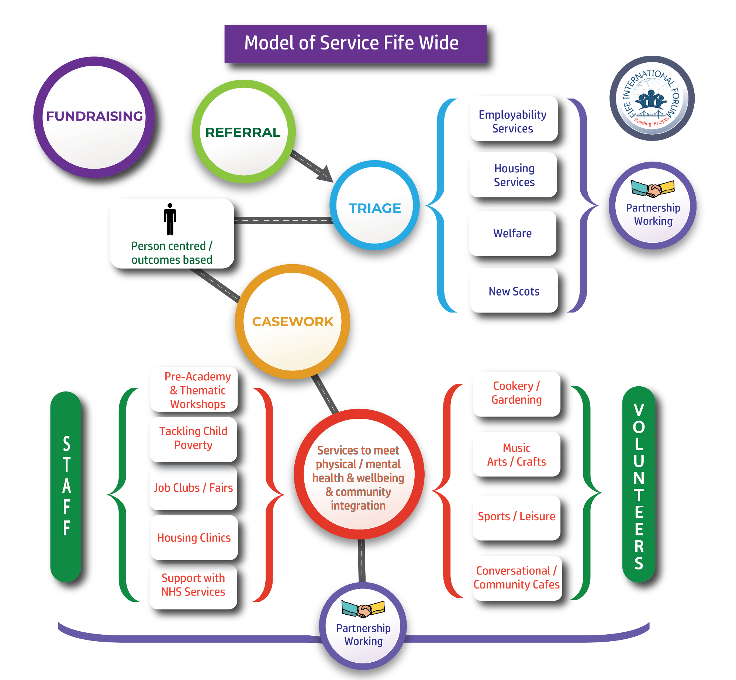


Fife International Forum – Organisation Structure – April 2025
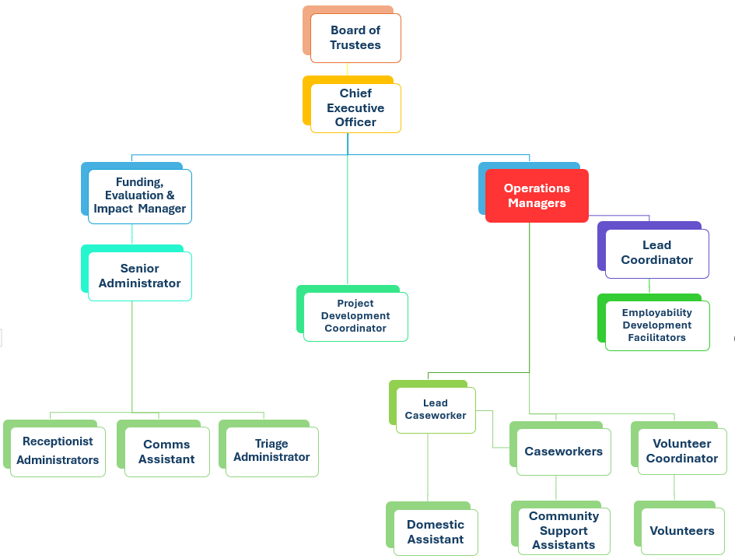

OPERATIONS MANAGER – JOB DESCRIPTION

ROLE PURPOSE
Working with the Chief Executive Officer and as a member of the Senior Management Team, the Operations Manager is responsible for developing, implementing, and evaluating the operational services and strategic plans that will achieve our charitable purpose.
This role is all about leading and managing the team to deliver and continuously improving our services, projects and programmes and ensuring we meet all regulatory compliance obligations.

REPORTING AND SUPPORT
Chief Executive Officer
DELIVERABLES
As the Operations Manager, you can expect your role to involve but not be limited to the following responsibilities:
• Planning, organising, and coordinating all aspects of operational processes, people, and systems to ensure that services are consistently delivered and maintained.
• Preparing detailed and relevant reports on allocated projects, ensuring accuracy and attention to detail for all information presented.
• Mapping all operational activities and responsibilities across the various roles within the team and overseeing the day-to-day management of all services, ensuring team goals are met.
• Designing and creating effective processes/systems and plans of action for all services. Monitoring and adjusting service processes whilst keeping costs in check.
• Leading and managing a team of case workers, developing and training staff to ensure that they have the necessary skills and experience to carry out their roles effectively.
• Undertaking supervision, providing regular feedback on performance for all staff under their management control to maintain professional competencies and ensure an effective and positive service for individuals that use our services.
• Actively encouraging the casework team and other staff to focus on developing external partnership working and establishing key contacts across all statutory, third, private and public sectors organisations.
• Maintaining a detailed overview of the short and long-term casework database providing support and advice where appropriate to ensure the best support solutions are put in place without delay.
• Establishing and maintaining a detailed overview of service delivery, monitoring metrics and beneficiary feedback to drive the continuous improvement of service practices.
• Planning and launching new awareness-raising initiatives and campaigns that publicise our services and raise our profile in the community and enable more people to benefit from our services.
• Acting as Fife International Forum's operational point of contact in the local and wider community, developing positive relationships, engaging with external stakeholders and regulators, building trust, and enhancing the organisation's reputation.

PEOPLE MANAGEMENT
The Operations Manager leads and manages the operational team, recruiting and developing people into roles that enable the organisation to deliver its strategic plan.
• Recruiting, coaching, supporting, developing, and managing all new and existing team members.
• Leading and managing the operational team, ensuring that services are well run, and team members feel valued and equipped to work effectively.
• Inspiring and supporting the team to meet their goals and understand how their contributions are vital to achieving their charitable purpose.
• Establishing clear lines of accountability and responsibility across the team that foster and maintain effective working relationships.
• Monitoring the team's productivity and practices in relation to service delivery and addressing any issues as they arise.

FINANCIAL AND LEGAL MANAGEMENT
The Operations Manager must act in the best financial interests of the organisation in their decision-making, putting the quality and compliance of services, cost control and the minimisation of loss at the centre of every activity.

OPERATIONS MANAGER – PERSON SPECIFICATION

SPECIFICATION | HEADING | DESCRIPTION | ESSENTIAL | DESIRED
QUALIFICATIONS | - A relevant degree or equivalent experience in an operations management role | Educated to degree, or equivalent with an excellent command of English proficiency. | X
QUALIFICATIONS | - Degree or HND in management | A management qualification or extensive previous experience in managing teams of staff. | X
SKILLS AND ABILITIES | - Leadership Competence | Demonstrable leadership competence, including integrity, self-discipline, communication and interpersonal skills, trustworthiness, teamwork, conflict management, problem-solving, sound judgement, initiative, and decision-making. | X
SKILLS AND ABILITIES | - Leading by Example | Reliability in complying with specific internal established control systems and protocols, leading by personal example, and encouraging all employees to do the same. | X
SKILLS AND ABILITIES | - Management of Staff | Experience of managing staff in a diverse team and providing regular feedback to staff on performance. Managing discipline and performance issues as required. | X
 | - Organisational Skills | Excellent organisational skills with meticulous attention to detail and the ability to move quickly and easily from planning to implementation. | X

SPECIFICATION | HEADING |  | ESSENTIAL | DESIRED
SKILLS AND ABILITIES | - Problem-Solving | The ability to balance and meet the needs of different people in the solution of problems and issues. | X
SKILLS AND ABILITIES | - Influential communication and Community Advocacy | Excellent English speaking and writing skills with the ability to communicate effectively with people whose first language is not English. | X
SKILLS AND ABILITIES | - Excellent at networking | Advocating for and acting as an ambassador of the organisation continuously building new and developing existing community relationships. | X
SKILLS AND ABILITIES | - Leadership, training development and facilitation skills. | An ability to design and develop training and processes for staff, under the performance management framework. | X
SKILLS AND ABILITIES | - Project Management Experience | Project Management skills with experience in delivering projects and initiatives within agreed timescales and budgets. |  | X
SKILLS AND ABILITIES | - Financial Management | The ability to budget and manage finance for projects. |  | X
SKILLS AND ABILITIES | - IT Skills | Excellent IT skills using Microsoft packages and databases. | X
SKILLS AND ABILITIES | - Policy & Ethics Adherence | Conduct all activities per all applicable laws and the organisation's standards and policies, including its ethics, code of conduct and health & safety policies. | X

SPECIFICATION | HEADING |  | ESSENTIAL | DESIRED
EXPERIENCE | - Report Writing & Data Analysis | Experience in writing reports and using databases to produce statistical information, with attention to detail is a key element of the task in analysing findings. | X
KNOWLEDGE | - Commitment to Migration & Diversity | Knowledge and a passion for learning more about the benefits of migration, diversity, and inclusion and the support we provide in education, upskilling, language support, employment opportunities, and social activities that enable people to integrate and play an active part in community life. |  | X
OTHER | - Driving Licence | Hold a current UK driving licence and access to a car. | X

OPERATIONS MANAGER
MAIN EMPLOYMENT TERMS & CONDITIONS

- SALARY: £36,309pa, based on a 35-hour week and pro-rata for part-time.

- CONTRACT: Full-Time.

WORKING HOURS
A full-time working week is 35 hours. (Working flexibly on five over six days per week)

OVERTIME:
A time off in lieu (TOIL) system is in operation per the policy.

ANNUAL LEAVE ENTITLEMENT
All employees are entitled to the equivalent of 5.6 weeks of annual leave, including nine public holidays in Scotland.

Birthday policy - all employees are granted a discretionary one day of paid leave on
their birthday each year.

We are keen to enhance our annual leave entitlement and provide additional benefits as our services grow.

DISCLOSURE SCOTLAND – PROTECTION OF VULNERABLE GROUPS (PVG)

SCHEME
The Operations Manager position is subject to an enhanced PVG background check.

BUSINESS MILEAGE
Business mileage is reclaimed at HMRC rates.

PENSION
Automatic enrolment. Employer contribution 3%. Employee minimum contribution 5%

EQUALITY AND DIVERSITY
Successful applicants must understand equality, diversity and inclusion principles and comply with Fife International Forum’s equality and diversity policies.

HEALTH AND SAFETY
All team members are responsible for implementing health and safety procedures in so far as it affects them, their colleagues, and others whom their work may impact. The successful applicant is also expected to monitor the effectiveness of health and safety arrangements relating to their work to ensure appropriate improvements are made.

OPERATIONS MANAGER

SELECTION PROCESS OVERVIEW

The Operations Manager selection process will consist of three stages:
- The first stage will take the form of an informal meeting with members of staff. This will provide an opportunity for all candidates to ask questions about the organisation, our mission and vision, our strategic plan, and the role of the Operations Manager.

- The second stage will take the form of a presentation and written exercise.

- The final stage will take the form of a formal interview with the Chief Executive Officer, the Senior Operations Manager and the Funding, Evaluation & Impact Manager.

- Please allow up to 3 hours for the complete interview process.

Following the selection process, we will complete a plenary session where the successful candidate will be decided.
As well as technical and competency-based questions linked to the organisation and the job description, there are also questions that we will be asking to assess you against the following criteria:

Delivering the role and growing the Operations Manager role aligned to the strategic plan:
  - Understanding of the challenges faced by people and the resultant needs of the international community in Fife as well as current policy and practice.
  - Coordinating area services and maximising the return on available resources.
  - How to create people-led services and activities that meet the needs of the local community.
  - Building and sustaining relationships and stakeholder management.

Cultural fit with the organisation:
  - Understanding our mission and vision at Fife International Forum.
  - Being able to visualise the future of the Area Programmes and changes for improvement that you will deliver.
  - Your personal purpose vs the purpose of the role.
  - Your values vs organisational values.
  - Your achievements, failures, learnings, and mindset.
  - Self-awareness, genuineness, fair-mindedness, and ability to do the right thing.

OPERATIONS MANAGER APPLICATION PROCESS

APPLICATION FORM
To ensure that all applicants have equal opportunities to provide all information that is relevant to this position, we would appreciate it if you could complete and email the separate application form included with this pack rather than a CV.

Personal details
Please let us know if your contact details change between your application and the interview date.

Education and training
Please provide a list of formal certified and informal training you have completed. We will ask you to provide certificates or information to assess whether you meet the qualification or required experience requirements of the Operations Manager position.

EQUAL OPPORTUNITIES
Fife International Forum is committed to a policy of equal opportunity for all. We will not discriminate on the grounds of gender, gender identity, race, disability, sexual orientation, religion or belief, age, those with caring responsibilities, part-time workers, or any other factor irrelevant to a person's work.

When applying, please note that personal details will be removed. The shortlisting panel will see only application information relating to your education, career history and personal statement.

APPLICATION CLOSING DATE
The closing date for all applications is 12:00 midday on Friday 23rd May 2025. Please note that due to our recruitment practices, we cannot accept applications received after the deadline. Interviews will be held week beginning 2nd June 2025.

EMAILING YOUR APPLICATION
Please email your completed application form to info@fifeinternational.uk

SHORTLISTED CANDIDATES
If you are shortlisted for an interview, we will contact you by email to invite you to meet with members of staff and attend a formal interview.

SELECTION PANEL
The selection panel will be comprised of three people. It will include the Chief Executive Officer, the Senior Operations Manager and the Funding, Evaluation & Impact Manager.

FEEDBACK
All unsuccessful candidates who have attended an interview will be offered feedback which may be helpful for future interviews.

Feedback is a two-way process, and in the spirit of continuous improvement, we would appreciate your feedback on how the application and selection process felt for you.

We hope that this candidate information pack provides you with all the information you need; however, please let us know if you have any questions or require further information.
Wishing you all the best with your application.

