**atsd**

Data Intelligence & Research Officer

**Application pack – May 2025**

**Contents**

Foreword 2

Our Mission and Purpose 4

Data Intelligence & Research Officer 5

Data Intelligence & Research Officer – Job Description 7

Data Intelligence & Research Officer - Person Specification 11

Employment Information – Data Intelligence & Research Officer 12

How to Apply 14

# Foreword

Dear Candidate,

Thank you for your interest in this post and in the Mental Welfare Commission.

**Our Mission** is to be a leading and independent voice in promoting a society where people with mental illness, learning disabilities, dementia and related conditions are treated fairly, have their rights respected, and have appropriate support to live the life of their choice.

It is an exciting time to join the Mental Welfare Commission to contribute to our strategic priorities, challenging and promoting change, focusing on the most vulnerable, increasing our impact and improving our efficiency and effectiveness.

This is an opportunity to contribute to a national organisation focussing on the rights of individuals. For details of our recent work including our reports following visits, responses to the Scottish Mental Health Law Review, Monitoring reports, Good Practice Guides, Themed Visits or Investigations, please click on our [web-link](https://www.mwcscot.org.uk/visits-and-investigations) to read about the range of work we do. This role will allow you to apply and develop your knowledge of ethical and legal considerations in the care of patients, service users and those important to them across different parts of Scotland.

Our office environment is modern, light, bright and green with superb views and is very close to Haymarket Railway station and transport links.

As an employer, we offer excellent terms and conditions of service including a generous pension scheme, a commitment to learning and development and access to an Employee Assistance Programme and comprehensive staff benefits.

We offer:

* a comprehensive range of HR policies including policies to help balance commitments at work and home and flexible family friendly working arrangements.
* training and development opportunities
* access to occupational health services
* access to an employee assistance programme
* access to staff benefits/staff discounts
* a cycle to work scheme.
* access to the NHS pension scheme

The following information will help you with your application:

* recruitment advertisement
* job description
* person specification
* terms and conditions of employment information sheet

We hope you are encouraged to apply and look forward to receiving your application form

(with font size no smaller than 11).

**HR Recruitment team**

# Our Mission and Purpose

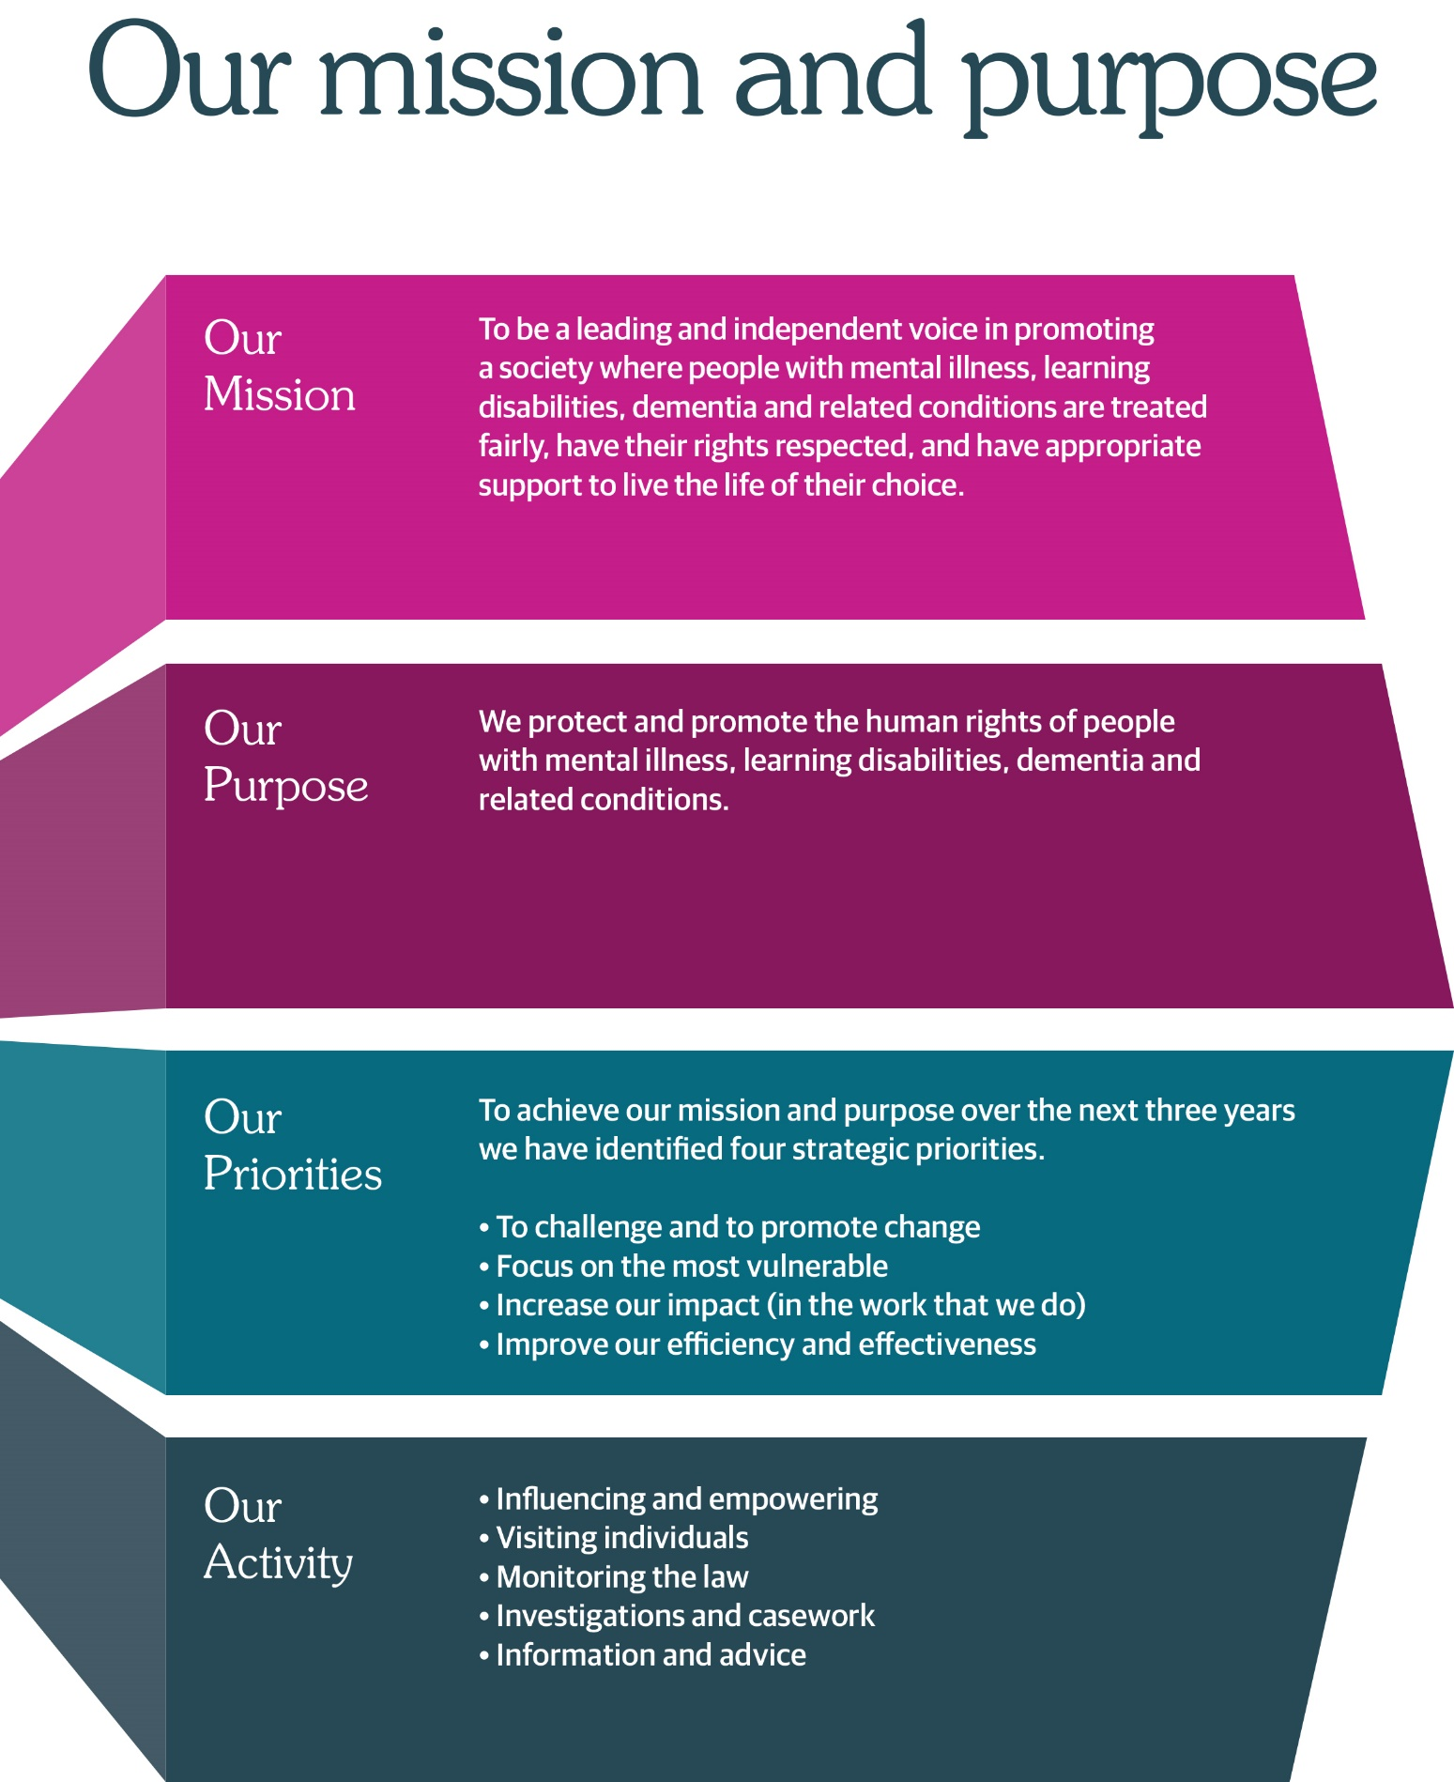



**Data Intelligence & Research Officer**

**Circa £46,012 - £49,636 (pro rata)**

**Fixed term (12 months in the first instance)**

**Based in Edinburgh, hybrid working options.**

**Part-time 17.5 hours**

We protect and promote the human rights of people with mental illness, learning disabilities, dementia, and related conditions.

We have an exciting opportunity for a Data Intelligence & Research Officer to join the Commission on a fixed term basis for 12 months.

This is an exciting opportunity to join our professional and multi-disciplinary team. This role will provide specialist health intelligence advice and practical support to colleagues within the Commission bringing together the current internal and external data, information and evidence-based policy and practice to create informed analyses and interpretation, to support decision making and monitor mental health and incapacity legislation.

To support the strategic priorities of the Mental Welfare Commission, bringing together our latest data with information and evidence-based policy and practice to create informed analyses and interpretation; to support decision making and monitor mental health and incapacity legislation.

As an employer, we offer excellent terms and conditions of service including a generous pension scheme, a commitment to learning and development and access to an Employee Assistance Programme and comprehensive staff benefits.

We also offer a comprehensive range of HR policies including policies to help balance commitments at work and home and flexible working arrangements.

At the Commission we champion diversity, inclusion, and wellbeing. We pride ourselves on being an employer of choice, cultivating a sense of belonging and providing a workplace where everyone feels valued. We aim to have a workforce which represents the wider society that we serve and therefore encourage applications from people of all backgrounds and under-represented groups.

Our office environment is modern, light, bright and green with superb views and is very close to Haymarket Railway station and transport links.

For more information on applying, please phone 0131 313 8772 or visit the website at <https://www.mwcscot.org.uk/about-us/work-us>

To apply, please send a copy of your CV and short application form to; mwc.recruitment@nhs.scot

Closing date for receipt of applications is **12.00 noon 23 May 2025.** Interviews will take place on **13 June 2025 either** at our office in Thistle House or via Microsoft Teams.

# Data Intelligence & Research Officer – Job Description

|  |  |
| --- | --- |
| **Job Title:** | Data Intelligence & Research Officer |
| **Reports To:** | Business Change & Improvement Manager |

|  |
| --- |
| 1. **Job Purpose** |
| To support the strategic priorities of the Mental Welfare Commission, bringing together our latest data with information and evidence-based policy and practice to create informed analyses and interpretation; to support decision making and monitor mental health and incapacity legislation. |

| 1. **Dimensions** |
| --- |
| The post holder has a remit to support the Commission’s strategic priorities by providing specialist advice to staff and senior management on audit and research methods, data collection and statistics. |

| **3. Key Result Areas** |
| --- |
| * Provide specialist health intelligence advice and practical support to colleagues within the Mental Welfare Commission in order to progress themed visits and other projects as per the Commission’s business plan. * Provide statistical reports to enable the Commission to monitor the operation of the Mental Health (Care and Treatment) (Scotland) Act 2003 and Adults with Incapacity Act 2000, ensuring the appropriate information governance around the handling of sensitive person-specific data in order to produce our statistical monitoring reports. * To liaise with external bodies and attend appropriate external audit and research groups re management information and statistics as required in order to place the Commission’s data-sets in context and consider collaborative work to make best use of these data-sets. * Develop and use datasets to support the work of the Mental Welfare Commission, using these datasets to produce regular reports to agreed timescales. * Create and employ processes to identify potential data quality issues and investigate and address these as appropriate in order to ensure data quality is maintained. * Manipulate and analyse large, complex and sensitive datasets across the full breadth of the work of the Mental Welfare Commission using a range of software/methods for both qualitative and quantitative methods and employ or advise on appropriate statistical techniques as required in order to support projects, themed visits from the Commission’s business plan. * Use a range of approaches and methodologies for reporting, presenting and disseminating information. * Interpret and present complex information ensuring that the interpretation is clear and presented in a way that can be easily understood by a diverse audience to maximise the impact of the Commission’s reports. * Ensure information provided in reports is accurate, of a high standard and fit-for-purpose. * Contribute to the research and development activities of the Mental Welfare Commission by supporting as required evaluations, surveys and/or audits using a range of quantitative and qualitative research skills. * To provide literature review searches and information on key topic areas to staff as requested in order to support agreed projects and themed visits as per the business plan. * Contribute to the reporting and dissemination of the findings from evaluation, surveys, audit, and research activities as required. * Work with the Information Governance manager and Caldicott Guardian to ensure all information and reports are produced in accordance with the Mental Welfare Commission’s policy, legislation and governance requirements. * Develop and maintain specialist knowledge of key sources of health intelligence and awareness of developments in these in order to be able to advise on relevant themed visits. * Contribute to training and CPD sessions delivered by the Mental Welfare Commission. |

|  |
| --- |
| **4. Planning and Organising**  The post holder will contribute to multiple pieces of work concurrently and will need to adjust priorities to meet changing demands.  The work plan of the post holder is agreed with the Executive Director and relates to the delivery of the strategic priorities of the Mental Welfare Commission. Reporting arrangements may change as the Commission is currently reviewing roles and responsibilities.    The post-holder will participate in the formal objectives setting and performance appraisal process of the Mental Welfare Commission and will take a pro-active approach in the formulation of a personal development plan. |

|  |
| --- |
| 1. **Internal and External Relationships** |
| The post-holder reports to the Executive Director who provides line management support. This may be subject to change based on a current review of roles and responsibilities within the Executive Team. However, the post holder will need to work independently and without close supervision but within a framework of agreed objectives.  Communication  The post holder will need to possess highly developed written and oral communication skills; experience of working with multi-disciplinary teams; project management skills; and, excellent organisational skills.  Communication will be both written and verbal undertaken via e-mail, telephone, teams or in person as appropriate and will range from a 1:1 discussion to participating in group discussions or presenting at a meeting.  Internal  The post-holder will advise members of staff and the senior management team, to ensure that data issues are recognised and that any statistics are used effectively to support Commission publications and business.  External  The post holder will also be required to liaise in person or by e-mail/telephone with colleagues from the following as appropriate e.g., Service user and Carer organisations, Public Health Scotland, Scottish Social Services Council (SSSC), Healthcare Improvement Scotland, Health Boards, Health and Social Care Partnerships, Office of Public Guardian, University departments and other audit and research organisations and.  The post holder will be able to join local and national health intelligence, audit and research networks to share and develop resources, knowledge and skills. |
| 1. **Most Challenging Aspects of the Job** |
| To manage conflicting demands and deadlines of multiple tasks and projects.  Establishing and maintaining effective working relationships with a range of professionals, dealing with differing opinions and priorities in a sensitive, diplomatic and professional manner.  Complex data analysis and development of comprehensive databases, systems and reporting solutions within short timescales for data reporting.  Continually researching, reviewing and updating methodologies to ensure their robustness and relevance. |

|  |
| --- |
| 1. **Skills/Qualifications and Experience** |
| Essential  Qualifications and training   * Relevant degree or equivalent experience AND a relevant postgraduate diploma/qualification or equivalent in-depth experience   Knowledge, skills and experience   * Experience of working with health/social work-related information with proven IT skills in an analytical capacity. * Experience in electronic information management and retrieval and ability to develop, manipulate and analyse large electronic datasets. * Excellent written and oral communication skills including presentation skills. * Expert knowledge of software packages such as Word, Excel, PowerPoint. * Knowledge of statistical software. * Experience of undertaking research, health needs assessments, evaluations and audits. * Experience in survey design and analysis. * Knowledge of GDPR and the governance around handling of sensitive person-specific data. * Ability to communicate effectively with, and interview, individuals with mental illness or learning disabilities, carers, advocacy workers and service providers.   Attributes   * Proven ability to manage and organise own workload. * Experience of effective team working. * Experience of working with multi-disciplinary teams. * Proven ability to meet deadlines.   Desirable  Qualifications and training   * A higher degree in a relevant discipline   Knowledge, skills and experience   * Experience in the health/social care/social work sector either through related audit, research or information work. * Demonstrate an understanding of project management.   Attributes   * Ability to meet short term requirements but not detract from the longer-term work priorities. |

# Data Intelligence & Research Officer - Person Specification

It is important to note that to be considered for appointment you must meet all of the essential criteria for the role. You should be able to demonstrate both within your application, and at interview (if invited to attend), how your skills, knowledge, values, and personal qualities match those required.

|  |  |
| --- | --- |
| **Essential** | **Desirable** |
| Qualifications and training   * Relevant degree or equivalent experience AND a relevant postgraduate diploma/qualification or equivalent in-depth experience.   Knowledge, skills and experience   * Experience of working with health/social work-related information with proven IT skills in an analytical capacity. (decide what IT system would they use to collate and analyse info) * Experience in electronic information management and retrieval and ability to develop, manipulate and analyse large electronic datasets. * Excellent written and oral communication skills including presentation skills. * Expert knowledge of software packages such as Word, Excel, PowerPoint. * Knowledge of statistical software. * Experience of undertaking research, health needs assessments, evaluations and audits. * Experience in survey design and analysis. * Knowledge of GDPR and the governance around handling of sensitive person-specific data. * Ability to communicate effectively with, and interview, individuals with mental illness or learning disabilities, carers, advocacy workers and service providers.   Attributes   * Proven ability to manage and organise own workload. * Experience of effective team working. * Experience of working with multi-disciplinary teams. * Proven ability to meet deadlines. | A higher degree in a relevant discipline   * Experience in the health/social care/social work sector either through related audit, research or information work. * Demonstrate an understanding of project management. * Ability to meet short term requirements but not detract from the longer-term work priorities. |

# Employment Information – Data Intelligence & Research Officer

The following notes summarise the key points of the terms and conditions.

Full details will be provided with offers of employment.

|  |  |
| --- | --- |
| **Headquarters** | Thistle House, 91 Haymarket Terrace, Edinburgh, EH12 5HE  Options for hybrid working |
| **Pay** | Circa £TBC |
| **Type of Contract** | Fixed term post for 12 months |
| **Manager** | The post-holder reports to the Business Change & Improvement Manager |
| **Hours of work** | Part-time 17.5 hours |
| **Leave** | **Annual Holidays**  The annual entitlement for full time posts is 25 days per year, rising to 30 days after 10 years’ relevant service. (NHS and local authority service is counted as relevant service). Leave entitlement is pro-rata for part-time posts.  **General/Public Holidays**  Public and privilege holidays total 11.5 days per leave year, 6 of these are on set dates and the remainder can be taken as required.  For part time posts, the public/privilege holiday entitlement is pro-rata to full time equivalent.  The leave year runs from 1st April to 31st March. |
| **Superannuation** | [NHS Pension Scheme](https://pensions.gov.scot/nhs/your-membership/your-contributions) is available to all staff subject to scheme rules.  Please click [here](https://pensions.gov.scot/nhs/your-membership/your-contributions) for contributions details.  The employer currently contributes an amount equal to 22.5% of pensionable pay into the scheme on members’ behalf. |
| **Staff Benefits** | Through the Commission Staff Benefits scheme there is access to a wide variety of offers and discounts from the UK’s most popular retailers and service providers. The current provider is EdenRed. There is also access to, [My Gyms discount site](https://www.mygymdiscounts.co.uk/?page=no-login), the UK's largest network of gyms, studios, fitness centres and sports clubs across the UK with discounted membership offers. A comprehensive Employee Assistance Programme is also available and access to a Cycle to Work Scheme.  (The Commission reserves the right to withdraw, amend the schemes and change providers as appropriate) |
| **Our values** | The Commission operates a set of internal values for staff. |
| **Performance,**  **Learning and Development** | There is a performance development system in operation within the Commission. Progression through the salary scale is subject to satisfactory performance. |
| **Data protection** | The information you provide on the application form and any supplementary forms will be used to assist in the process of recruitment and selection in accordance with the Policy of the Mental Welfare Commission.  If you are successful in your application the information you provide will be used for HR and Payroll purposes. By signing the declaration section of the application form it is understood that you consent to the use and storage of your personal information for the above stated purposes. |
| **Work outside the Commission** | It is important to identify and minimise any conflicts of interest that could prevent staff from making fair and objective judgements or could be perceived as doing so by people with lived experience and carers, practitioners, and the public. Details are contained in the Commission’s Conflict of Interest Policy. |
| **Probationary period** | The post requires a 6 months’ probationary period. |
| **Disclosure Scotland** | You will be required to apply for a Basic Disclosure Certificate and completion of a self declaration. An overseas criminal convictions check may also be required in the case of periods overseas. |
| **Occupational Health Screening** | Any offer of employment is subject to satisfactory Occupational Health clearance. The successful candidate will be asked to complete a Pre-Employment Health Questionnaire. NHS Lothian Occupational Health will make an assessment on your fitness to carry out the post based on the information contained within the questionnaire. In certain circumstances further information is required before clearance can be given, and Occupational Health may contact you by telephone or request that you attend for an appointment. Clearance may be subject to you attending for a post-employment appointment and it is vital that you attend this appointment if required |
| **Complaints** | The Commission has a Complaints Handling Procedure. All applicants have access to it if they feel they have been unfairly treated during the recruitment and selection process. External applicants should direct any concerns to the Human Resources department and internal applicants have recourse to the Commission’s Grievance Procedure. |
| **Equal opportunities** | The Commission is an equal opportunities employer. |
| **Feedback** | We do recognise the time and effort it takes to apply for a position. Following the short-listing process, you will be notified about the outcome of your application by email. |

# How to Apply

The Mental Welfare Commission encourages applications from all sections of the community.

We hope the information we have provided will encourage you to find out more about this opportunity.

To apply, please send a copy of your CV and short application form to; mwc.recruitment@nhs.scot

Closing date for completed applications is 12.00 noon 23 May 2025.

Interviews will take place on 13 June 2025 at Thistle House, Edinburgh or Via Microsoft Teams.

