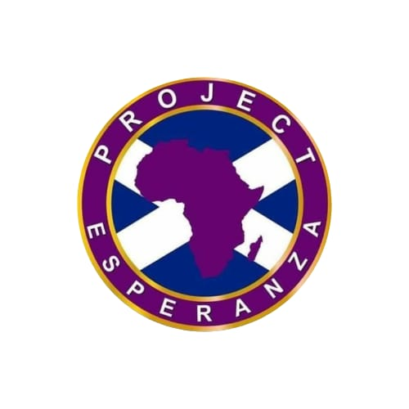
FGM Steering Committee – Role Description and Specification
Project Esperanza

Purpose of the Committee:
The FGM Steering Committee is a strategic advisory body established to guide, inform, and oversee the delivery and development of Project Esperanza’s Female Genital Mutilation (FGM) awareness, prevention, and support programme. The Committee is accountable to the Board of Trustees and plays a critical role in ensuring that our programme and service is culturally competent, trauma-informed, and impactful.

Committee Composition:
The Committee will consist of 6–8 members drawn from relevant sectors, including:

- 1 Religious Leaders (one Muslim and one Christian)
- 1 Community Leaders/Elders (one Muslim and one Christian)
- 1 Healthcare professional
- 1 Education professional
- 1 Legal and safeguarding expert
- 1 Mental health and trauma specialist
2 advocates with lived experience

Time Commitment:

Attend 4 meetings per year (quarterly)

Occasional participation in ad hoc consultations, subgroups, or urgent decision-making (as required)

Preparation time for reading reports, programme updates, and proposals ahead of meetings

Our Participation Policy
We anticipate most meetings will be half days. Our rate is £60 for a half day meeting (up to 3 hours).

We will also reimburse you for the costs associated with your attendance throughout the duration of this project, e.g., travel expenses or childcare costs. These will be paid directly to you on receipt of a receipt or an invoice.

Responsibilities:

1. Strategic Oversight

Provide guidance on the direction, goals, and implementation of the FGM programme
Ensure alignment with Project Esperanza’s mission and values
Recommend improvements based on monitoring and evaluation data

2. Accountability to Trustees

Report quarterly to the Board of Trustees with progress, risks, and key insights
Submit annual summary of activities and strategic recommendations

3. Programme Quality and Impact

Review and advise on campaign strategies, materials, and engagement plans
Ensure programmes are trauma-informed, inclusive, and culturally appropriate
Advise on safeguarding, legal compliance, and risk management

4. Community Voice and Engagement

Act as a bridge between the community and the charity
Encourage diverse representation, including voices of survivors
Promote transparency, trust, and collaboration within the community

5. Resource and Partnership Support

Identify relevant partnership opportunities and funding sources
Support Project Esperanza’s advocacy efforts and public engagement

Person Specification:

Demonstrated commitment to women’s rights, child protection, and anti-FGM work

Knowledge or lived experience related to FGM, safeguarding, or trauma-informed care

Ability to work collaboratively and respectfully across cultures

Strategic thinker with sound judgment

Willingness to act in the best interests of Project Esperanza and its beneficiaries

Term of Appointment:

Members will be appointed for an initial term of 2 years, renewable by mutual agreement.

Send your cv and cover letter to fgm@projectesperanza.org.uk

