# **Equality and diversity monitoring form**

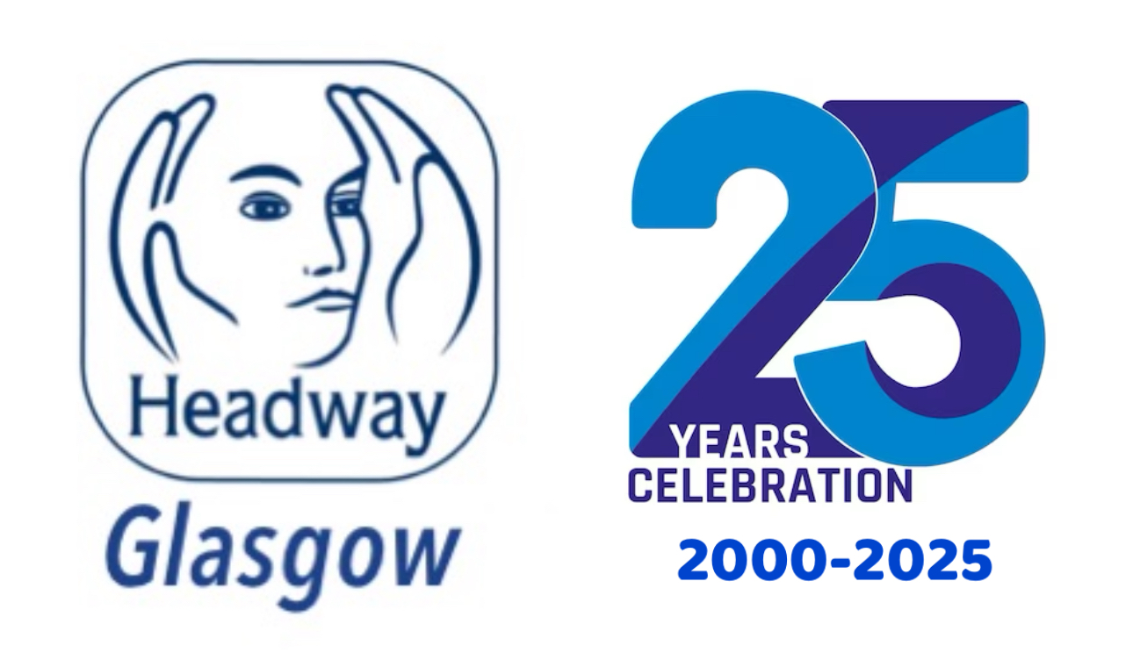

Headway Glasgow is a registered charity and prides itself on being an inclusive organisation and wants to meet the aims and commitments set out in our equality policy. This includes not discriminating under the Equality Act 2010.

Please complete this form to help us understand the diversity of our job/volunteering applicants.

Completing this form is voluntary. The information provided will be kept confidential. The information is going to be used to help us understand the diversity of our organisation.

None of the information you provide will be linked to your application but will be separated from your application and kept securely only for anonymous monitoring purposes.

If you have any questions about the form contact our Manager Bob Bogle in confidence on bob.bogle@headwayglasgow.co.uk

Please return the completed form to info@headwayglasgow.co.uk

## **Age**

What is your age?

19 or under

20 to 29

30 to 39

40 to 49

50 to 59

60 to 69

70+

Prefer not to say

## **Disability**

Do you have a disability, impairment or health condition which affects your day-to-day activities?

Yes   
 No   
 Prefer not to say

The information in this form is for monitoring purposes only. If you believe you need a reasonable adjustment, then please discuss this in confidence with our Manager, Bob Bogle.

## **Ethnicity**

What is your ethnicity?

This may be different to your nationality, place of birth or citizenship.

### Asian or Asian British

Asian British

Bangladeshi

Chinese

Indian

Pakistani

Another Asian background, please say what:Click or tap here to enter text.

Prefer not to say

### Black, African, Caribbean or Black British

African

Black British

Caribbean

Another Black, African or Caribbean background, please say what:Click or tap here to enter text.

Prefer not to say

### Mixed or Multiple ethnic groups

Asian and White

Black African and White

Black Caribbean and White

Another Mixed or Multiple ethnic group, please say what:Click or tap here to enter text.  
 Prefer not to say

### White

English

Gypsy or Irish Traveller

Irish

Northern Irish

Scottish

Welsh

Other European

Another White background, please say what:Click or tap here to enter text.

Prefer not to say

### Another ethnic group

Arab

Another ethnic group, please say what:Click or tap here to enter text.

Prefer not to say

## **Religion or belief**

What is your religion or belief?

No religion or belief

Buddhist

Christian

Hindu

Jewish

Muslim

Sikh

Another religion or belief, please say which:Click or tap here to enter text.

Prefer not to say

## **Sex**

What is your sex?

Female

Male

Prefer to self describe, please say how:Click or tap here to enter text.

Prefer not to say

## **Gender reassignment**

Is the gender you identify with the same as your sex recorded at birth?

Yes

No

Prefer not to say

## **Sexual orientation**

What is your sexual orientation?

Asexual

Bisexual

Gay

Heterosexual

Lesbian

Pansexual

Questioning

Prefer to self-describe, please say how:Click or tap here to enter text.

Prefer not to say