
sd
HR Adviser
Full Time

Application pack – April 2025

Contents

Foreword 2
Our Mission and Purpose 4
HR Adviser 5
HR Adviser – Job Description 7
HR Adviser - Person Specification 11
Employment Information – HR Adviser 12
How to Apply 14

Foreword

Dear Candidate,

Thank you for your interest in this post and in the Mental Welfare Commission.

Our Mission is to be a leading and independent voice in promoting a society where people with mental illness, learning disabilities, dementia and related conditions are treated fairly, have their rights respected, and have appropriate support to live the life of their choice.

It is an exciting time to join the Mental Welfare Commission to contribute to our strategic priorities, challenging and promoting change, focusing on the most vulnerable, increasing our impact and improving our efficiency and effectiveness.

This is an opportunity to contribute to a national organisation focussing on the rights of individuals. For details of our recent work including our reports following visits, responses to the Scottish Mental Health Law Review, Monitoring reports, Good Practice Guides, Themed Visits or Investigations, please click on our web-link to read about the range of work we do. This role will allow you to apply and develop your knowledge of ethical and legal considerations in the care of patients, service users and those important to them across different parts of Scotland.

Our office environment is modern, light, bright and green with superb views and is very close to Haymarket Railway station and transport links.

As an employer, we offer excellent terms and conditions of service including a generous pension scheme, a commitment to learning and development and access to an Employee Assistance Programme and comprehensive staff benefits.

We offer:
- a comprehensive range of HR policies including policies to help balance commitments at work and home and flexible family friendly working arrangements.
- training and development opportunities
- access to occupational health services
- access to an employee assistance programme
- access to staff benefits/staff discounts
- a cycle to work scheme.
- access to the NHS pension scheme

The following information will help you with your application:
- recruitment advertisement
- job description
- person specification
- terms and conditions of employment information sheet

We hope you are encouraged to apply and look forward to receiving your application form
(with font size no smaller than 11).

HR Recruitment team

Our Mission and Purpose
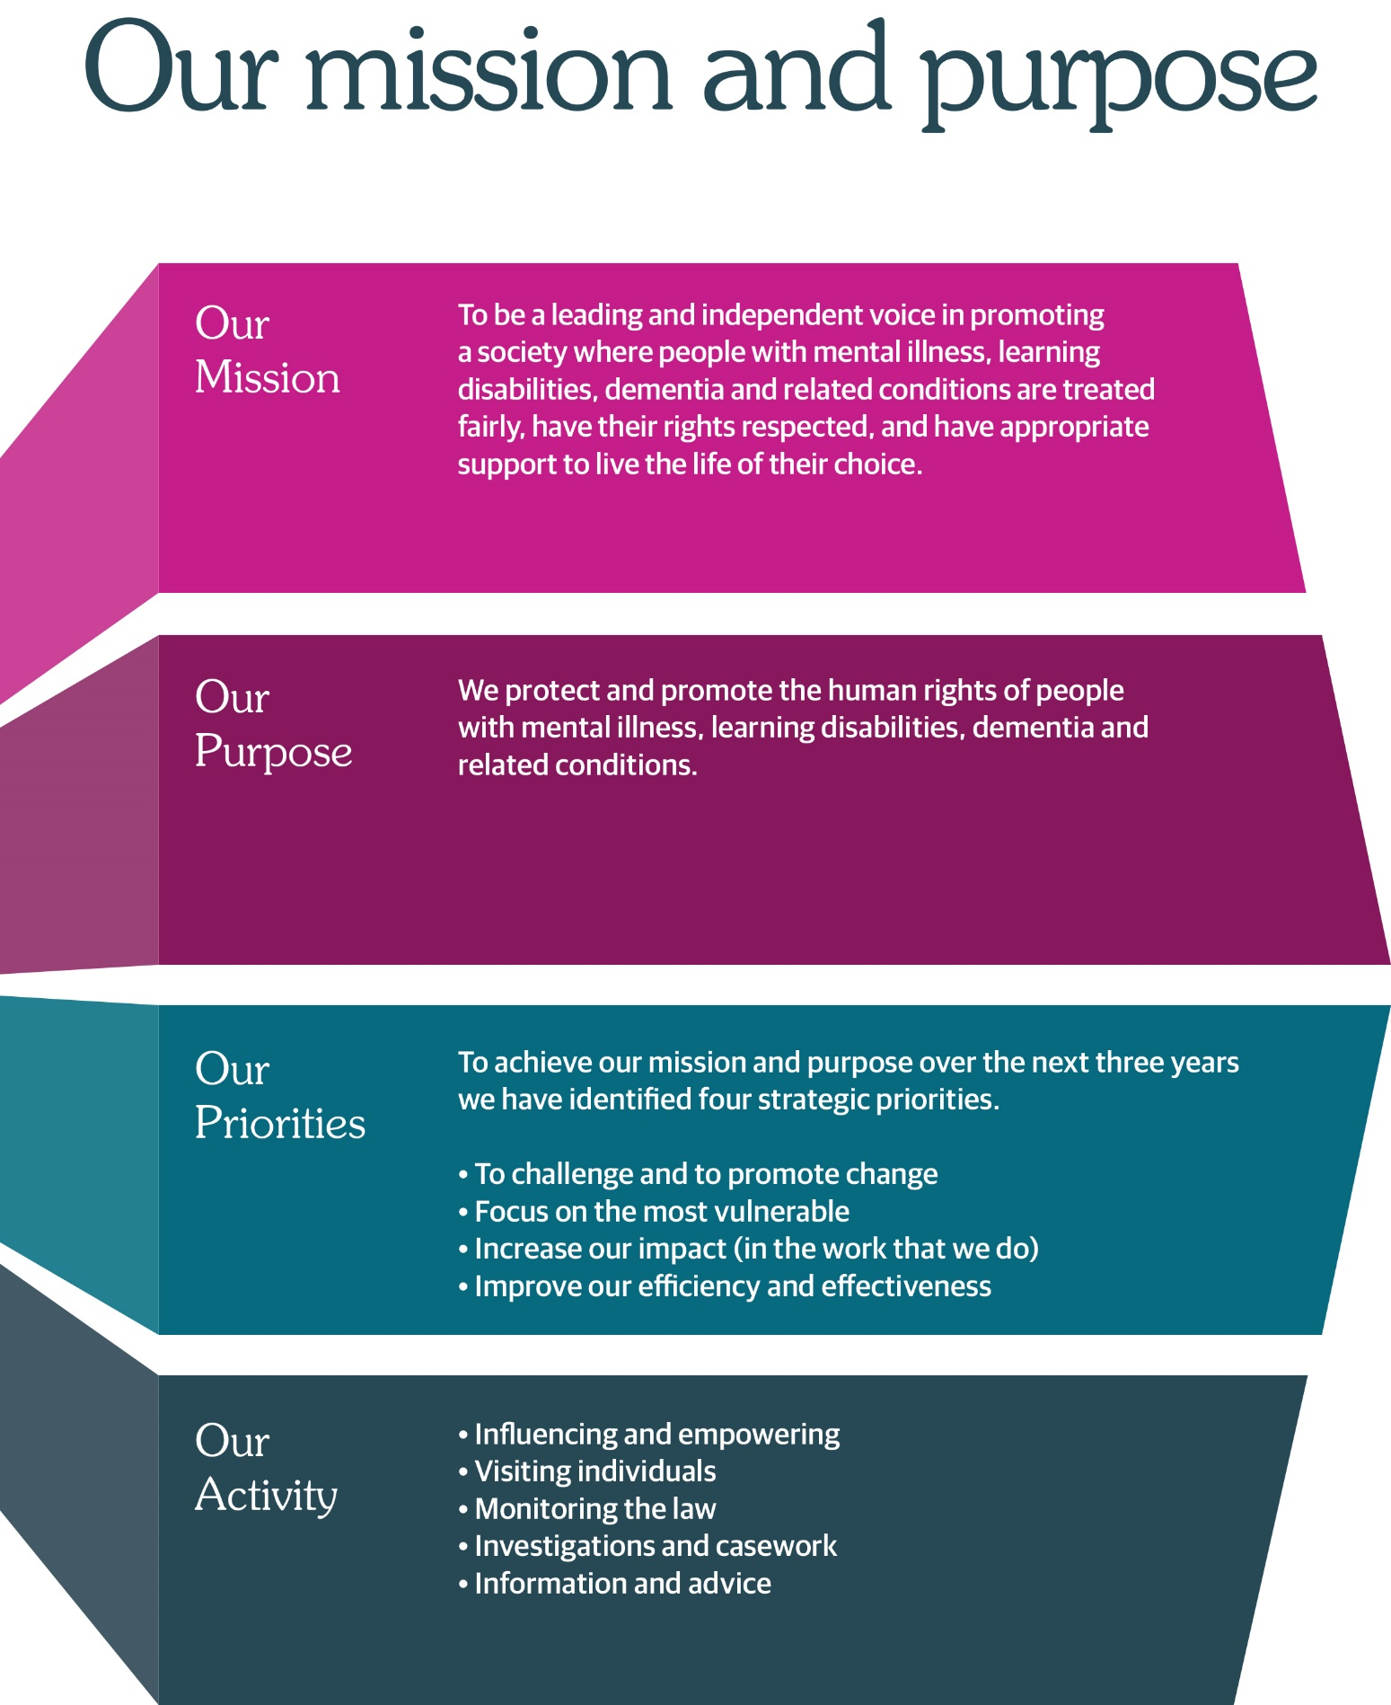



HR Adviser

Circa £31,938 per annum

Based in Edinburgh, hybrid working options.

Full time 35 hours a week

We protect and promote the human rights of people with mental illness, learning disabilities, dementia, and related conditions.

We have an exciting opportunity for a HR Adviser to join the Commission on a permanent basis.

1. To manage the recruitment process for all staff ensuring job descriptions and person specifications are up to date, draft adverts for line manager approval, manage relationship with advertising agency and organise interview schedule in accordance with Commission policy and procedures.

2. Process all information relevant to starters and leavers to ensure that staff recruitment and departures are managed in accordance with Commission policies and procedures.

3. Ensure that sickness absence is managed equitably across the Commission and that this is carried out in accordance with the Commission’s Ill Health Policy.

4. Plan, produce and implement induction processes to ensure that there is ap-propriate material available for all new staff and part time Commissioners and a structured environment for the delivery of induction.

5. Prepare, maintain and analyse the training and development database, ensuring that staff have the required training to carry out their roles, continuous professional obligations are met, budgetary control, and the Commission has ac-curate and current records on all staff.

6. Produce quarterly management information, covering issues such as sick absence levels, staff turnover, secondment information and training undertaken, for Management Group, to enable them to make informed staff planning and management decisions.

7. Manage the administration of the Commission’s appraisal system, ensuring that appraisal discussions are completed fully and on time, are in line with the Commission’s policies and procedures and appropriate information is fed into the training strategy.

8. Undertake, or contribute to, specific project work under the di-rection of the HR Manager to ensure HR systems and processes accommodate the changing requirements of the Commission and are in keeping with best practice.

As an employer, we offer excellent terms and conditions of service including a generous pension scheme, a commitment to learning and development and access to an Employee Assistance Programme and comprehensive staff benefits.

We also offer a comprehensive range of HR policies including policies to help balance commitments at work and home and flexible working arrangements.

At the Commission we champion diversity, inclusion, and wellbeing. We pride ourselves on being an employer of choice, cultivating a sense of belonging and providing a workplace where everyone feels valued. We aim to have a workforce which represents the wider society that we serve and therefore encourage applications from people of all backgrounds and under-represented groups.

Our office environment is modern, light, bright and green with superb views and is very close to Haymarket Railway station and transport links.

For more information on applying, please phone 0131 313 8772 or visit the website at https://www.mwcscot.org.uk/about-us/work-us

To apply, please send a copy of your CV and short application form to; mwc.recruitment@nhs.scot
Closing date for completed applications is 12.00 noon 23rd May 2025.

Interviews will take place the week commencing the 2nd June 2025 at Thistle House, Edinburgh.

HR Adviser – Job Description

Job Title: | HR Adviser
Reports To: | HR Manager

- Job Purpose
To provide professional HR services and support across a wide range of HR and OD areas and assist in shaping the future workplace for the Commission.

- Dimensions
There are approximately 83 staff employed in the Commission with various work patterns and working arrangements including hybrid working.
The Commission’s office is based in Edinburgh, but practitioner and engagement staff work across the different geographical areas in Scotland.
The staff group includes senior managers, doctors, nurses, social workers, researchers, administration, communication, engagement, IT, finance and business professionals.
The Commission also participates in a national doctors’ rotational training programme and HR co-ordinates the scheme allowing trainee psychiatrists to get experience and training assignments at the Commission.

Due to the small size of the organisation, this post has a wide variety of tasks in supporting the Commission’s human resources work and providing assistance to the Human Resources Manager.

The Human Resources team provides a comprehensive service across the full range of HR areas including recruitment & selection, induction & training, employee engagement, health and wellbeing and internal Equality, Diversity and Inclusion.

- Role of the Mental Welfare Commission for Scotland
We protect and promote the human rights of people with mental illness, learning disabilities, dementia and related conditions

We do this by:

- Checking if individual care and treatment is lawful and in line with good practice
- Empowering individuals and their carers through advice, guidance and information
- Promoting best practice in applying mental health and incapacity law
Influencing legislation, policy and service development

- Key Result Areas

- Manage recruitment and provide specialist advice and guidance on all aspects of the process in line with the agreed policies and procedures and statutory frameworks ensuring that recruitment requirements, from advertisement until an employee’s commencement in post and Induction, are completed in an efficient, customer focused way. This includes ensuring relevant pre-employment checks and legal compliance requirements are met.

- Advise and support managers and staff on areas of employee relations including policy advice, attendance management, performance appraisal, occupational health and wellbeing, terms and conditions and preparation of contracts, inductions and exit interviews to support the Commission’s objectives and ensure compliance with statutory rights and other policy and legislative standards.

- Drive forward the continued development and implementation of any HR systems in use at the Commission, including YouManage and Oracle. Ensure that HR and Workforce data is updated, that support and training for managers and staff on the system and new applications is available and be able to fully use the system in the preparation of HR reports to deliver comprehensive management and workforce information.

- Support the HR manager where required in helping with research/project/performance measures of HR work that contributes to the provision of a quality and professional HR service and in keeping with best practice.

- Undertake HR policy review work, researching, drafting and revising policies and participate in consultation exercises, co-ordinate policy implementation and the embedding of work procedures and processes to support policies and ensure legal compliance.

- Participate in programmes of work in support of Equality, Diversity and Inclusion across the organisation, preparing statistics and reports in line with legislation and be an active member of the internal Equality Committee.

- Contribute to the Learning and Development and Organisational Development agenda including the design, delivery, and evaluation of training interventions, in order to meet the developing needs of the organisation and take an active role in the promotion and development of the Learning Management system and development of new e-learning modules and maintenance and roll out of the system. Facilitate and co-ordinate training records and bookings as required.

- Develop professional networks with other organisations to allow sharing of best practice and continuously improve HR practices and processes and bring new insights and ideas to support the organisation.

- Carry out HR administration across the employee lifecycle of activities and oversee the effective management of HR records and systems ensuring compliant records management and efficient and accurate HR administration.

- Planning and Organising

The postholder will for the most part manage their own workload on a day-to-day basis.

Project and non-routine work will be subject to direction from the HR Manager.
Regular catch ups and meetings with the HR manager.
Priority work areas will be determined by a combination of objectives and on-going demand led requirements.

Review of work will be in accordance with the performance management arrangements, in the form of an annual appraisal and PDP.

- Internal and External Relationships
The role involves an excellent level of verbal and written communication skills working supportively with staff and managers at all levels throughout the organisation.

Internal

Supports and enables the development of effective working relationships and consultative communication processes with managers and staff in

Provides professional and timely HR advice and support to managers. Will escalate to the HR manager as required

Works with the Head of Culture and Corporate Services in embedding organisational values and across HR/OD areas of work as required.

External

HR networking groups and other organisations to establish and maintain networking.

Training providers –to source and book training to ensure that all staff have the opportunity to attend training courses as part of their CPD.

Occupational Health Department to discuss employee health and well-being issues.

Scottish Public Pensions Agency re pension information and updates.

Recruitment agencies – liaison on short-term recruitment projects.

Media platforms and employment organisations advertise job vacancies and attract candidates.

Job applicants and external interview panel members to promote good relations and co-ordinate recruitment.

Provider of HR Management system, Learning Management system and Staff Benefits portal for knowledge updates, active management of systems and promotion to staff and managers.

- Most Challenging Aspects of the Job
Working in a small organisation requires adaptability and flexibility to meet a variety of competing priorities. The ability to be able to manage time effectively and to take ownership of tasks is essential.

Adapting to the new ways of working and supporting staff and managers with different work patterns and working arrangements, hybrid working and providing an HR service through a mixture of in person liaison and virtual liaison to build an inclusive and cohesive team of staff/managers across the organisation.

- Skills/Qualifications and Experience
- Degree level qualification or equivalent experience/competence
- CIPD qualified or equivalent experience
- Proven generalist HR experience, ideally at HR Adviser level
- Experience in managing the Recruitment and Selection process
- Sound knowledge of employment legislation and HR practice
- Experience of writing and updating HR policies in line with best practice
- Knowledge and experience of HR Administration and records management
- Interpersonal, communication and influencing skills
- Strong planning and project management skills
- Organisational, time management and prioritisation skills
- Team working skills
- IT and keyboard skills
- Proficient in use and implementation of HR Information Systems & MS Office packages

HR Adviser - Person Specification

It is important to note that to be considered for appointment you must meet all of the essential criteria for the role. You should be able to demonstrate both within your application, and at interview (if invited to attend), how your skills, knowledge, values, and personal qualities match those required.

Essential | Desirable
- Degree level qualification or equivalent experience/competence  - CIPD qualified or equivalent experience  - Proven generalist HR experience, ideally at HR Adviser level  - Experience in Recruitment and Selection  - Sound knowledge of employment legislation and HR practice  - Experience of writing and updating HR policies in line with best practice  - Knowledge and experience of HR Administration and records management  - Interpersonal, communication and influencing skills  - Strong planning and project management skills  - Organisational, time management and prioritisation skills  - Team working skills  - IT and keyboard skills  - Proficient in use and implementation of HR Information Systems & MS Office packages | - HR Adviser experience  - Experience/competence in using Youmanage HR system and or Oracle Cloud  - Experience/competence in using LearnPro Learning Management system

Employment Information – HR Adviser

The following notes summarise the key points of the terms and conditions.

Full details will be provided with offers of employment.

Headquarters | Thistle House, 91 Haymarket Terrace, Edinburgh, EH12 5HE  Options for hybrid working
Pay | Circa £31,938
Type of Contract | Full Time Permanent
Manager | The post-holder reports to the HR Manager
Hours of work | Full-time posts are normally 5-days per week of 35 hours, exclusive of breaks but the hours of attendance may be varied, by agreement, to meet the needs of the work.
Leave | Annual Holidays  The annual entitlement for full time posts is 25 days per year, rising to 30 days after 10 years’ relevant service. (NHS and local authority service is counted as relevant service). Leave entitlement is pro-rata for part-time posts.  General/Public Holidays  Public and privilege holidays total 11.5 days per leave year, 6 of these are on set dates and the remainder can be taken as required.  For part time posts, the public/privilege holiday entitlement is pro-rata to full time equivalent.  The leave year runs from 1st April to 31st March.
Superannuation | NHS Pension Scheme is available to all staff subject to scheme rules.  Please click here for contributions details.  The employer currently contributes an amount equal to 22.5% of pensionable pay into the scheme on members’ behalf.
Staff Benefits | Through the Commission Staff Benefits scheme there is access to a wide variety of offers and discounts from the UK’s most popular retailers and service providers. The current provider is EdenRed. There is also access to, My Gyms discount site, the UK's largest network of gyms, studios, fitness centres and sports clubs across the UK with discounted membership offers. A comprehensive Employee Assistance Programme is also available and access to a Cycle to Work Scheme.  (The Commission reserves the right to withdraw, amend the schemes and change providers as appropriate)
Our values | The Commission operates a set of internal values for staff.
Performance,  Learning and Development | There is a performance development system in operation within the Commission. Progression through the salary scale is subject to satisfactory performance.
Data protection | The information you provide on the application form and any supplementary forms will be used to assist in the process of recruitment and selection in accordance with the Policy of the Mental Welfare Commission.  If you are successful in your application the information you provide will be used for HR and Payroll purposes. By signing the declaration section of the application form it is understood that you consent to the use and storage of your personal information for the above stated purposes.
Work outside the Commission | It is important to identify and minimise any conflicts of interest that could prevent staff from making fair and objective judgements or could be perceived as doing so by people with lived experience and carers, practitioners, and the public. Details are contained in the Commission’s Conflict of Interest Policy.
Probationary period | The post requires a 6 months’ probationary period.
Disclosure Scotland | You will be required to apply for a Basic Disclosure Certificate and completion of a self-declaration. An overseas criminal convictions check may also be required in the case of periods overseas.
Occupational Health Screening | Any offer of employment is subject to satisfactory Occupational Health clearance. The successful candidate will be asked to complete a Pre-Employment Health Questionnaire. NHS Lothian Occupational Health will make an assessment on your fitness to carry out the post based on the information contained within the questionnaire. In certain circumstances further information is required before clearance can be given, and Occupational Health may contact you by telephone or request that you attend for an appointment. Clearance may be subject to you attending for a post-employment appointment and it is vital that you attend this appointment if required
Complaints | The Commission has a Complaints Handling Procedure. All applicants have access to it if they feel they have been unfairly treated during the recruitment and selection process. External applicants should direct any concerns to the Human Resources department and internal applicants have recourse to the Commission’s Grievance Procedure.
Equal opportunities | The Commission is an equal opportunities employer.
Feedback | We do recognise the time and effort it takes to apply for a position. Following the short-listing process, you will be notified about the outcome of your application by email.

How to Apply

The Mental Welfare Commission encourages applications from all sections of the community.

We hope the information we have provided will encourage you to find out more about this opportunity.

To apply, please send a copy of your CV and short application form to; mwc.recruitment@nhs.scot
Closing date for completed applications is 12.00 noon Friday 23rd May 2025.

Interviews will take place the week commencing 2nd June 2025 at Thistle House, Edinburgh.

