Role Description
Division: Information, Advice and Friendship Services
Department: Helpline
Location: Blend of office (Edinburgh-based) and home working (in Scotland)
Geographical focus: Scotland-wide
Contractual status: Fixed term until 30/06/2026, subject to funding
Hours: 21 hours per week (part-time)
Line Manager: Advice Team Leader
Direct Reports: None
Salary: £23,489.38 pa pro rata (£14,093.63 pa actual)

Job Purpose
Our people are central to our success in delivering services for older people in Scotland. We pride ourselves on having a positive working environment and culture.

We know that growing older doesn’t come with a manual. Later life can bring opportunities and challenges, and people may need to know about rights, organisations and services which are often unfamiliar. That’s why we provide free information, advice and friendship to support older people on a diverse range of topics.

Older people in Scotland need our support now more than ever and through living our values you will play a significant part in empowering and enabling them to access their rights and entitlements.

People-centred in approach, you will be responsible for providing an exemplary ‘First Port of Call’ service in a hybrid virtual contact centre environment. You will respond to inbound and outbound contact, providing information and friendship to older people living in Scotland, their families and carers. You will provide cover and support to other telephony services within Age Scotland.

Living our values, you will approach the role with integrity, while involving, inspiring and empowering our teams, so that together we can create better outcomes for older people in Scotland.

Organisational Chart

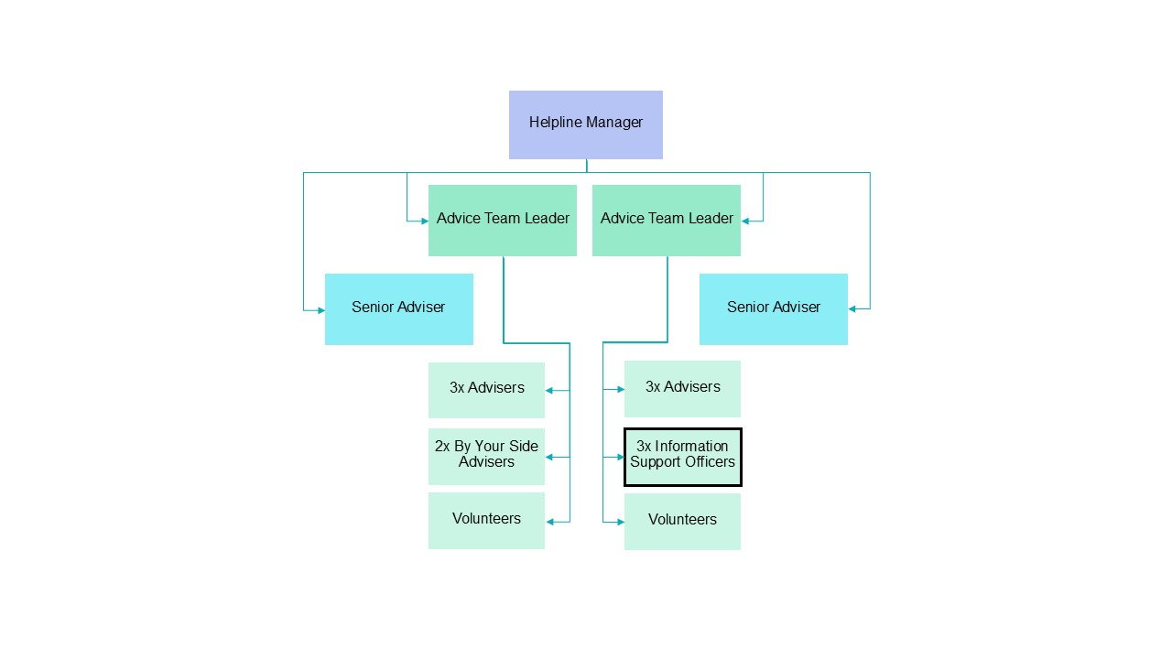

What you’ll do

- Provide a friendly and professional service and support the client’s positive journey.
- Assess client enquiries and identify the most appropriate services and options for their situation.
- Manage interactions in line with agreed processes: capture and record information, provide clients with signposts, order fulfilment items, escalate to other teams, and refer customers to other services as required.
- Manage clients’ expectations and adapt to current campaigns and/or media activity.
- Accurately record client and interaction data within our CRM, telephony and other systems.
- Handle enquiries in line with our regulatory and quality standards, including: Age UK Information & Advice Quality Programme and Scottish National Standards for Information and Advice Providers.
- Recognise, assess and escalate safeguarding incidents in line with agreed procedures.
- Recognise and assess complaints, resolve simple concerns and escalate more complex issues to the relevant individual or team.
- Maintain up-to-date knowledge and understanding of Age Scotland’s information guides and factsheets.
- Assist with administration as required.
- Complete all activities in line with agreed policies and procedures.

- Establish client contact preferences and comply with data protection processes.
- Offer friendship when our clients call for a chat.
- Undertake any other related work as designated by the Helpline Manager.

What you’ll bring

Knowledge & Experience:

Essential
- Previous customer service experience.
- A good understanding of issues affecting older people.
- Ability to listen to callers and demonstrate empathy and understanding.
- Previous experience of using CRM systems to process customer data.
- An understanding of, and commitment to, equal opportunities; you need to relate positively to people of different cultures, backgrounds and experience and believe in the equal value of people regardless of race, religion, culture, gender, age, disability or sexuality.

Desirable
- Experience working in a fast-paced environment.
- Experience in a generalist information and advice telephone service.

Skills & Qualities:

Essential
- Good understanding of Word / Excel / Outlook.
- Effective listening, oral and written communication skills.
- Accurate data entry skills.
- Confident, professional, outgoing telephone manner.
- Patience.
- Flexible attitude to hours of work.
- Ability to work as part of a team.

Qualifications:

Desirable
- Customer Service Qualification.
- ECDL (European Computer Driving Licence) or equivalent computer skills qualification.

Additional requirements
- Commitment to the aims and vision of Age Scotland and an ability to demonstrate our values (Empowering, Inspiring, Inclusive and Integrity) in your work.
- Commitment to providing older people with high quality services.
- Commitment to tackling the stigma of isolation and loneliness.

- Commitment to working alongside volunteers and supporting their development.
- An understanding of and commitment to equal opportunities.
- Willingness to work from the Edinburgh office when required (NB, travel costs from home to the office will not be reimbursed by Age Scotland).
- Employees are expected to have a suitable home-work space with a good broadband connection for occasional home working.
- Employees enrolled in Multi-Factor Authentication (MFA or 2FA) will be expected to install and maintain an app on either their personal or work mobile device.

Notes

- This role description is not intended to be exhaustive in every respect, but rather to clearly define the fundamental purpose, responsibilities and dimensions for the role. Therefore, this role description does not describe any individual role holder.
- In addition to the contents of this role description, employees are expected to undertake any and all other reasonable and related tasks allocated by line management.

