|  |  |
| --- | --- |
| **Job Title:** | **One-to-One Services Coordinator** |
| **Salary:** | £28,937.55 (Pro rata) Hourly £15.91 |
| **Hours:** | **18 hours per week (expected 09.30-3.30 Tues & Thurs/10.00-4.00 Wed)** |
| **Annual Leave:** | **18 days per year** |
| **Contract:** | **2 years fixed term (subject to 3-month probation/may be extended depending on funding** |
| **Pensions:** | **TPT Pensions at 6% Employers Contribution** |
| **Reports to:** | **Operations Manager** |
| **Location:** | **North Berwick Coastal Ward** |

**Background** **Coastal Community Connections (North Berwick)**

NBCCC was set up in June 2019 by the North Berwick Health and Wellbeing Association, to engage with people experiencing the impact of loneliness. We achieved charitable status (SC050505) in Sept 2020.

***Our Vision***

Creating compassion, companionship and confidence in our community.

***Our Mission***

To have a community where no-one need feel isolated or lonely, by connecting people to local networks, activities and friendships.

We provide access to the following:

* Drop-in activities (e.g Scone Cafe)
* One-to-one befriending
* One-to-one Buddy Walks
* Weekly group walks
* Our monthly Community Connections newsletter
* Various other partnership activities.
* EASE Training – End of Life Skills Aid for Everyone
* Public awareness events – Demystifying Death Week in May and Absent Friends Week in November

We currently have a part-time team of four staff and around 30 active volunteers

***Our Values***

**Engaging & Working Together:** Working collaboratively is at the heart of our commitment to make a positive impact within our coastal community. We believe our strength lies in our ability to connect with others, work as a team, and develop innovative solutions that meet the needs of our users and is in line with our vision and purpose.

**Continuously Improving:** We are dedicated to the principle of continuous improvement. We believe that by actively listening, learning, embracing change and being conscious of our environment we demonstrate that we are open to improved ways of meeting our vision.

**Communicating Openly:** Open and authentic communication is the fundamental principle guiding our relationships, within our charity and with the community. We are committed to fostering a culture of diversity, honesty, and transparency, seeking and sharing feedback.

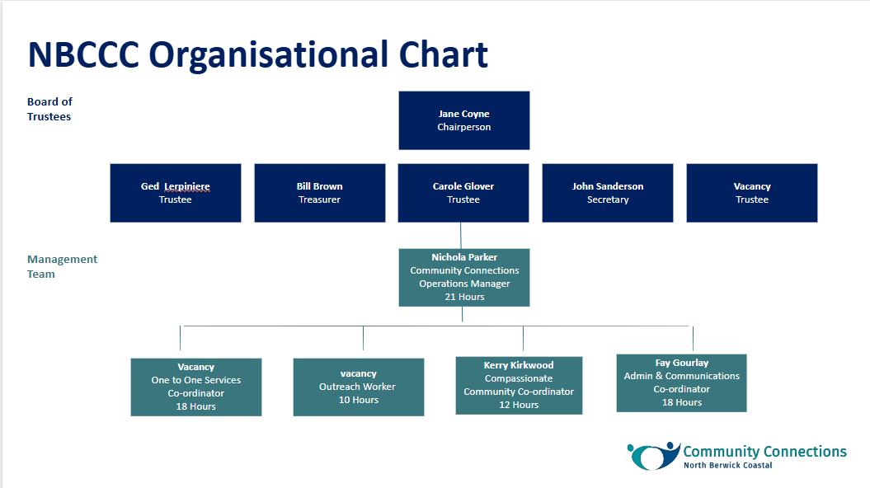

**Confidentiality**

All staff must respect the confidentiality of any matters they may learn in the course of their duties relating to members, staff, and the general public as well as matters of business concerning the project.

**Equal Opportunities Statement**

NBCCC welcomes diversity in the people we provide a service to and in our workforce. Diversity is not just seen as something to aim for but as something to be valued and an asset in delivering different services to different people.

NBCCC recognises that certain groups and individuals are discriminated against in society and is committed to ensuring that equal opportunity becomes an integral feature of all its activities.

All employees are required to comply with NBCCC’s Equality and Diversity Policy.

The duties and requirements in this job description are not exhaustive and amendments and additions may be required in line with future policy changes.

**One-to-One Services Coordinator - Job Purpose**

The focus of Community Connections is to help members clients to re-engage with the community through social contact and

NBCCC can provide specific support on a one-to-one basis to a number of people. We require someone to join our small team to manage referrals to our one-to-one services, assess need and match people with volunteers where appropriate. This role includes responsibility for supporting and coordinating our one-to-one volunteers, and shared responsibility for recruiting and training our volunteers across the organisation.

A key area of work is in supporting people through the loneliness that comes with the end of life and loss of a loved one. In the past two years we have developed our compassionate community work to deliver End of Life Skills for Everyone Training and are currently piloting a new service to support people through bereavement. The One-One services Co-Ordinator will support the Compassionate Communities Co-Ordinator to deliver this service.,

# **Key Responsibilities**

* *Lead on the development and delivery of our existing one-to-one services*
* *Support the Operations Manager in the recruitment and training of new volunteers*
* *Provide leadership, support and supervision for volunteers*
* *Respond to and follow up new referrals for one-to-one services*
* *Develop, manage and oversee the maintenance of current records for one-to-one volunteers and for customers receiving these services*
* *Develop and oversee the monitoring and evaluation of one-to-one services*
* *Work in collaboration with other staff, local organisations and key stakeholders to ensure best ways of meeting customer needs*
* *Adhere to Safeguarding and other relevant NBCCC Policies and Procedures, and ensure volunteers’ compliance with these*
* *Deliver End of Life Skills for Everyone training, and support Compassionate Communities Co-Ordinator*

# **Key Duties**

The main duties and accountabilities of the post are detailed below. In addition to these duties the role will be subject to adjustment from time to time and all employees are expected to carry out other reasonable tasks requested by the Operations Manager in the furtherance of the organisation’s wider objectives. This post will occasionally involve some evenings and weekend work as required.

### **Financial**

* Maintain records of any relevant expenditure in the performance of duties
* Follow procedures to Submit expenses claims to with evidence of expenditure
* Identify and recommend to Operations Manager any appropriate project purchases helpful to the delivery of services

### **Operational management and governance**

* Work closely with colleagues to support new customer referrals
* Liaise with relevant professionals as required regarding referrals
* Undertake initial individual assessments for one-to-one referrals and potential signposting
* Match people to volunteers for face to face and/or telephone contact
* Liaise with the Operations Manager regarding referrals, integration with/transitions to our services and other community-based group activities
* Regularly drop into activities to maintain contact and awareness and ensure smooth potential transitions to these
* Provide relevant material on one-to-one services for social media, website, newsletter and Annual Report
* Contribute to reports for the Board of Trustees on one-to-one services and outcomes against our targets
* Co-facilitate our Ease Training Courses and other Compassionate Community projects,
* Liase with appropriate colleagues to ensure more complex referrals are appropriately signposted.
* Contributing to relevant peer groups’ development, as agreed by Board
* Liaise with Compassionate Communities Coordinator re any relevant crossover, signposting etc
* Oversee, maintain and update relevant records for one-to-one services, liaising with Operations Manager and Administration and Communications Assistant
* Participate in regular staff team meetings
* Attend relevant in-house and external training courses as identified by and agreed with the Operations manager

**Project development and delivery**

Support the Operations Manager in developing and improving NBCCC’s services to the community, including new or one-off projects where appropriate (for example Fringe by the Sea activity)

**Line Management**

There are no direct staff reports, however the post holder will on occasion direct the activities of the Outreach Worker

**Volunteers**

Manage and coordinate the work of volunteers (primarily Befriending and Buddy Walking) Support the NBCCC Team in recruiting and inducting volunteers Contribute to planning and delivery of NBCCC Volunteer In-House Training

Networking and public relations Participate in appropriate networking activities and outreach events to promote NBCCC’s work and help bring about collaborations and new referrals

#### ***Please see Person Specification below***

#### ***Person Specification***

#### ***Essential Skills and Qualifications:***

**Experience:**

* Experience of working or volunteering in a mental health and/or befriending setting
* Ability to demonstrate an understanding of mental health issues
* Experience of working with and supporting volunteers, supervising, coaching, mentoring, training, retaining etc
* Strong commitment to equal opportunities issues & their impact on the organisation
* Awareness of relevant health & safety issues, risk assessments etc

**Knowledge:**

* Understanding of and commitment to equality and inclusion, practices
* Understanding of GDPR & Safeguarding safeguarding and safe working practices
* Experience and knowledge of working with sensitive and confidential information

**Skills & Behaviours:**

* Excellent interpersonal and communication skills, with the ability to engage with a diverse range of people.
* Delivery of workshops, community activities and events
* Strong commitment to equality, diversity, inclusion and anti-discriminatory practice.
* Empathetic, patient, and non-judgmental, focused on the needs of the individual whilst working within boundaries and guidelines.
* Recognises the importance of the contribution from volunteers and is enthusiastic about their ideas whilst working within guidelines and in pursuit of the Charity mission.
* Works collaboratively with others as part of a team but comfortable working independently
* Motivated, proactive, and able to work flexibly in response to community needs.
* Strong organisational skills and the ability to manage a varied workload.
* Confident in record-keeping, data management, and reporting.
* Strong IT skills (Outlook, spreadsheets, producing word documents)

**Desirable:**

**Qualifications:**

* NVQ/SVQ Level 4 in counselling or equivalent in Health and Social Care, Community Development.

**Experience:**

* Experience of delivering training to volunteers
* Previous experience working in a rural or coastal community.
* Experience in hosting workshops or group activities
* Experience of directing the work of others
* Experience of supporting people through Bereavement

**Skills:**

* Knowledge of Microsoft 365/Customer Management Systems
* Trained in the delivery of End-of-Life Skills for Everyone

**Training & Induction**

* The successful candidate will be required to attend the **End-of-Life Skills for Everyone as a delegate and a secondary course to enable delivery of this activity**

**Other Requirements:**

* **Driving Licence:** Full, clean driving licence and access to a car is desirable but not essential
* **Background Check:** Subject to satisfactory PVG (Protecting Vulnerable Groups) check.

**Supervision and Accountability**

To comply with supervision policy, which includes regular supervisions with the Line Manager.