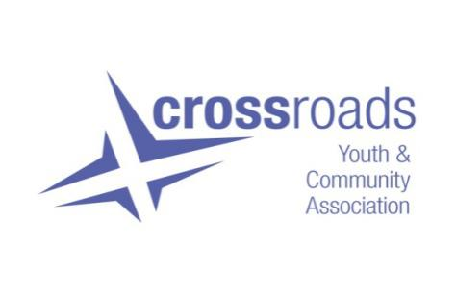

**Job Description**

**JOB TITLE**: Digital Inclusion Worker

**HOURS OF WORK:** 21hrs PW (Mon – Fri with evening and weekend work as required)

**SALARY: SJC Scale Point 23-26 (£30109 - £31961 at 35hrs pw)**

**CONTRACT:** Until end March 2028. Three year post subject to a three month probationary

period.

**LOCATION:** Based within theCharity’s main office in the Gorbals working across the Gorbals.

**ACCOUNTABLE TO:** Joint staff team, Charity Manager, Board Members

**The Aim of Community Work in Crossroads**

Crossroads Youth and Community Association’s work and values are built on the central belief that “everyone has the right to live gloriously: whatever in society prevents this, should be challenged and whatever in the individual helps should be nurtured”

The main aim of community development work in Crossroads is to collectively bring about social change and justice, by working with communities to:

* Identify their needs, opportunities, rights and responsibilities
* Plan, organise and take action
* Evaluate the effectiveness and impact of the action

We will do all this in ways which continually challenge oppressions and tackle inequalities staying true to our beliefs that community development should be rooted in values and principles.

**The Main Purpose of this Role**

At its heart, the main purpose of this role is to address both the cause and impact of digital inequality within the Gorbals by supporting individuals and communities to gain the skills, confidence and access required. This role will help bridge the digital divide by working collaboratively with third sector partners.

To do this you will take an approach that is universal, human and place based to;

Ensure that interventions and solutions are rooted in the experiences and challenges faced by local people and the partnership forum.

Work collaboratively with third sector partners to strengthen our approach to digital inclusion, and to share resources and skills.

Increase capacity of local people to take on digital leadership roles in the community through accredited training.

**Main Duties of the post**

* To create a sense of community around digital inclusion activities.
* To support the development of local responses to digital exclusion.
* To enable community influence and control.
* To represent and promote the work of Crossroads to partners, other organisations and

statutory bodies on the aims and outcomes of project work in order to gain support and promote the aims and profile of the project.

* To update and maintain organisation website.

**Key Tasks**

* To undertake community engagement around digital inequality.
* Learn the root causes of digital exclusion locally and develop ways to help people with different needs gain basic digital skills and safely and access online services and technology.
* Oversee and disseminate data packages to those at risk of digital exclusion (the data packages are in partnership with National Data Bank so needs to be recorded in line with requirements).
* Work in partnership with the local community and project partners (manly third sector forum) to develop and maintain a digital inclusion training and learning calendar of events.
* Build a network of digital champion volunteers to provide digital support services across the area.
* Develop positive and lasting relationships (and project buy-in) with colleagues, community and partners.
* Review and update in collaboration with partners and the local community the Gorbals Digital Inclusion strategy.
* To develop the skills, confidence and knowledge of groups to enable them to achieve their aims.
* To attend and fully participate in service delivery staff/joint staff meetings and Board meetings as required.
* To work co-operatively as part of Crossroads’ wider staff team.
* To carry out administration/finances relating directly to the post in line with organisational procedures and to support the work of the admin/finance Officer relating to the wider work of Crossroads.
* To prepare written reports and review/evaluation material for Crossroads’ Board, funders and other target audiences as appropriate.
* To build networks and partnerships and represent Crossroads at external events.
* To participate in staff training and development.
* To comply with Crossroads’ policies, procedures, frameworks and processes.
* To undertake any other reasonable duties commensurate with the post at the agreed request of the staff/joint staff, Charity manager and Crossroads’ board.
* To be willing to work unsocial hours, weekends etc as the role requires.

This list of duties is not exhaustive and will be reviewed periodically in discussion with the post holder.