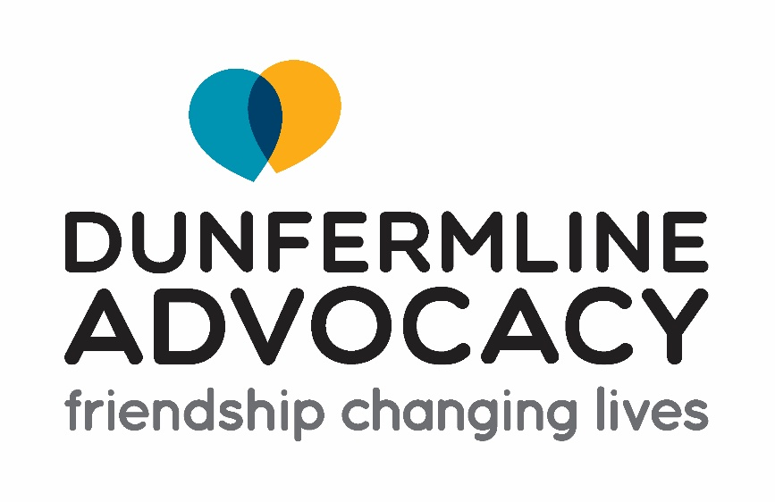

Staff Application Form


Guidance notes for applicants

Application information

Thank you for your interest in joining the team at Dunfermline Advocacy.

Please read these notes carefully, as well as the job description and person specification before completing and submitting your application.

We are a values led organization and seek to recruit people who reflect our values as this is essential for delivering our vision and strategic commitments.

For us, it is most important that you share Dunfermline Advocacy’s values and approach, and that you have the core skills and experience required to perform the role. It’s therefore important for you to evidence how you share our values and explain how you meet the knowledge, skills and experience criteria outlined in the role profile, giving specific examples where possible.

We are committed to ensuring equality of opportunity and avoiding unconscious bias and as such we only share Section B of the application form with our shortlisting panel, where there is no identifying personal information. Therefore, we cannot accept additional documents such as CV’s as they will not be able to be taken into consideration.

Shortlisting, interviews, and appointments

Shortlisting for advertised posts is generally completed during the week following the closing date. You will be notified by email within 3 weeks of the closing date if you have been unsuccessful.

If you are successful in proceeding to the interview, we will send you an invitation confirming the time for the interview and the relevant arrangements. Interviews will take place at our office on the 17th June 2025. If you have any additional requirements for attending the interview, please let us know in the relevant section of the application form.

All candidates invited for interview will be asked to give a presentation of up to 10minutes on a relevant topic, details of which will be provided if invited for interview.

Any offer of employment made following interview is subject to the receipt of satisfactory references, appropriate checks by Disclosure Scotland and evidence of your right to work in the UK.

References

It is essential that you provide full referee details from your most recent employer/ volunteer opportunity. References cannot be accepted from friends or family. If you have just left college or university, references can be provided by your tutors. We will not contact your referees until a conditional offer is made.

PVG

As this is a regulated post, any offer of employment is subject to a completed satisfactory PVG check for both Children and Protected Adults. The successful candidate will be unable to commence until this has been completed, so we ask all candidates invited for an interview to bring the required ID documents to be checked at interview to avoid any delays.

Data Protection

Your application will always be treated confidentially. Its contents will only be disclosed to those involved in the recruitment and selection process.

If you are appointed, this form will be used as part of your personal employee file and to gather workforce information. The information will be held in accordance with current Data Protection legislation.

Forms for unsuccessful candidates are retained for a period of six months after which they are confidentially shredded. We may keep limited information for statistical and monitoring purposes.

Returning the application form

Please ensure that all sections of the application form are fully completed. The completed form should be returned by email to tricia@dunfermlineadvocacy.org by the deadline of Tuesday the 10th of June at 12 noon.

We wish you luck with your application and please do not hesitate to contact us if you have any questions.



Application for employment – Section A

Please do not include a CV with this application as it will not be accepted. Applications received after the closing date/time will also not be considered.

Applicant Number (office use only)
Post applied for:
Where did you hear of this vacancy:

Personal information
(CONFIDENTIAL:This section is for HR use only and will be removed prior to sharing the application for shortlisting purposes)

1. Personal details
Name
Address
Email address
Phone number (Home)
Phone number (Mobile)

2. Right to work in the UK (If you are selected for interview, you will be asked to provide evidence that you have the legal right to work in the UK)
Are you eligible to work in the UK | Yes No ☐
If yes, please give details. (UK Citizen, Visa arrangement etc.)

Are you a member of the PVG Scheme | Yes ☐ No ☐
If yes, is this in respect of regulated work with: | Adults ☐ children ☐ both ☐

If you are invited for an interview and have any additional requirements, please give details.

Have you ever been subject to formal disciplinary procedures or been dismissed from a previous employment or voluntary position or resigned from a position pending disciplinary investigations taking place?  If yes, please give details in a separate letter. | Yes ☐ No ☐

4. References

Please give details of two references, at least one of whom should be your current / most recent employer. References will be taken up for candidates successful at interview.

 | Reference 1 | Reference 2
Name
Relationship to applicant
Address
Phone number:
Email Address:

5. Declaration

I declare that the information given on this form and on any other documents supporting this application is to the best of my knowledge, true and complete.

By signing this form you are providing consent to your data being used in line with Health in Mind’s Privacy Policy.

Signature |  | Date



Application for employment – Section B

Applicant number (office use only)
Post applied for:
1. Current or most recent employer

Starting with the most recent, please provide details of all your relevant work experience explaining any gaps in your employment history and reasons for leaving employment. Please indicate whether the role was on a permanent, interim, fixed or volunteer basis.

Name and address of employer:
Date employed from: |  |  | Date employed to:
Paid ☐ Student Placement ☐ Volunteer Role ☐
Job title and brief details of responsibilities and transferrable skills for this post.
Reason for leaving

2. Employers Details
Employer’s name and address:
Date employed from: |  |  | Date employed to:
Paid ☐ Student Placement ☐ Volunteer Role ☐
Job title and brief details of responsibilities and any transferrable skills for this role:
Reason for leaving

Employer’s name and address:
Date employed from: |  |  | Date employed to:
Paid ☐ Student Placement ☐ Volunteer Role ☐
Job title and brief details of responsibilities and any transferrable skills for this role:
Reason for leaving

Employer’s name and address:
Date employed from: |  |  | Date employed to:
Paid ☐ Student Placement ☐ Volunteer Role ☐
Job title and brief details of responsibilities and any transferrable skills for this role:
Reason for leaving

3. Education and Professional Development

Please complete your highest level of academic qualification and any other relevant qualifications only.

From | To | Establishment | Course of study  (state whether full-time or part-time) | Qualification gained and level of pass  (if applicable)

Please provide us with details of any relevant Professional Development you have undertaken in last 10 years only.

Date completed: | Name of course | Details:

4. Membership of professional bodies

Name of Professional Body | Date of Membership &  Membership Number | Status

6. Knowledge, Skills and Experience
Please refer to the job description and person specification and outline below how you meet the core requirements for these areas. Please give specific examples/details rather than just stating you have the knowledge, skills and experience required.

