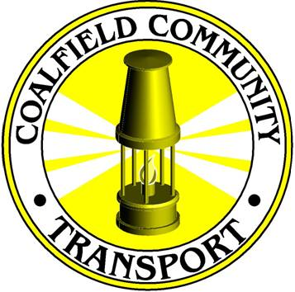

**COALFIELD COMMUNITY TRANSPORT**

**About Coalfield Community Transport**

CCT is a registered charity and was established by a local group of volunteers in 2002. The charity provides a range of transport related services across East Ayrshire to meet the diverse needs of its residents.

As well as providing community and voluntary groups with access to affordable and accessible transport to allow them to participate in community activities, Coalfield Community Transport works to improve access to services and jobs.

Coalfield Community Transport currently operates a fleet of 21 vehicles, the majority with full accessibility for people with disabilities, and provides employment for 28 people.

With a distinctive identity which is recognised locally and nationally, this popular and much needed transport service is making a positive impact in communities across East Ayrshire.

**Our Mission**

*“To provide accessible, affordable and appropriate transport solutions for eligible groups and socially or economically disadvantaged individuals in East Ayrshire with the aim of encouraging greater community participation and social inclusion.”*

**Our Services**

Coalfield Community Transport provides a wide range of transport related services for community and voluntary groups and residents who are frail, elderly, have a disability, live in a rural area without access to their own transport or are unable to access public transport.

* **Group Transport** - Coalfield Community Transport operates its services under a Section 19 Minibus permit and has a membership scheme for eligible groups. Over 150 groups from across East Ayrshire currently use this service regularly to attend meetings and excursions, with over 200 MiDAS (Minibus Driver Awareness Scheme) trained volunteer drivers.
* **Dayhopper and Awayhopper Services** - The ‘Dayhopper’ service provides a shopping and excursion service for vulnerable people, and enable individuals who would not normally travel because of cost and accessibility issues to travel outwith the local area. The club has over 350 members and operates five days a week.

An ‘Awayhopper’ service offers the opportunity for members to take affordable short breaks.

* **Social Care Transport** - Coalfield Community Transport operates social care contracts on behalf of East Ayrshire Council, transporting older residents to and from day care facilities across East Ayrshire.
* **ASN & Early Years’ Service** - Delivered on behalf of East Ayrshire Council, transport services are provided for vulnerable young children who attend School & Early Years Childhood Centres.
* **Cumnock Connector** - This is a demand responsive service, funded by Strathclyde Partnership for Transport, providing access to a range of services for vulnerable residents who have difficulty accessing public transport.
* **Training** - MiDAS and PATS training is provided for all volunteer drivers and escorts, with a range of further training courses being developed to enhance current provision.  
    
  Coalfield Community Transport was the first community transport operator in South West Scotland to be accredited to the South West Scotland CT Quality Network 2013 and was sponsored by Strathclyde Partnership for Transport to establish a quality standard for community transport groups in the area.

**Management Structure**

Coalfield Community Transport is managed by a voluntary Board of Trustees, which meets on a regular basis and receives regular reports on operations and finance. The Board sets the strategic direction and reviews progress at its meetings.

The Executive Manager has responsibility for ensuring the implementation of the strategy and reporting to the Board, and the overall management of the service, including finance, marketing, legal, operations, training, HR, Health and Safety, development activities, fund raising, and its employees.

The Transport Manager has been appointed to oversee the day to day operation of the service, who reports to the Executive Manager.

**Premises**

Centrally located premises provide a visible presence, office accommodation and training facilities, and space to garage vehicles at Caponacre industrial Estate in Cumnock. In addition, the premises are easily accessible and provide ample parking space for drivers’ own vehicles.

Coalfield Community Transport is a Scottish Charitable Organisation (No. SC032515).

Coalfield Community Transport

Block 4 Unit 1 Caponacre Industrial Estate , Cumnock, KA22 1SH

Telephone: 01290 429088

Email: [enquiries@yellowbuses.org.uk](mailto:enquiries@yellowbuses.org.uk)